**DevOps Project**

**Problem Statement:**

Create an end-to-end CI/CD pipeline in AWS platform using Jenkins as the orchestration tool, GitHub as scm, maven as the build tool, deploy in a docker instance and create a docker image, store the docker image in ECR, Kubernetes deployment using ECR image. Build sample java web app usi

Approach:

Requirements:

✓ CI/CD pipeline System

✓ Git - local version control system.

✓ GitHub - As Distributed version control system.

✓ Jenkins - Continuous Integration tool.

✓ Maven - As a Build Tool.

✓ docker -Containerization

✓ Kubernetes - As Container Management Tool

Step-1:

➢ Setup CI/CD with GitHub, Jenkins, Maven & Tomcat.

➢ Setup Jenkins

➢ Setup & Configure Maven, Git.

➢ Setup Tomcat Server.

➢ Integrating GitHub, Maven, Tomcat Server with Jenkins

➢ Create a CI and CD Job.

➢ Test the Deployment

Step-2:

➢ Setup CI/CD with GitHub, Jenkins, Maven & Docker.

➢ Setting up the docker Environment.

➢ Create an Image and Container on Docker Host.

➢ Integrate Docker Host with Jenkins.

➢ Create CI/CD Job on Jenkins to build and deploy on container.

Step-3:

➢ Build and Deploy on Container.

➢ CI/CD with GitHub, Jenkins, Maven & Kubernetes.

➢ Setting up the Kubernetes (EKS).

➢ Write pod service and deployment manifest file.

➢ CI/CD Job to build code on Jenkins & Deploy it on Kubernetes.

Step-4:

➢ Deploy artifacts on the Kubernetes

➢ Write codes in the artifacts of docker and Kubernetes which we want to run.

➢ Now build the code in Jenkins.

➢ Check in Kubernetes the pods are getting created or not.

➢ Now copy the service IP and paste it in the browser and check the output.

**Solution:**

**#1: Git-Client:**

Created Instances on AWS name as developer-server, Jenkins server and Tomcat server with same key-pair and same security group.

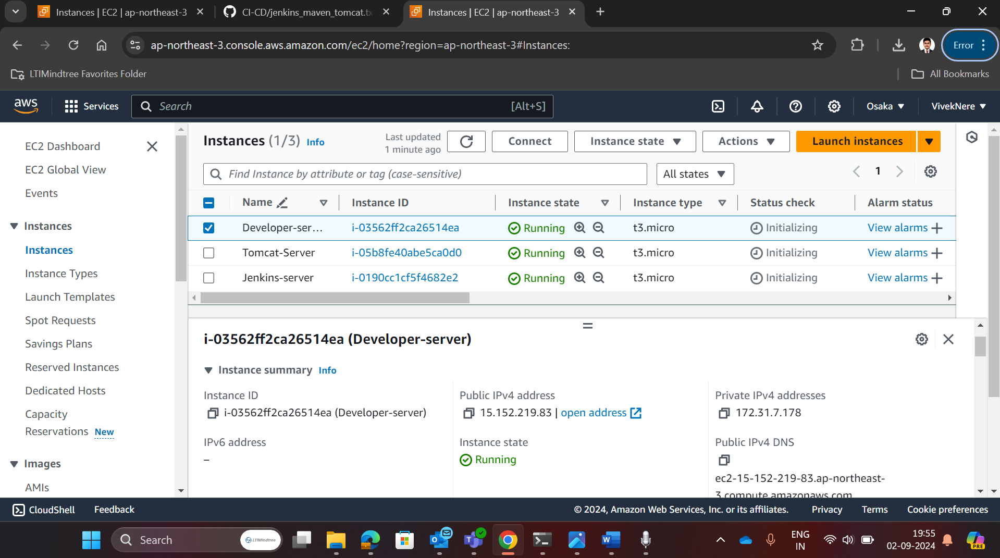

Connected developer server instance with local system through ssh and gave it a localhost name as developer-server

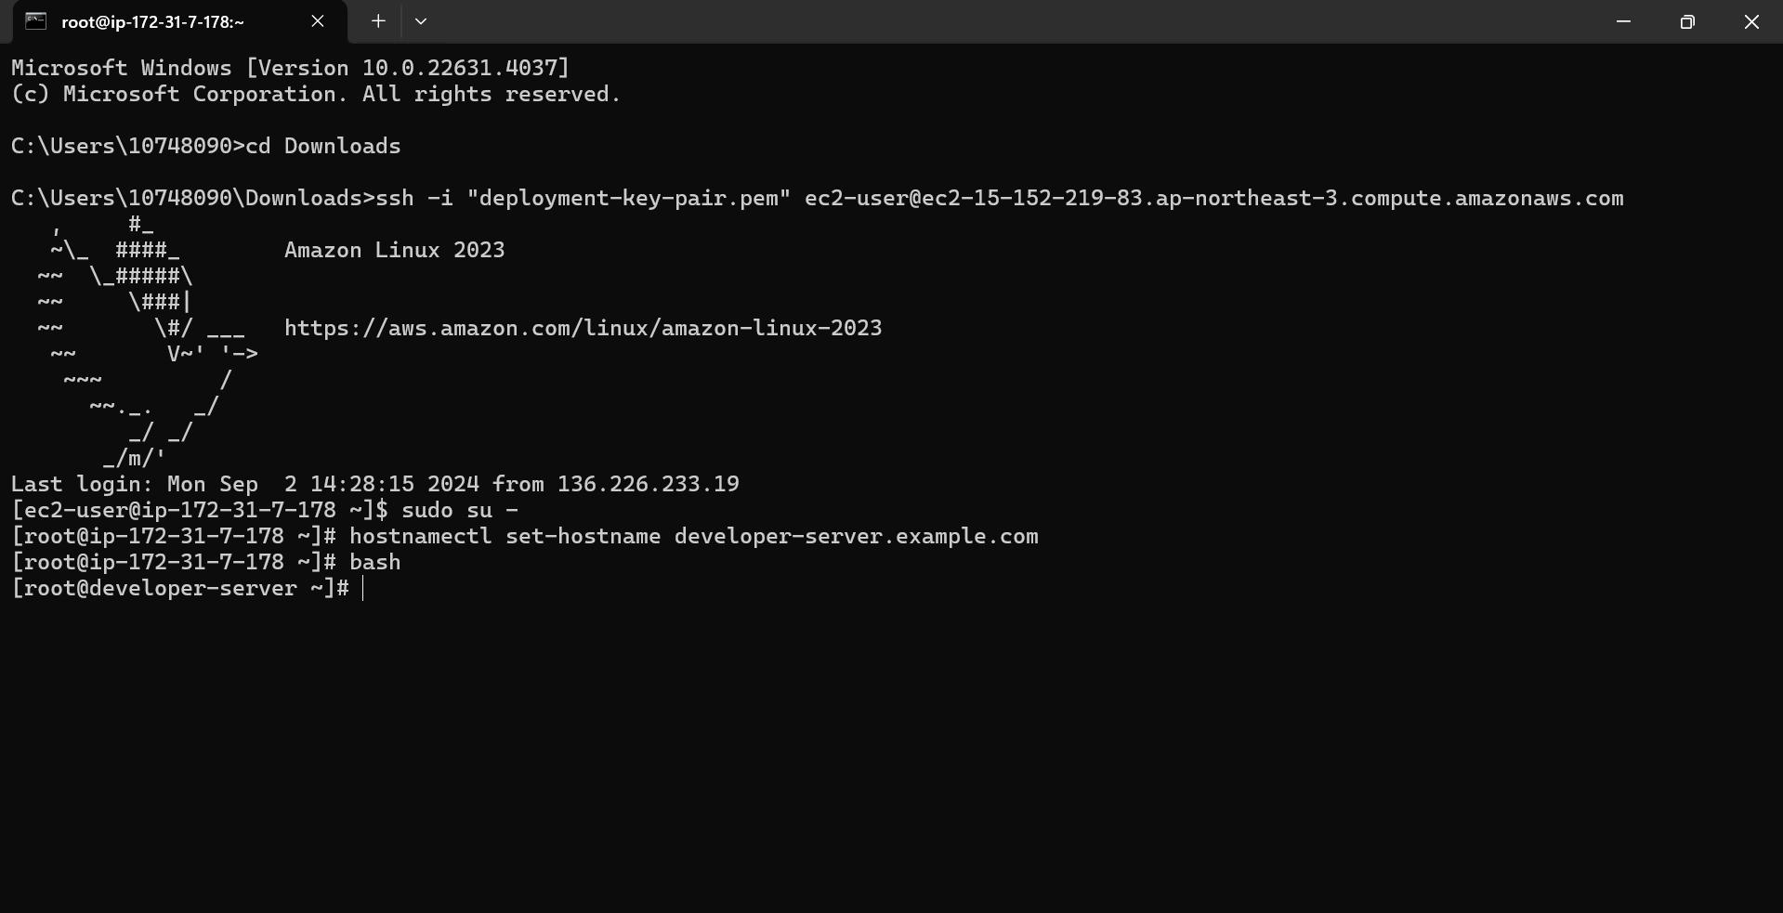

Installed and initialized git in developer-server

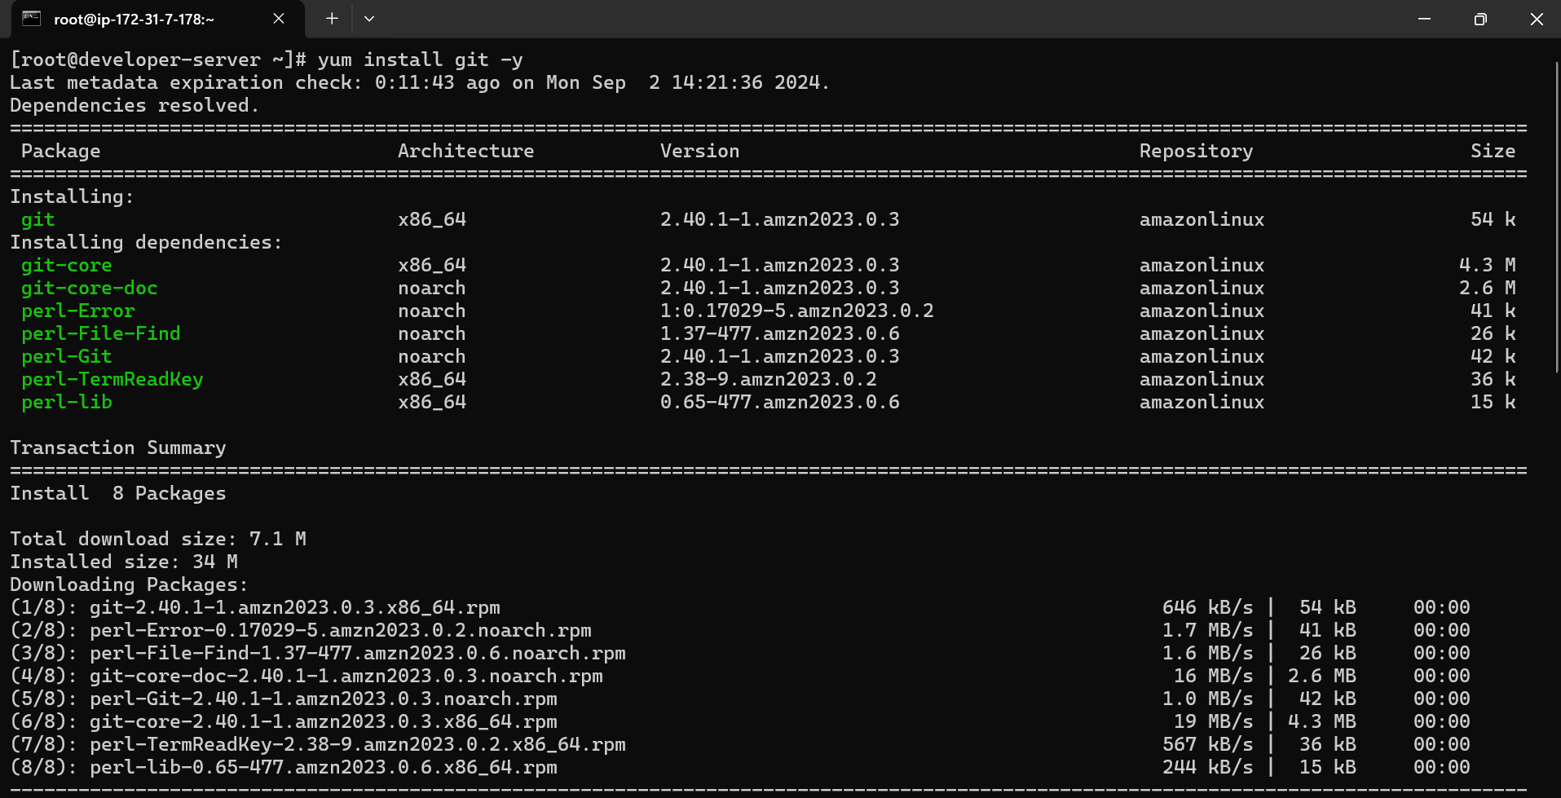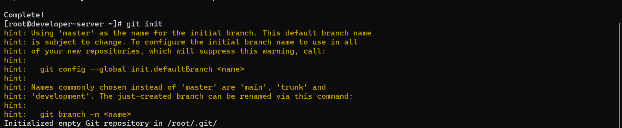

Created and added public ssh-key to github-account for ssh-authentication

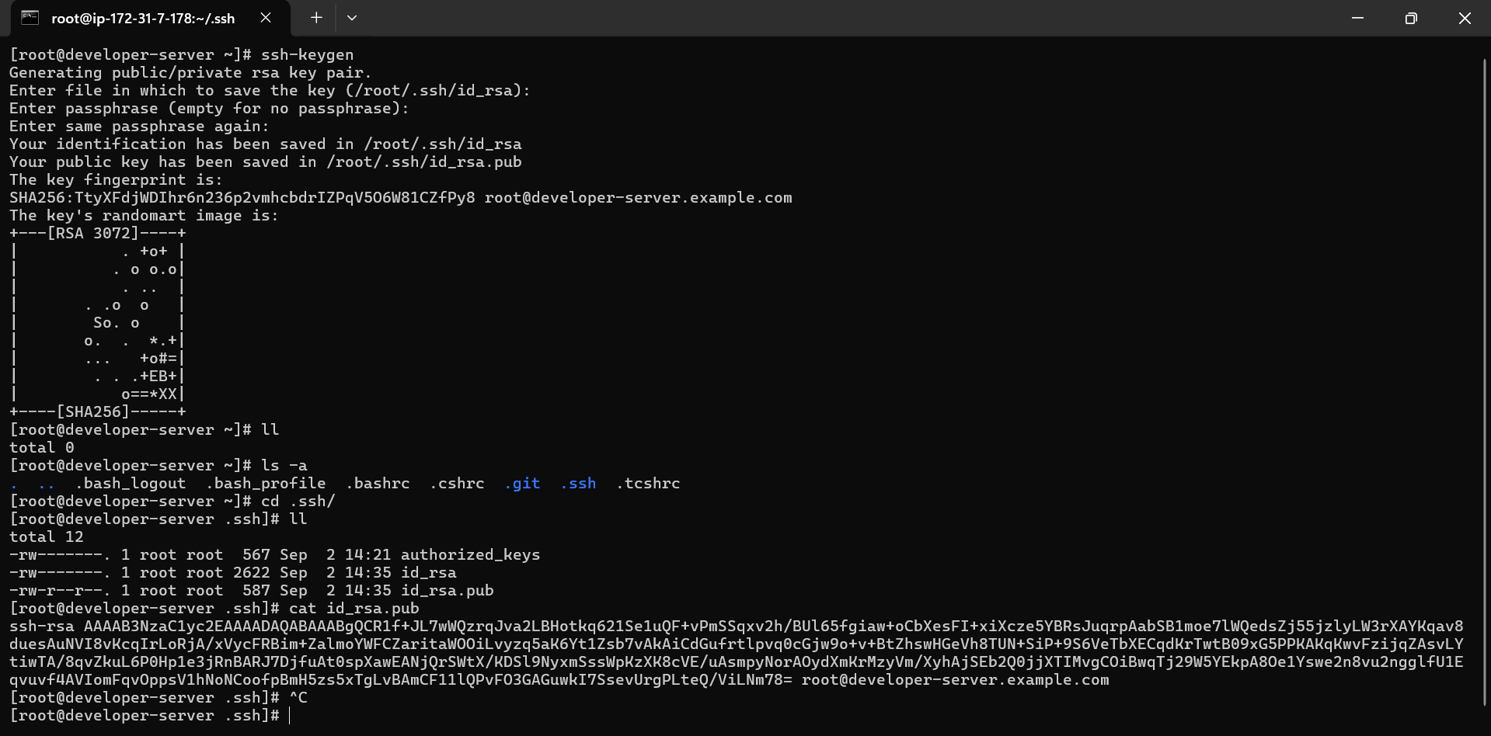

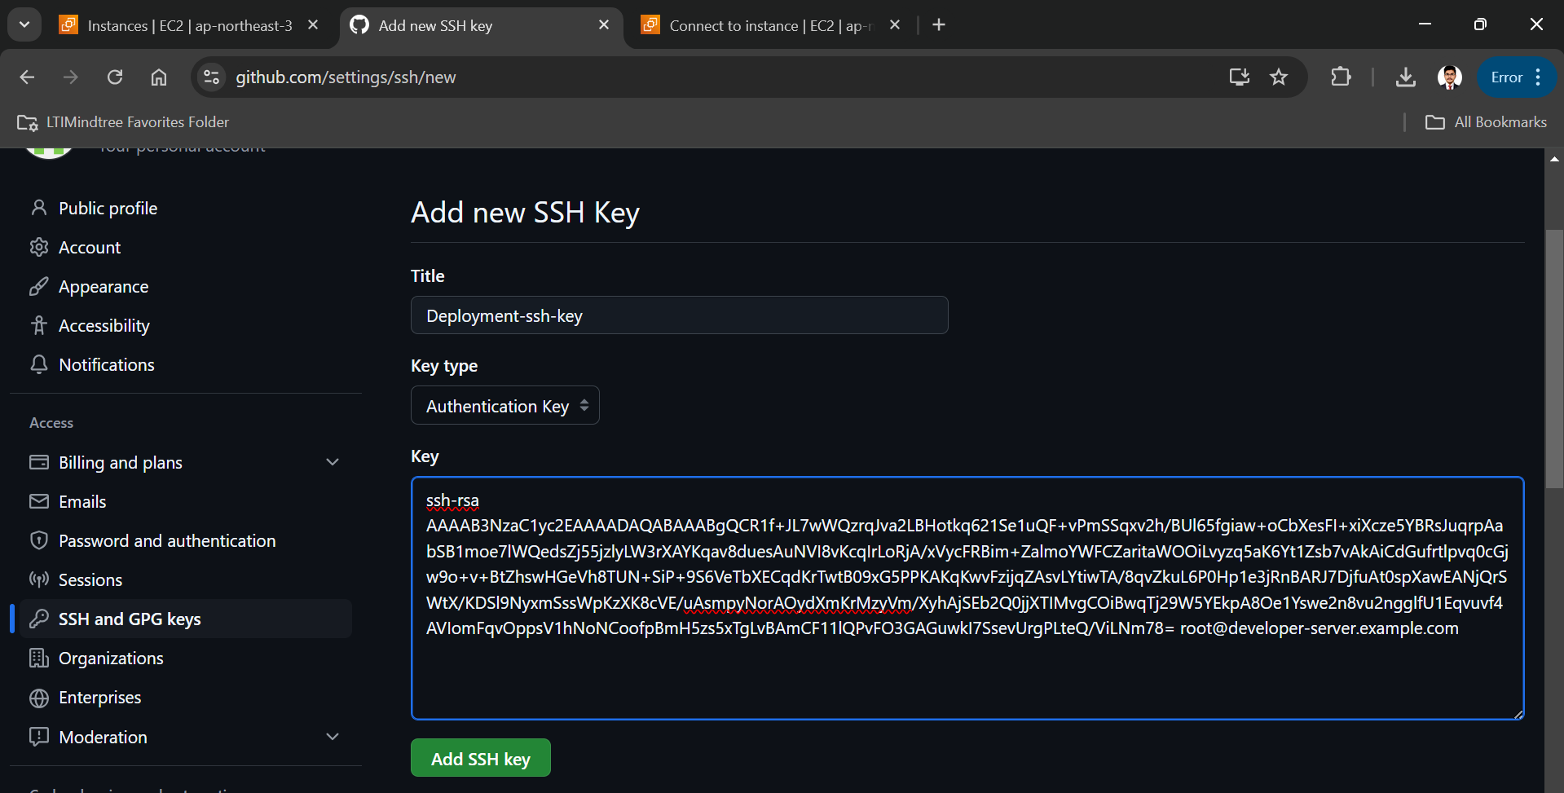

CLONE JAVA PROJECT FROM GIT REPOSITORTY WHERE IT IS PRESENT

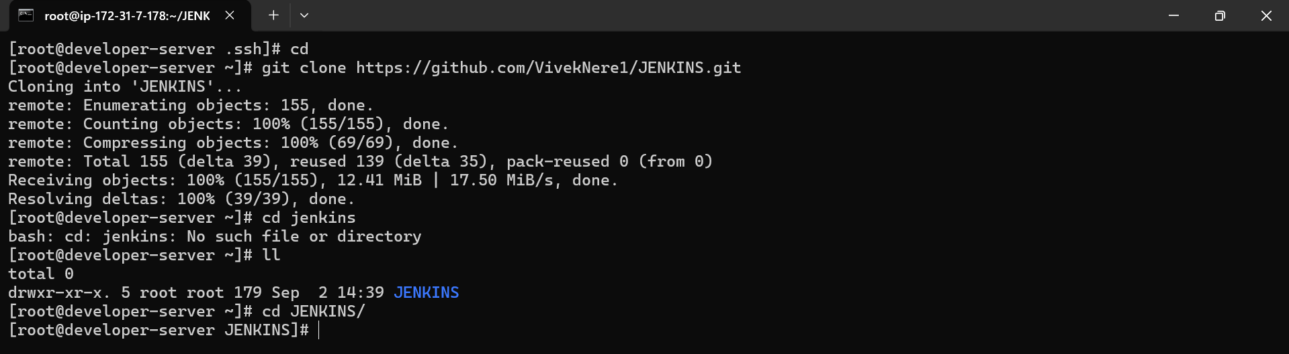

Created deployment name repository in my account to push the code in that repository which we have cloned just now

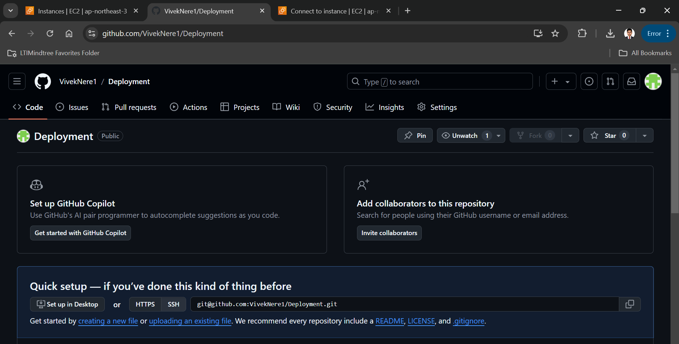

Now we have successfully push the code on my own branch

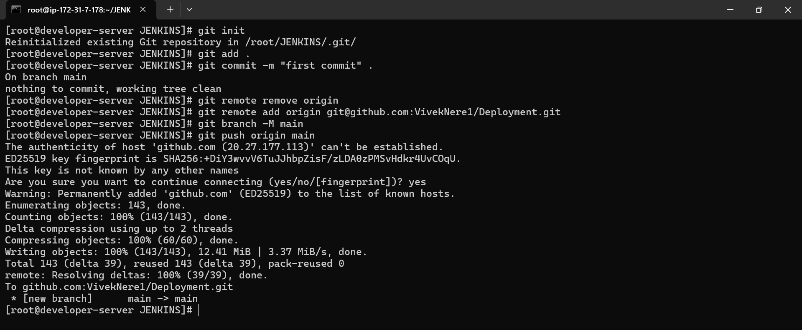

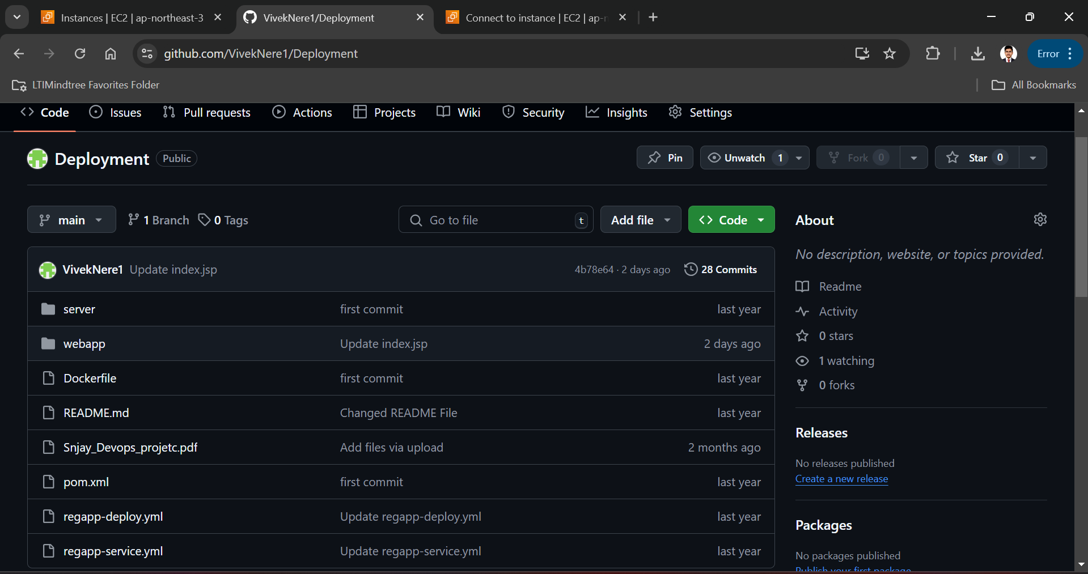

Now we have to open Jenkins-server instance in our machine using ssh and I have gave the hostname as Jenkins-server

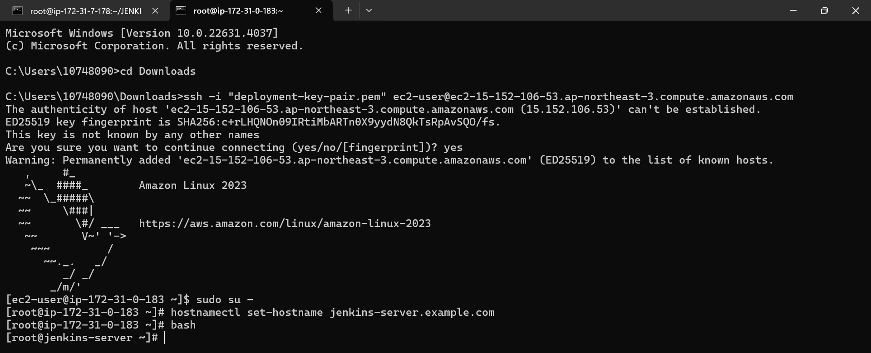

Now we have to add one extra inbound rule in security group for Jenkins server instance with port number 8080

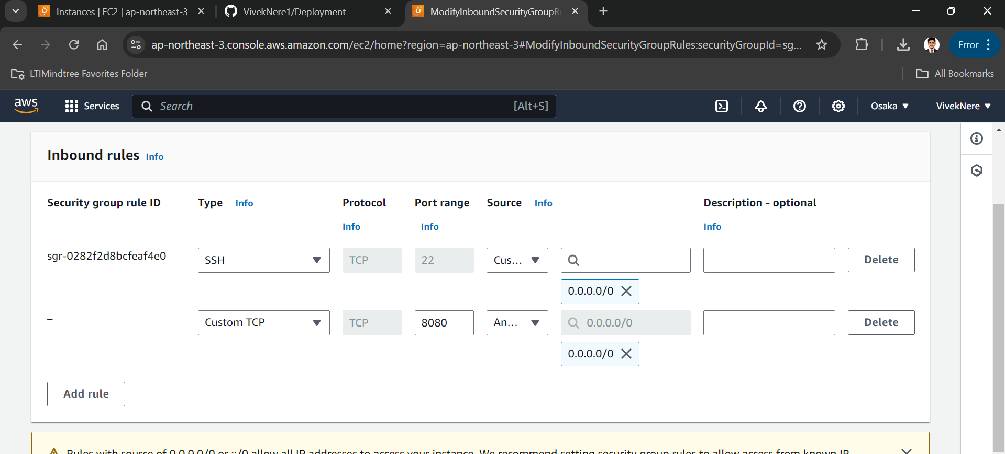

Now we have to install and initialized git in Jenkins-server

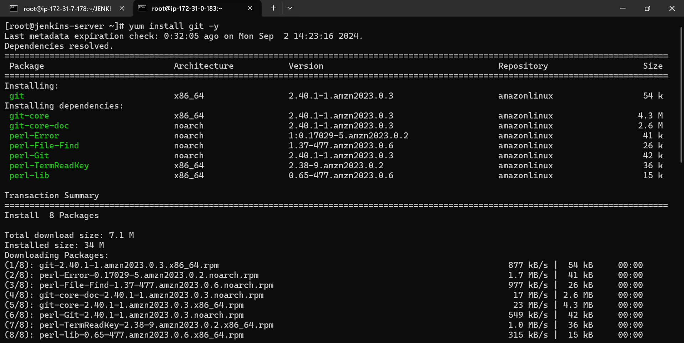

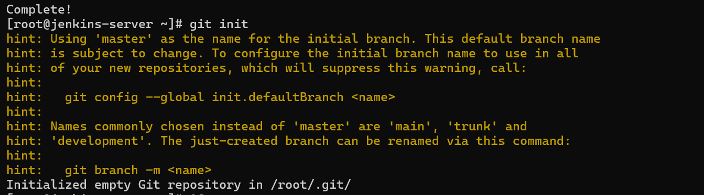

**#2: Jenkin & Maven :**

Now we have to install and configure java and Jenkins on Jenkins-server

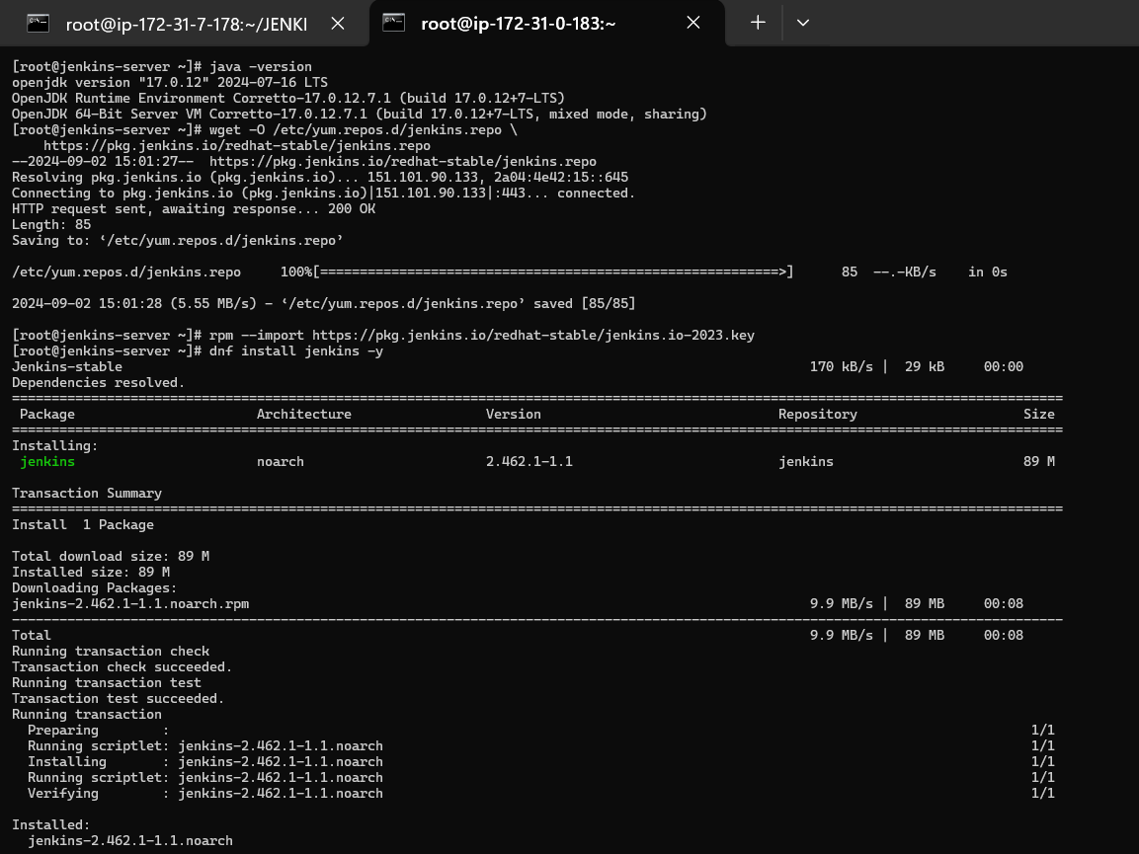

Enable and started Jenkins



Accessed Jenkins dashboard via, Jenkins-server machine’s public ip address and 8080 port, and completed login process.

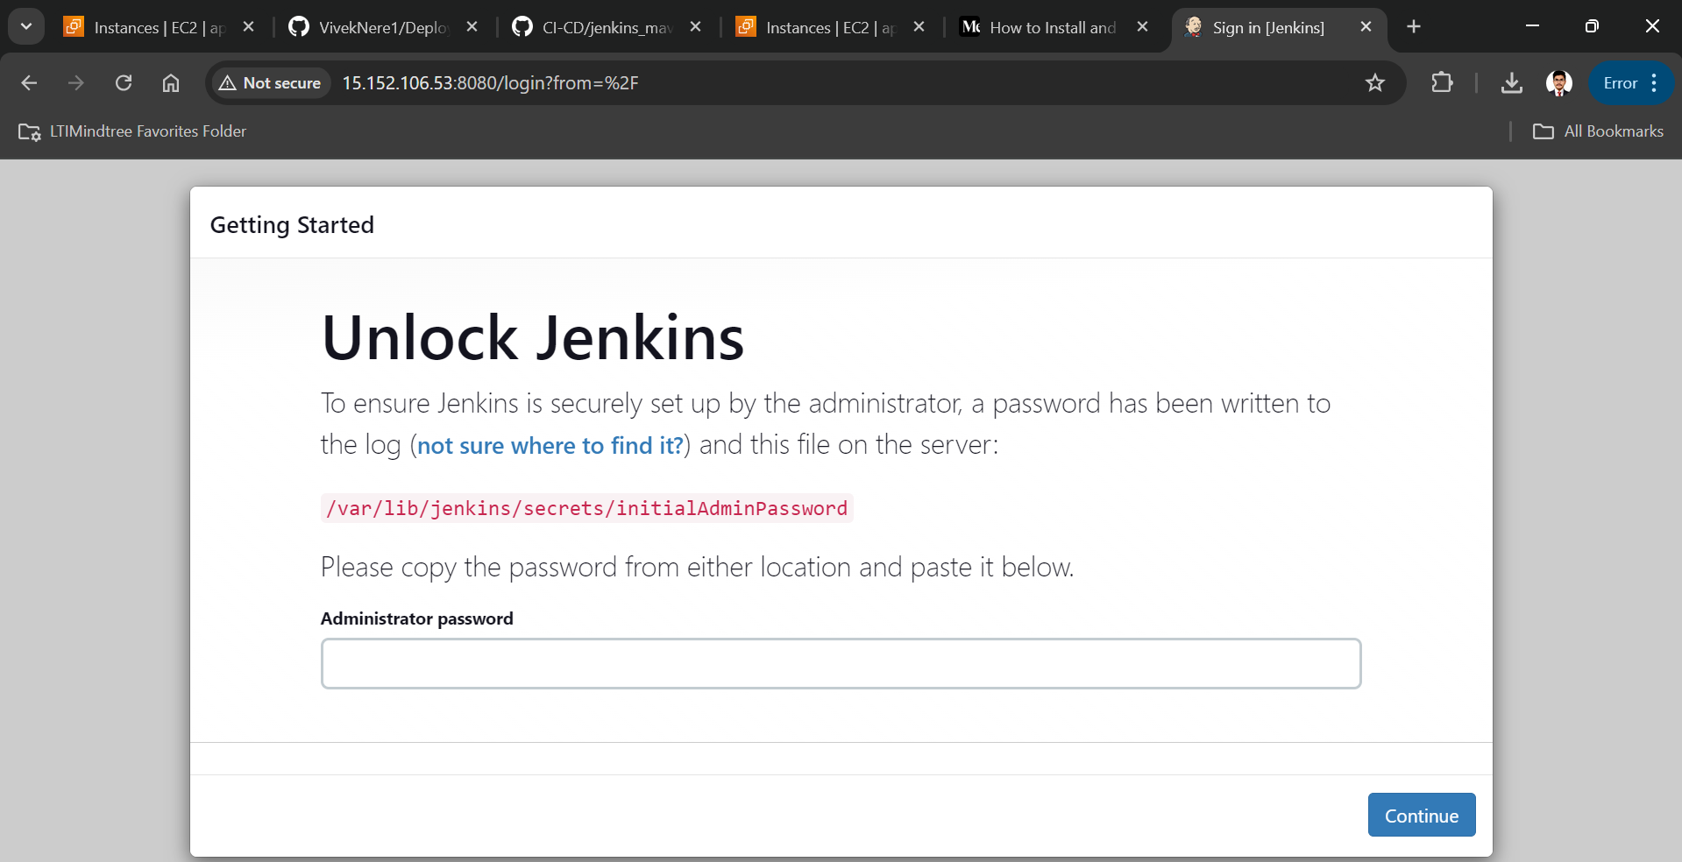

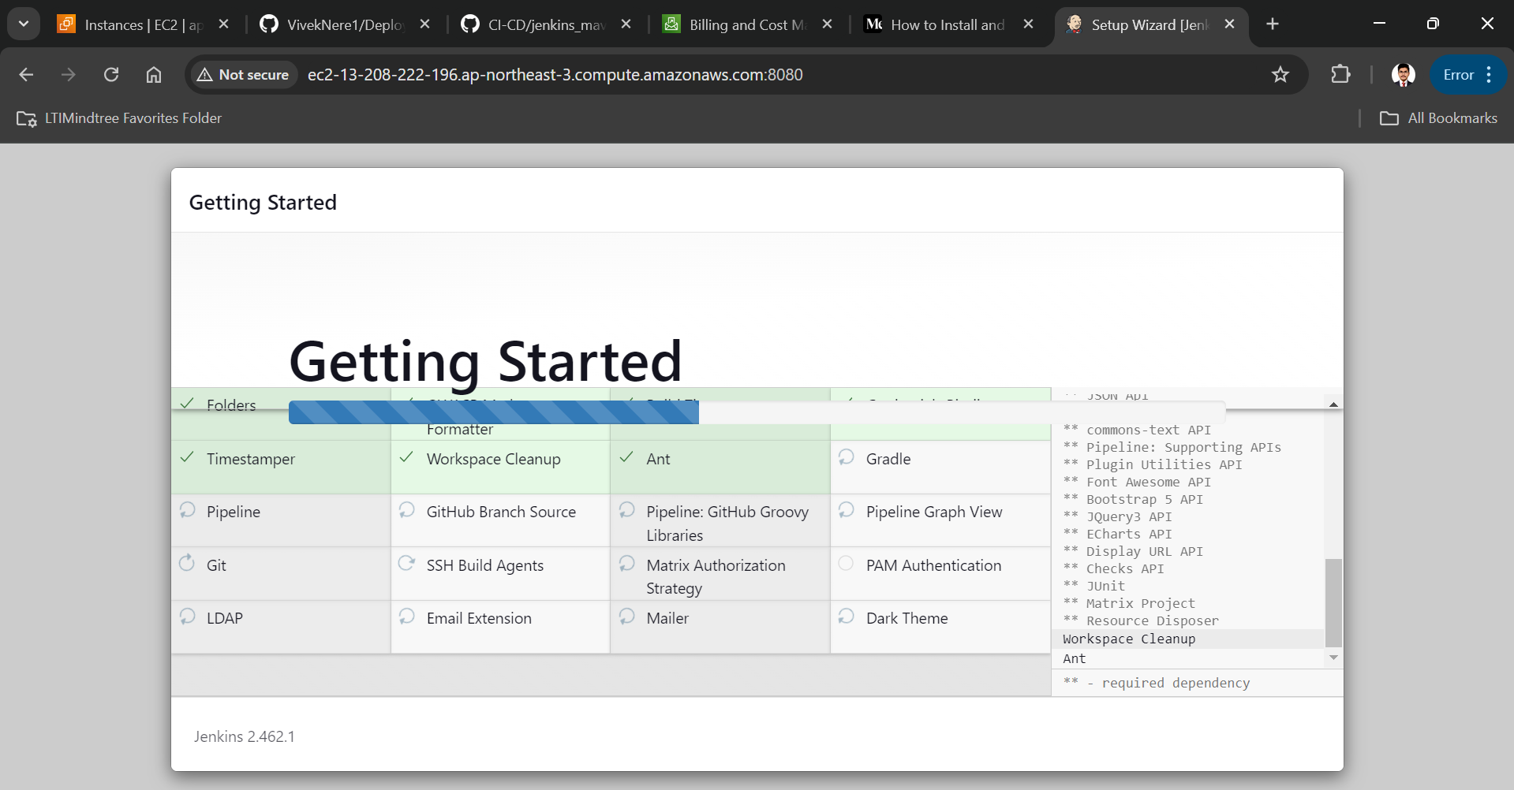

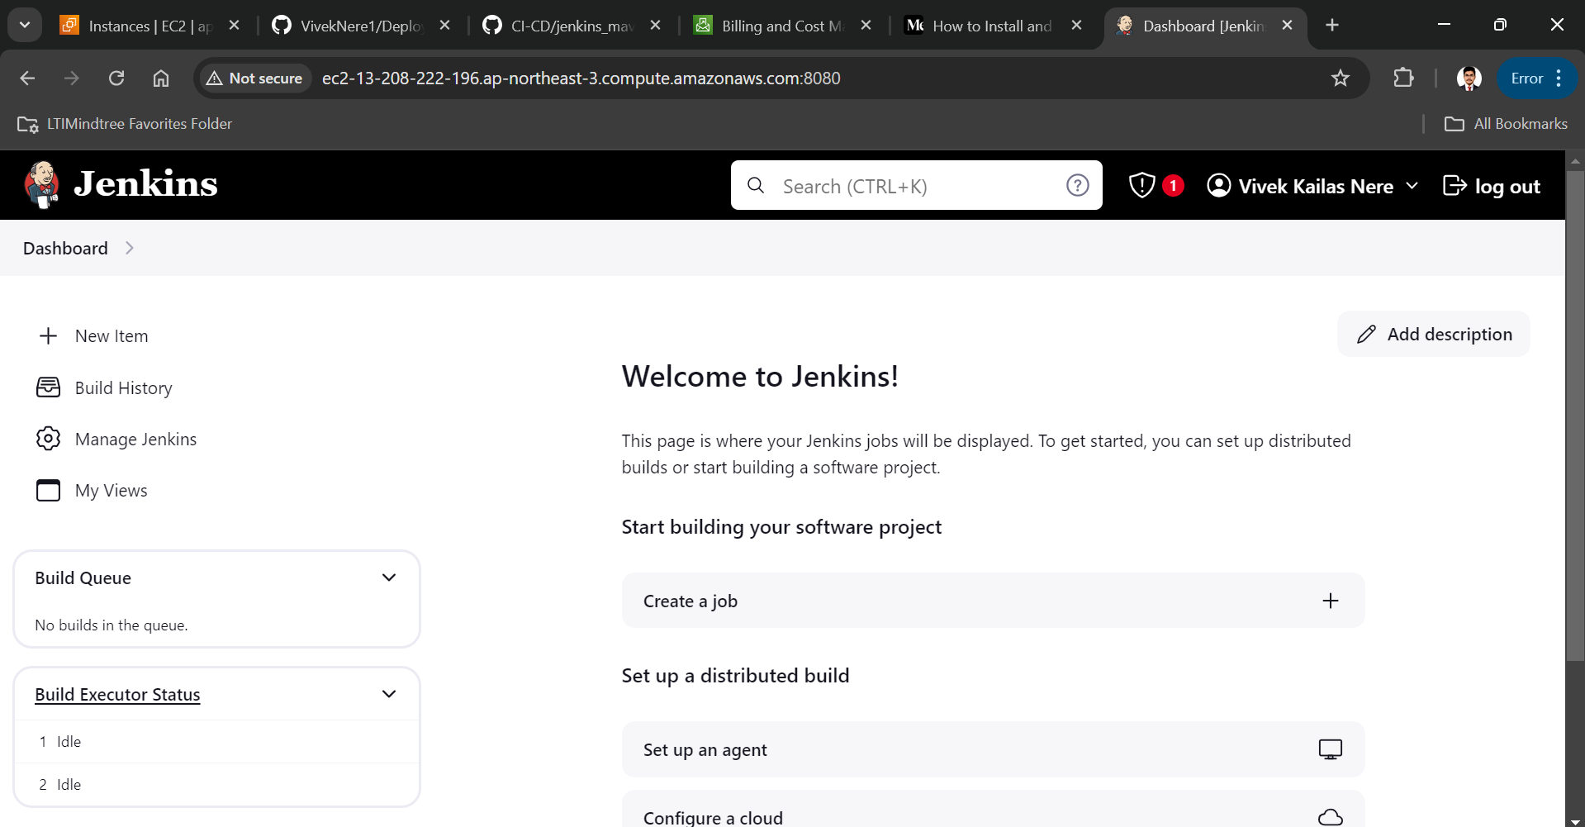

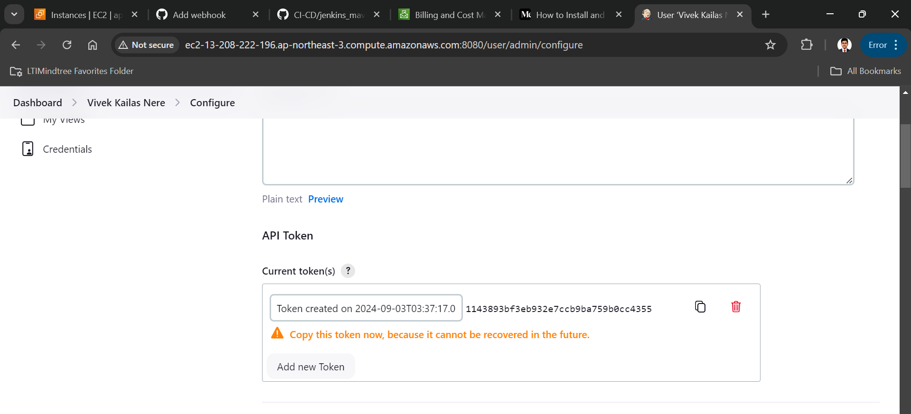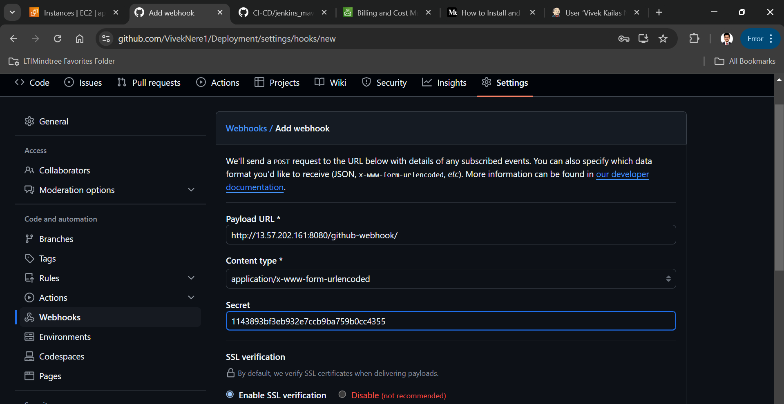

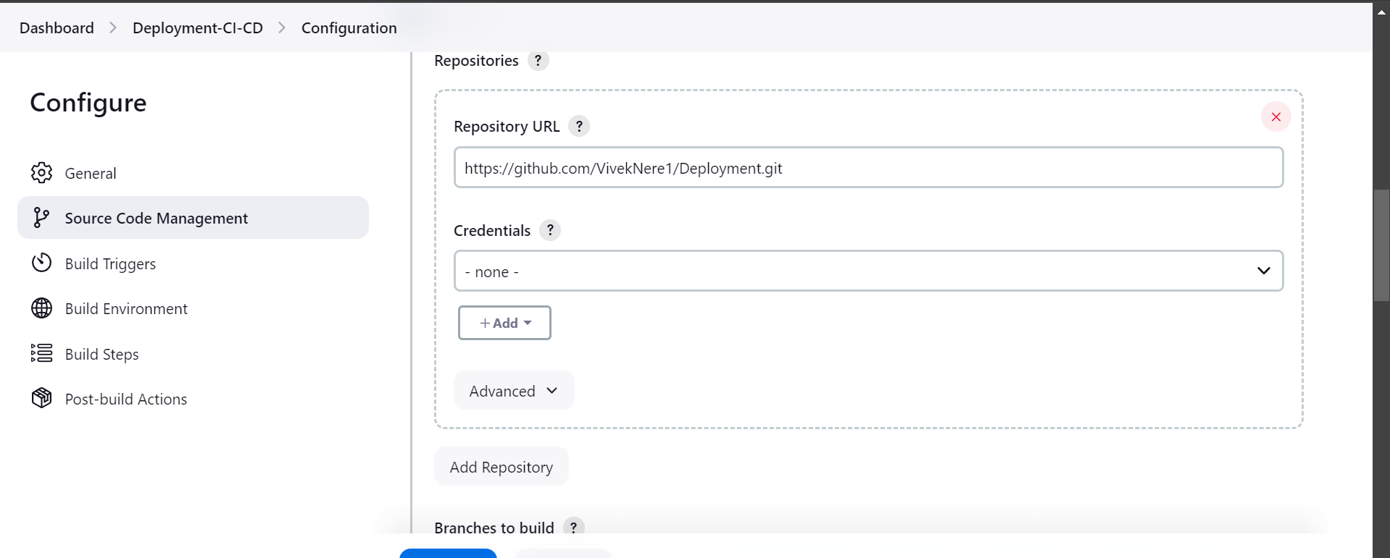

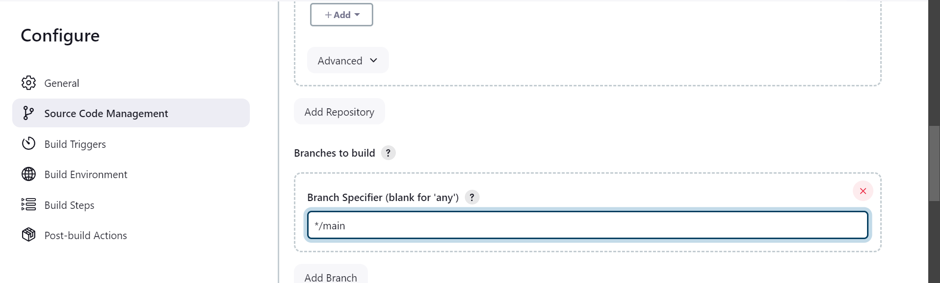

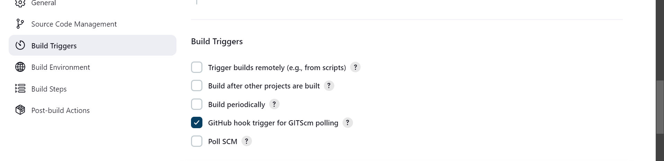

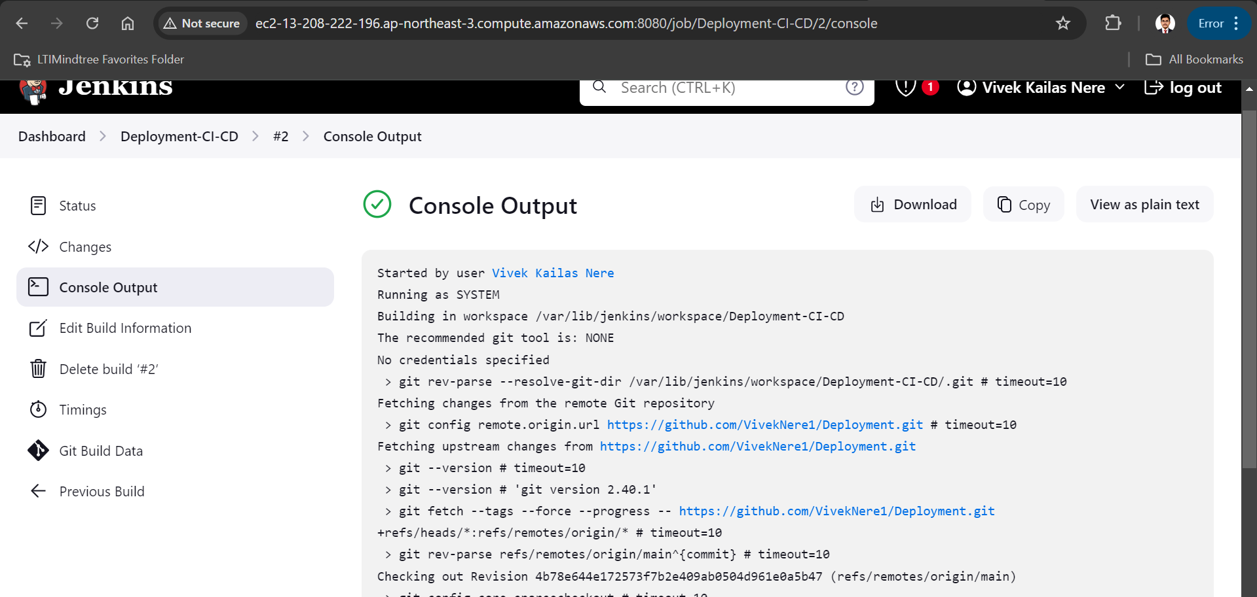

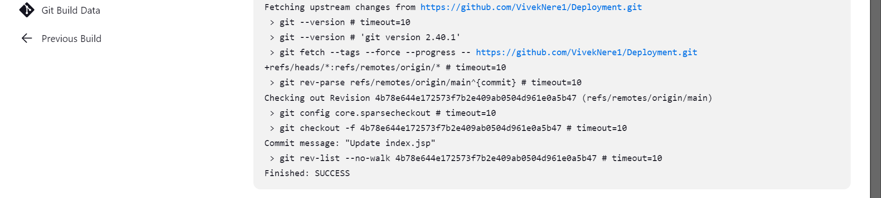

#Installation and Configuration of maven:

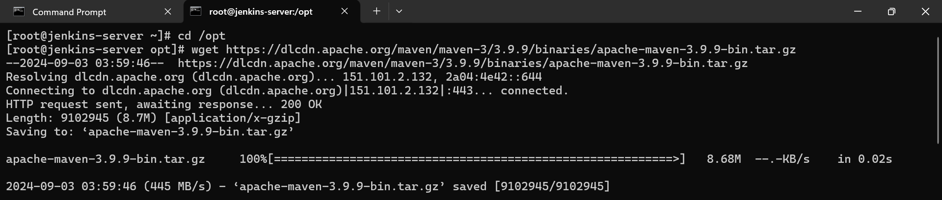

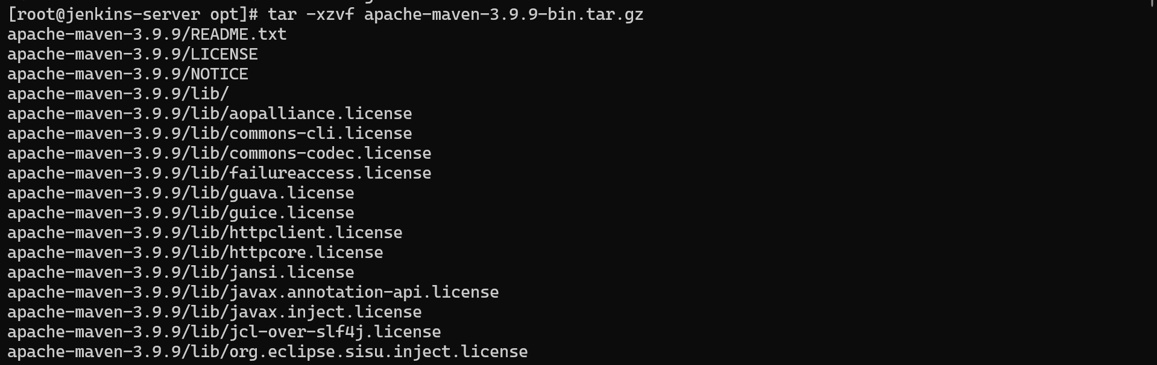

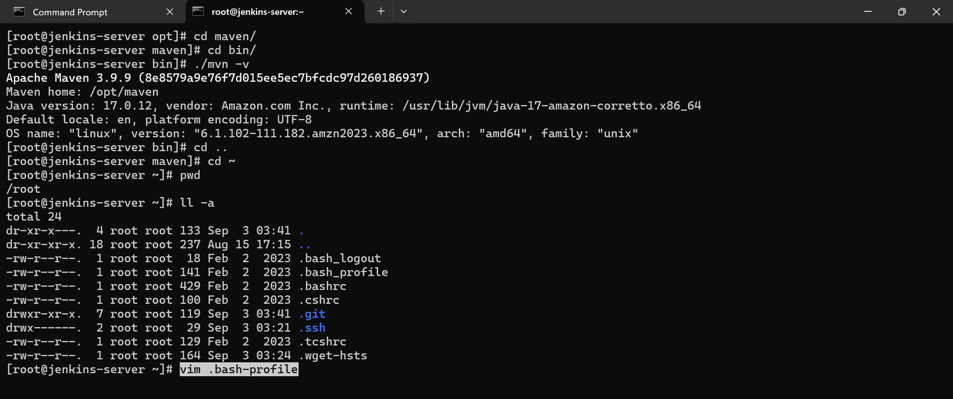

#Install maven plugins and configure Jenkins for maven

in Jenkins -> manage Jenkins -> plugins -> available plugins -> install maven integration

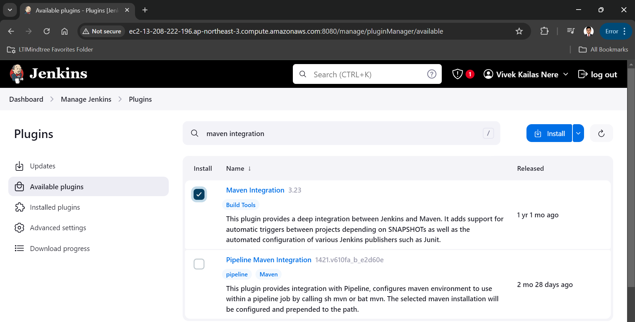

To find out the home directory of maven and java

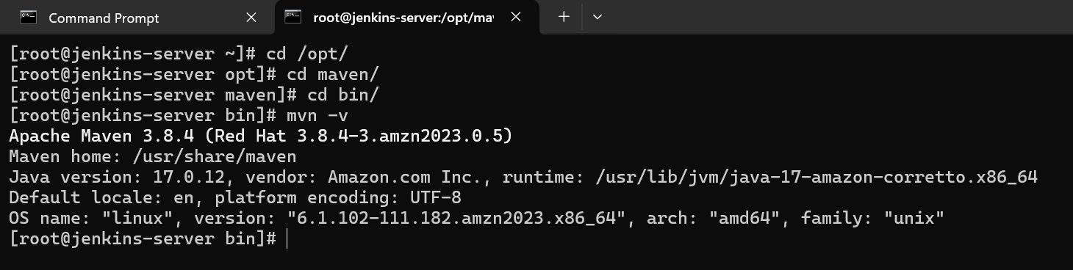

* now we need to configure this plugins for that go to manage Jenkins

tools-> add JDK -> name=java11 JAVA_HOME=/usr/lib/jvm/jre-17-openjdk

then add maven ==> name=maven , MAVEN_HOME= /usr/share/maven

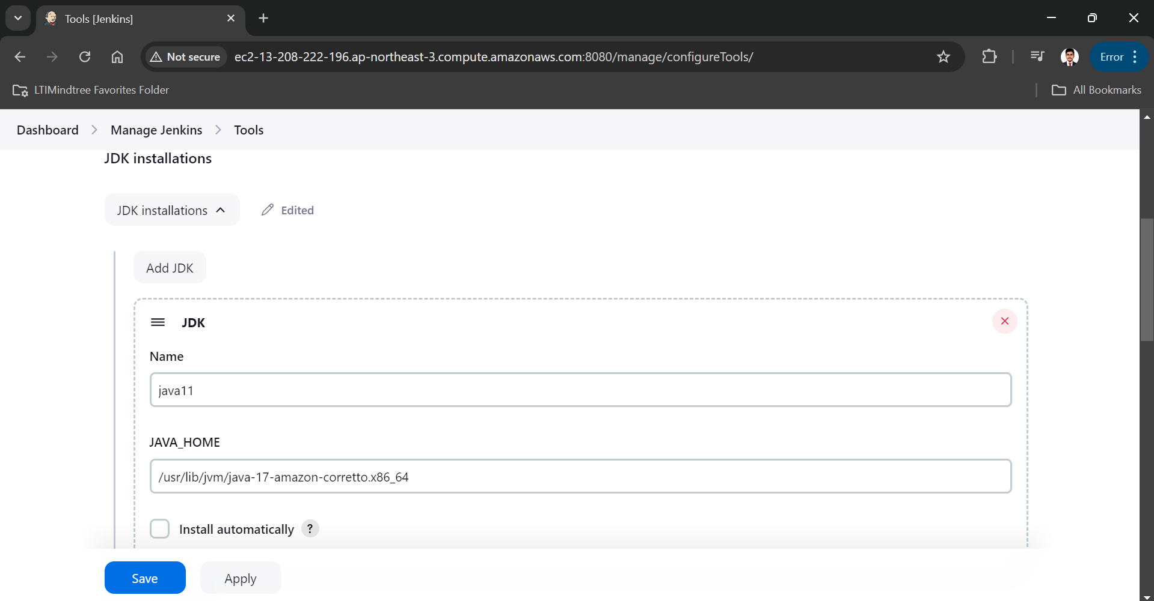

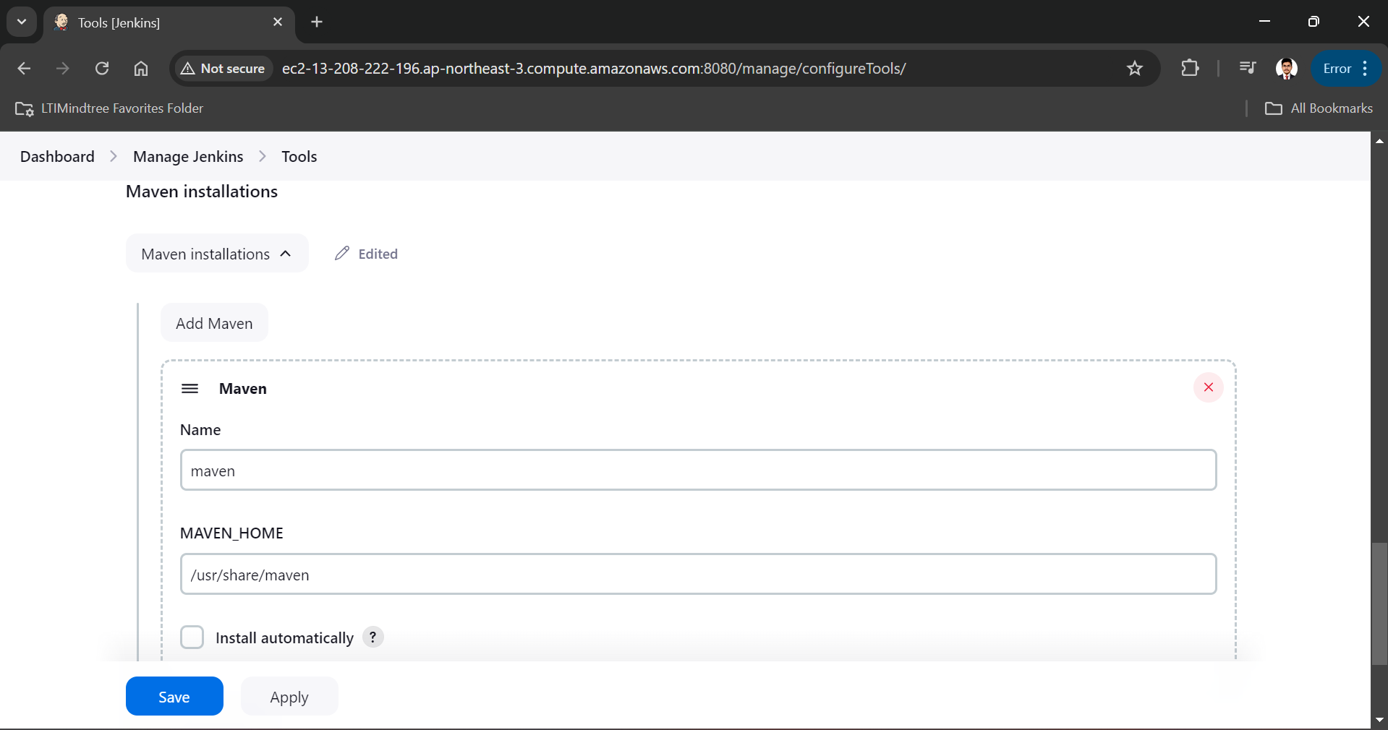

* now manage Jenkins -> plugins -> Intsalled plugins -> Disable the GITHUB branch source plugins & enable GitHub plugin and restart.

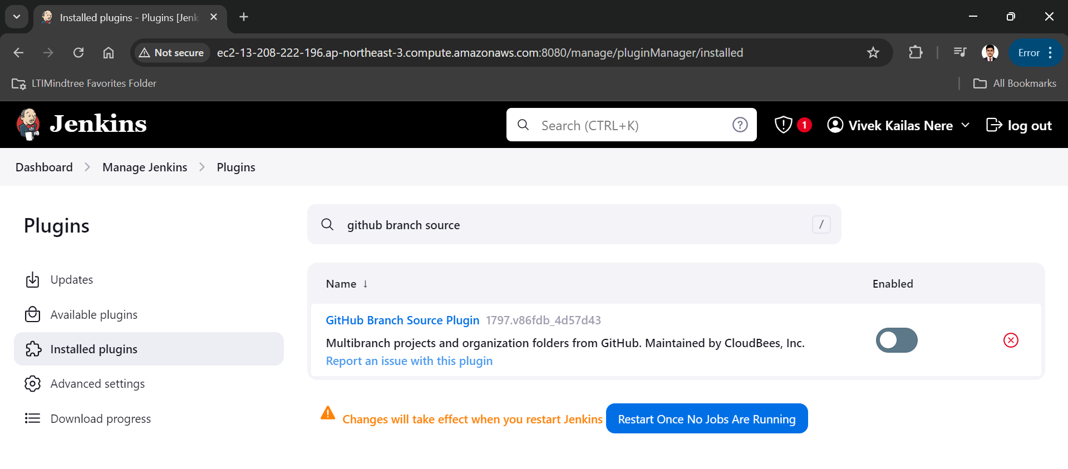

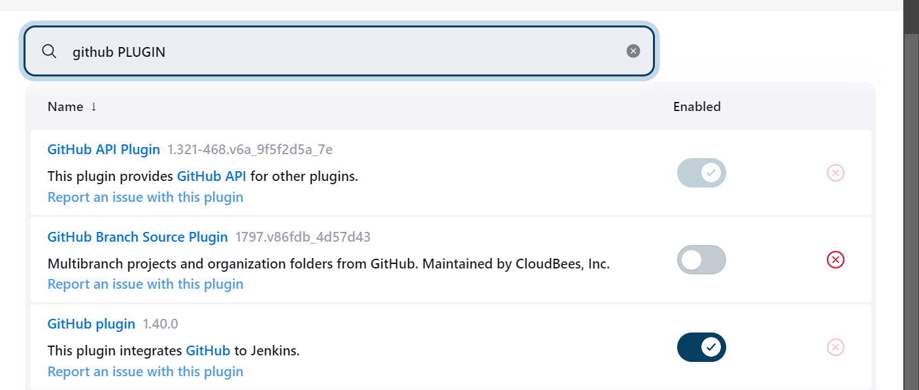

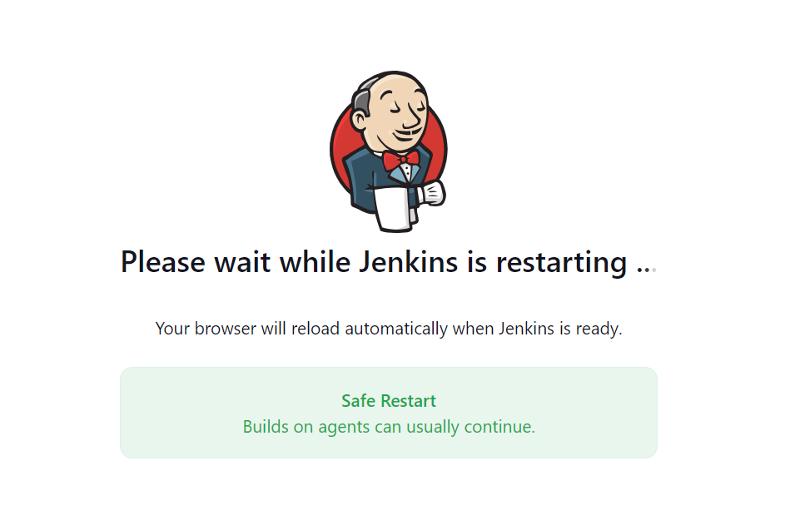

**#3: Tomcat**

#Installation and configuration of Tomcat:

Open the tomcat-server instance into local machine by using ssh and set a hostname as tomcat-server

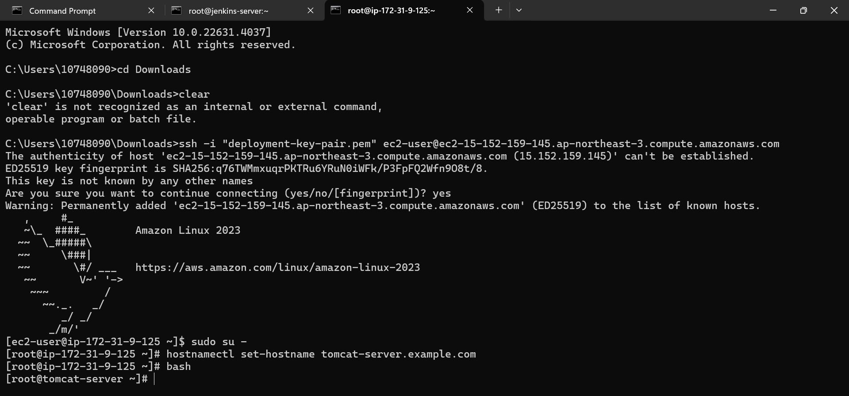

Installed java in tomcat-server

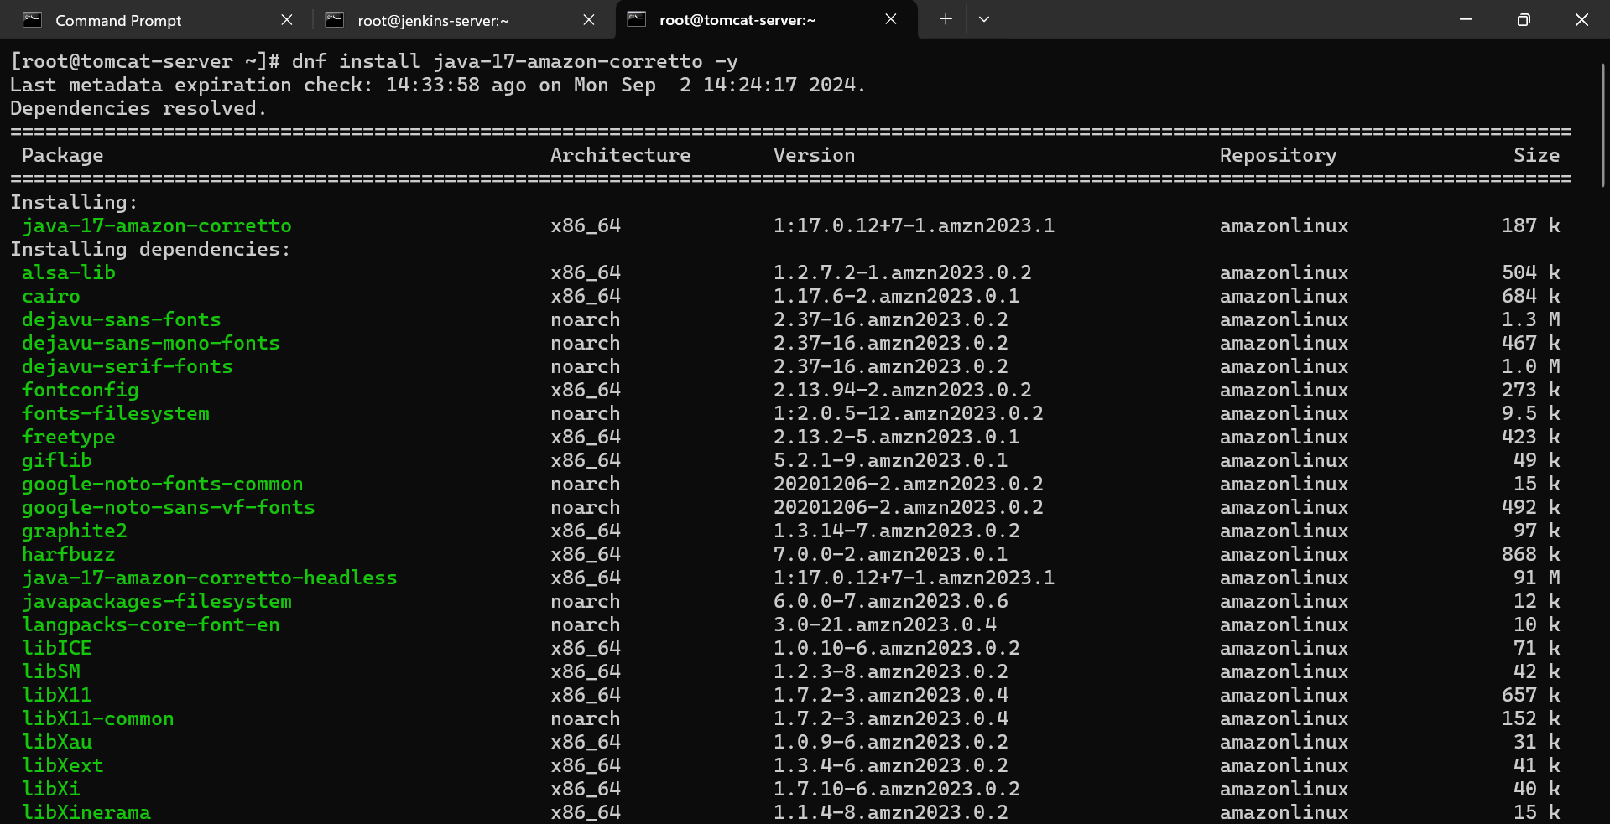

Download tar file of tomcat from tomcat official website in /opt folder

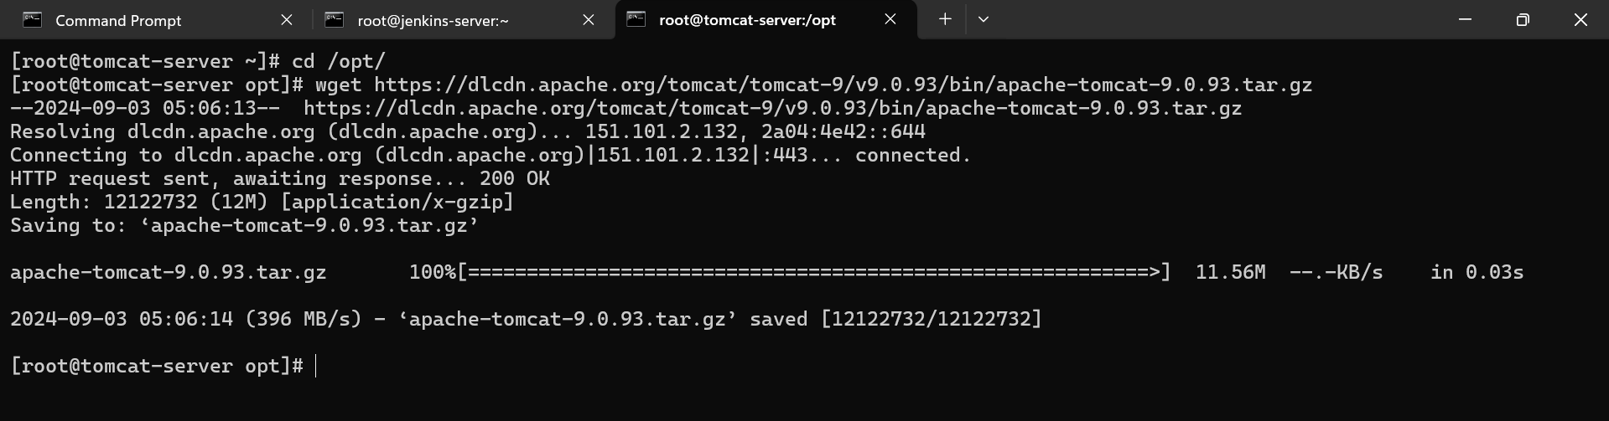

Extract tar file:

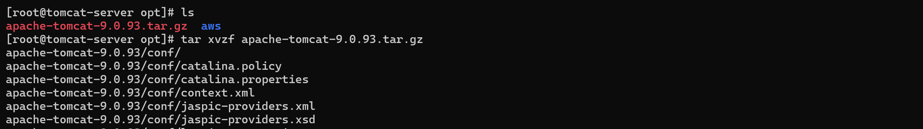

Move in tomcat folder

Now we have to start the tomcat server

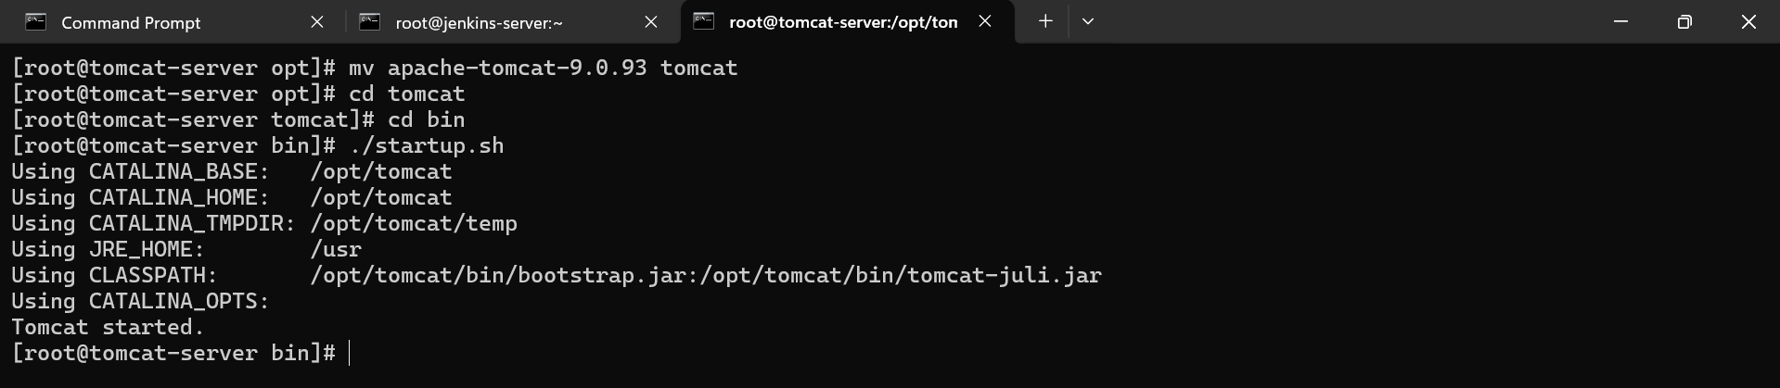

in google open http://(ip of tomcat server instance):8080

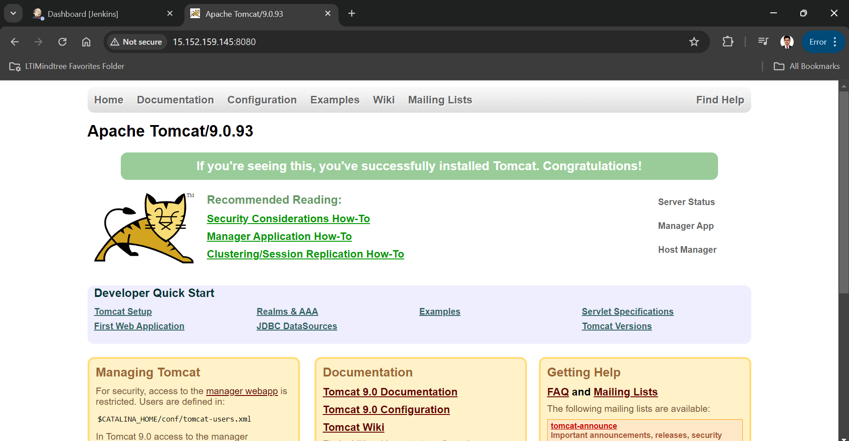

now we have make some changes in context.xml file for that we need to find that file in tomcat

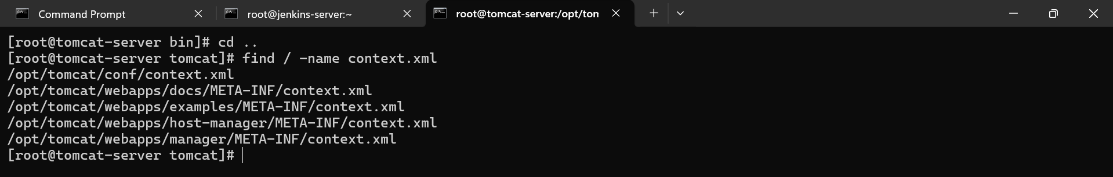

#comment value tag sections in below all files

[root@tomcat-server bin]# vim /opt/tomcat/webapps/examples/META-INF/context.xml

[root@tomcat-server bin]# vim /opt/tomcat/webapps/host-manager/META-INF/context.xml

[root@tomcat-server bin]# vin /opt/tomcat/webapps/manager/META-INF/context.xml

<!-- <Valve className="org.apache.catalina.valves.RemoteAddrValve"

allow="127\.\d+\.\d+\.\d+|::1|0:0:0:0:0:0:0:1" /> --!>

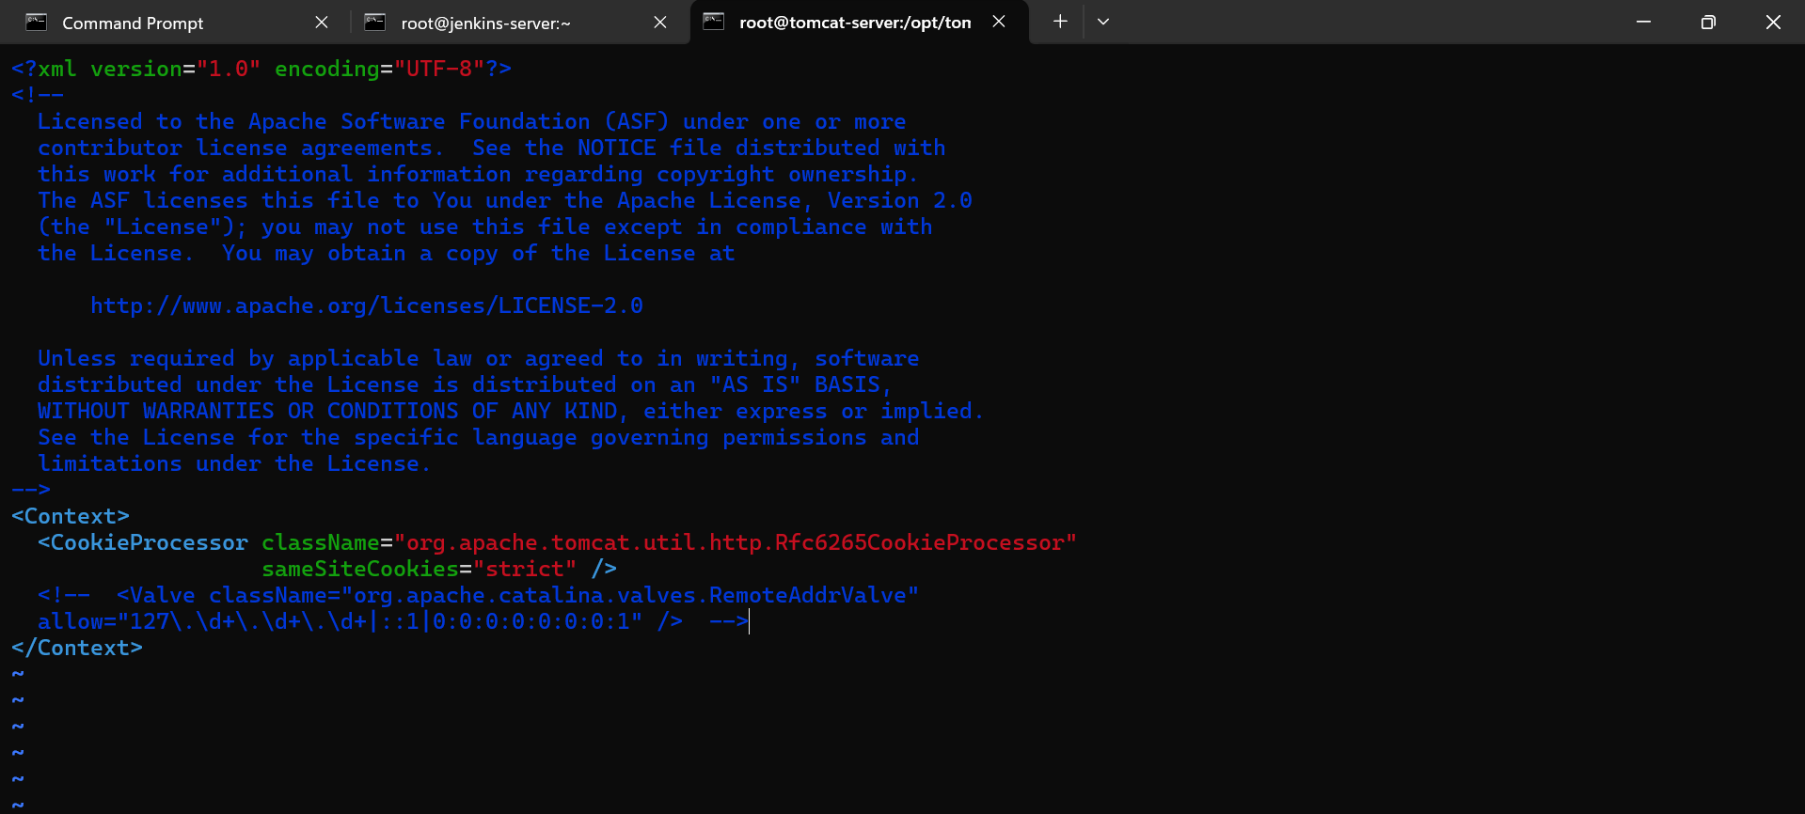

Now we need to change tomcat user configuration info:

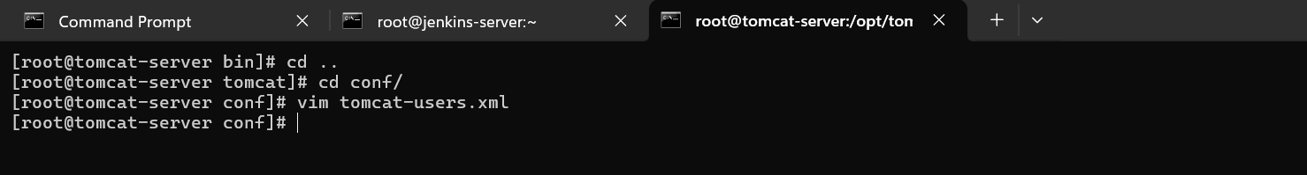

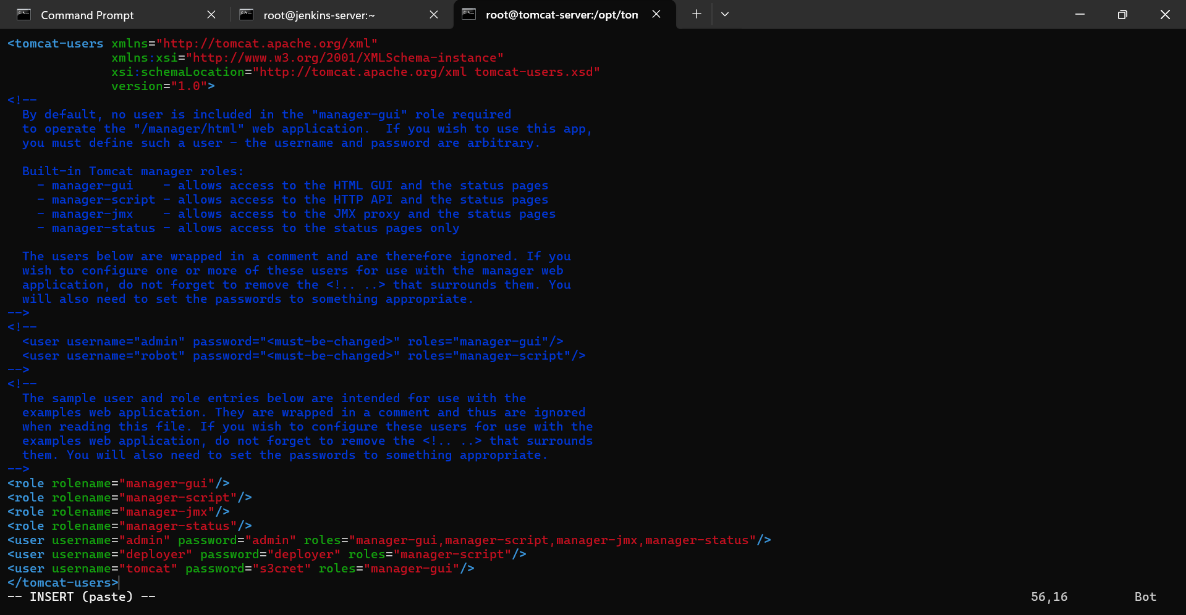

now we need to reboot the tomcat server

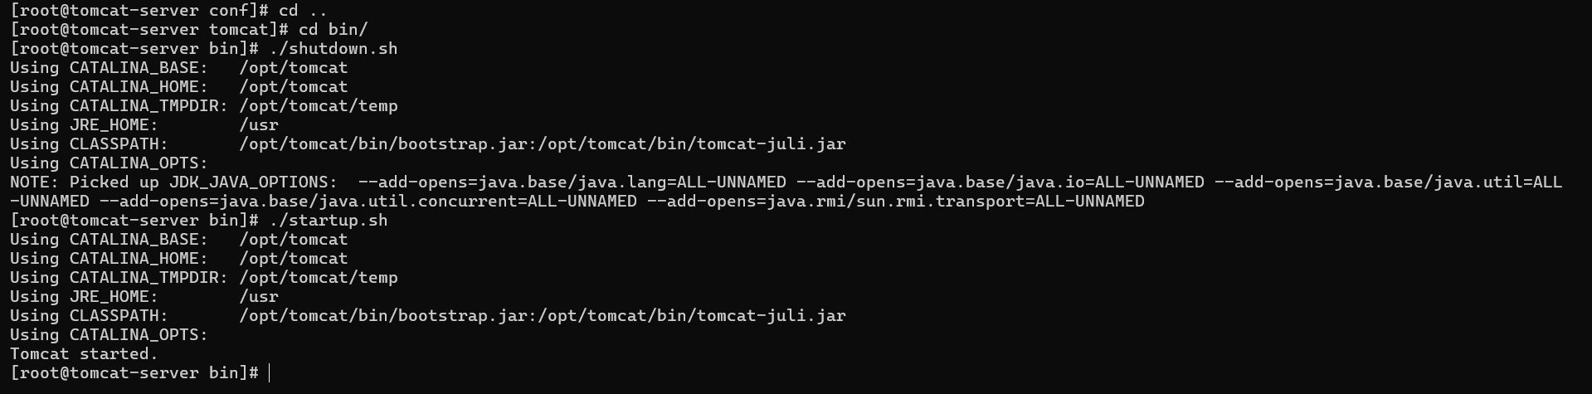

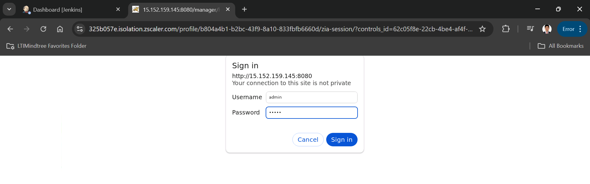

Integrating tomcat server with Jenkins:

there is no predefined tomcat plugin in Jenkins so we need to install "deploy to container plugin" then configure the tomcat server with credentials

manage genkins -> plugins -> available plugins -> deploy to container

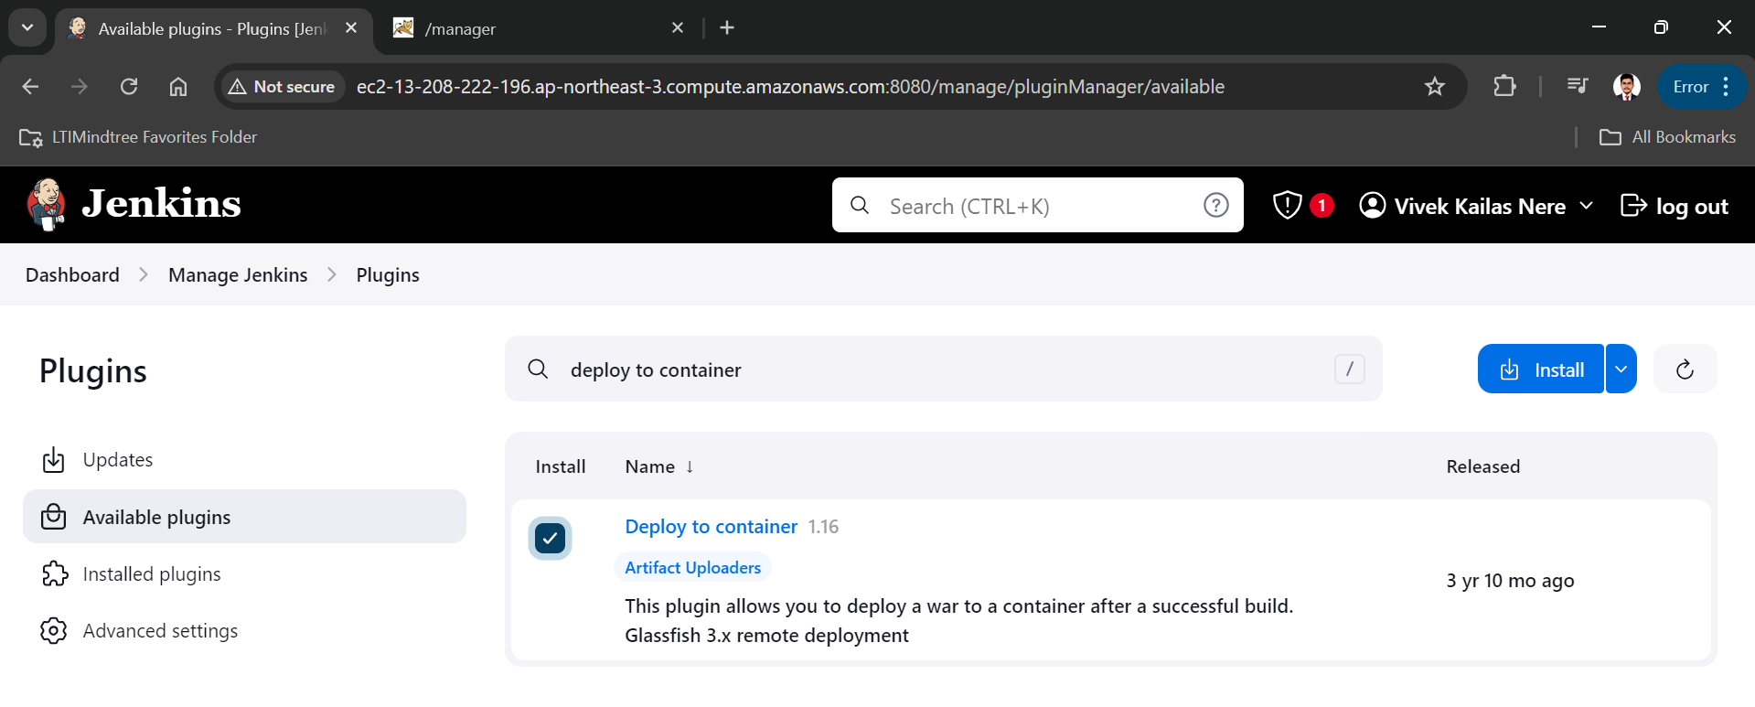

now we need to add credentials of tomcat to the Jenkins

manage Jenkins -> credentials -> system -> global credentials -> add credentials(<user username="deployer" password="deployer" roles="manager-script"/>) id and description=tomcat-credentials

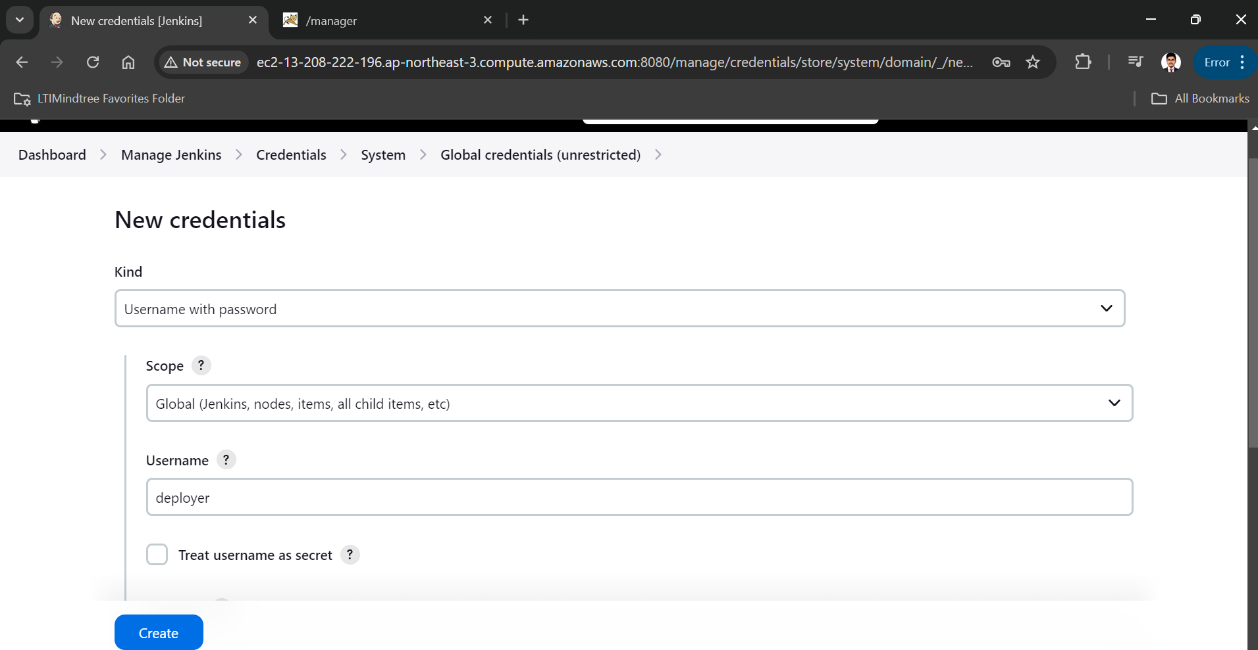

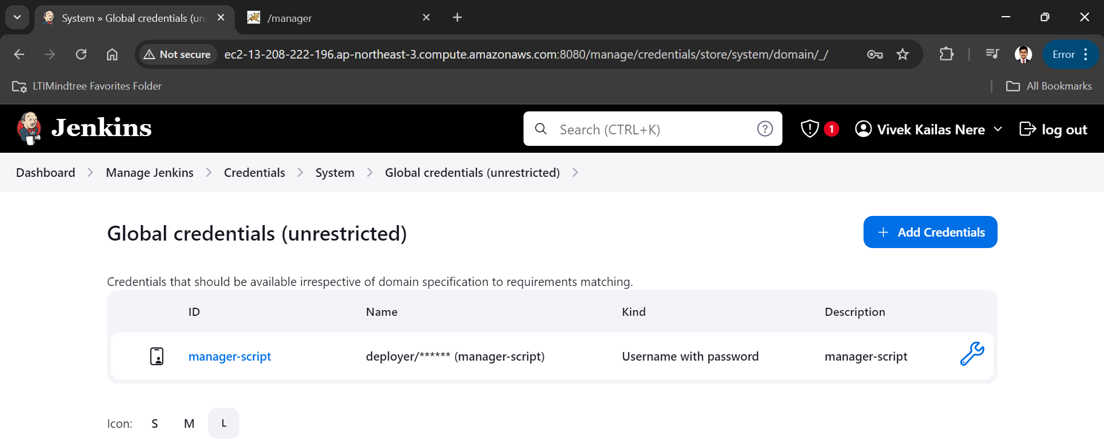

then go to dashboard and create new item name as BuildAndDeployToTomcat as a maven project

add git repository http url

make branch main

and at the last click on "Add post-build action" and select "Deploy war/ear to a container"

in war/ear file add "**/*.war"

add container Tomcat 8.x

add tomcat-server instance url

save and apply

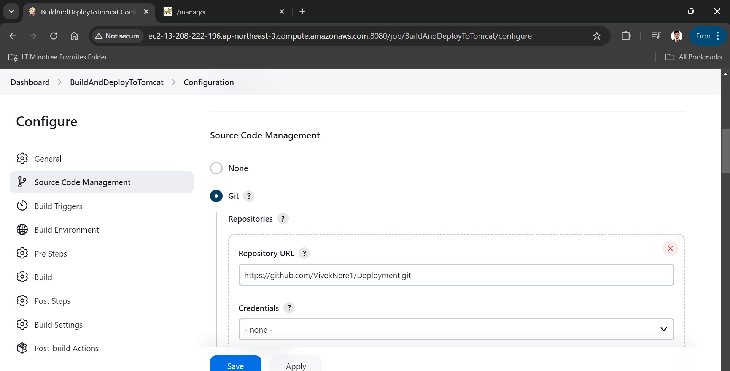

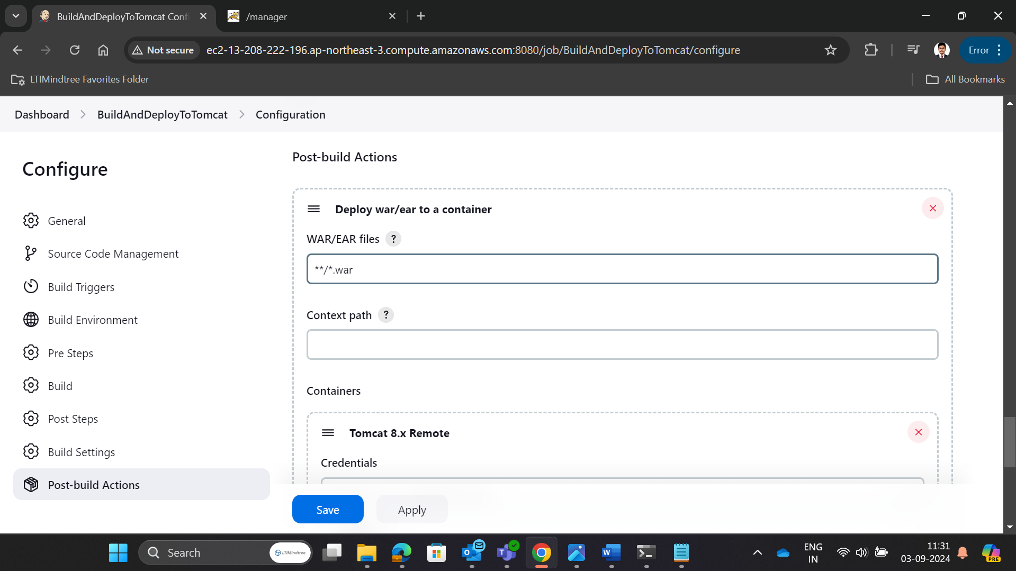

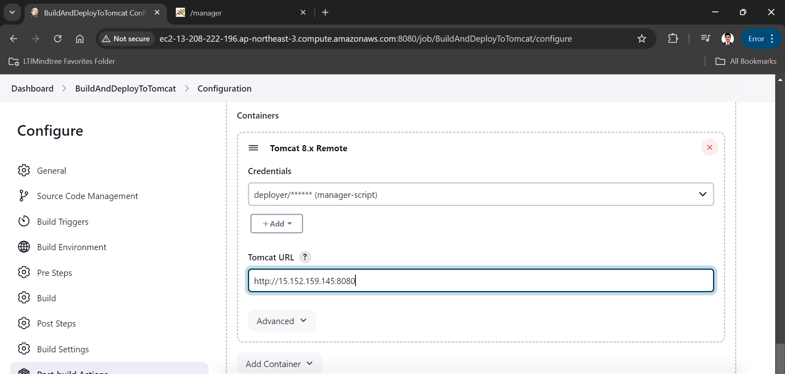

We have suceesfully deployed project on tomcat server

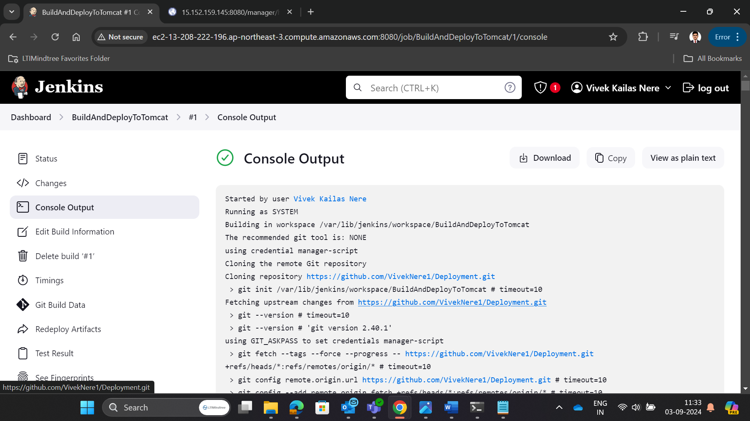

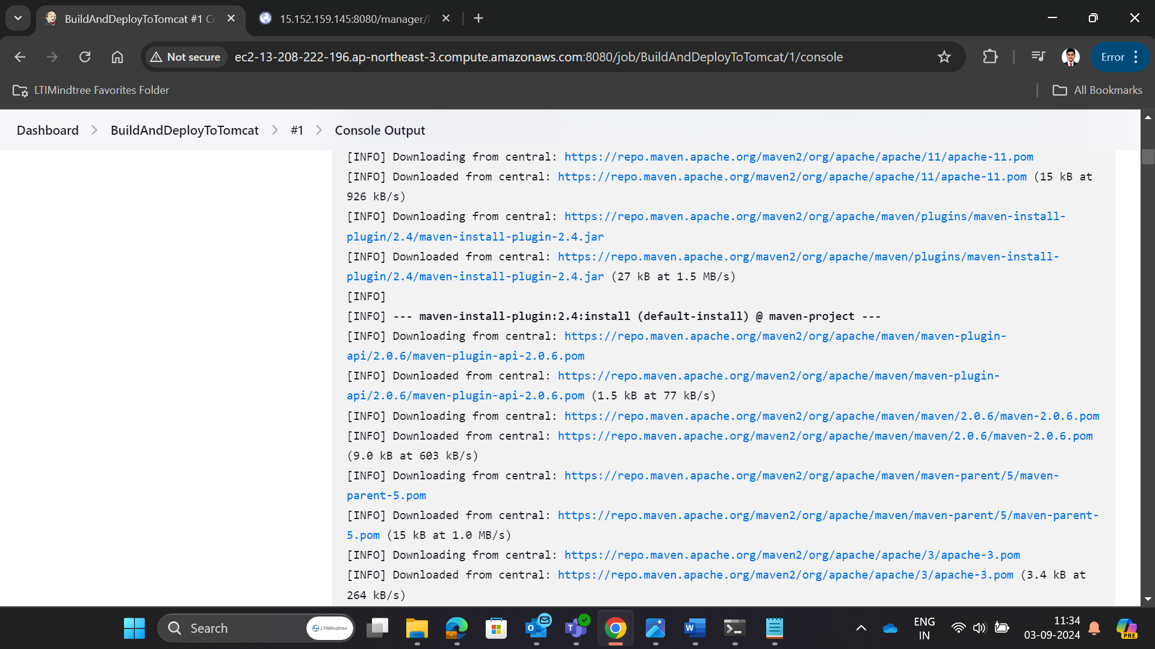

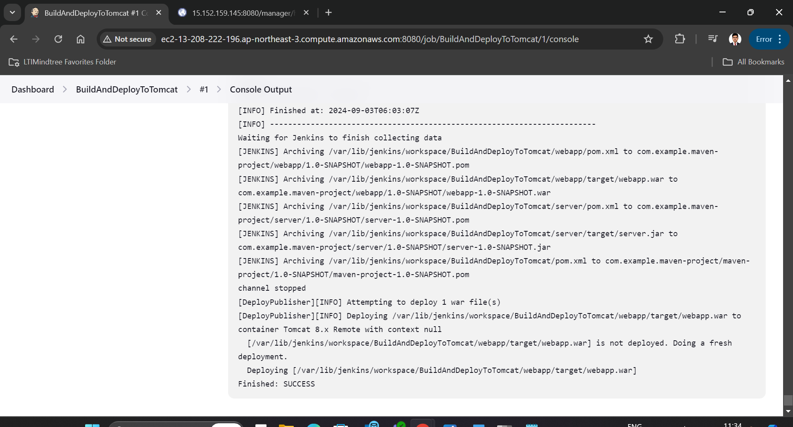

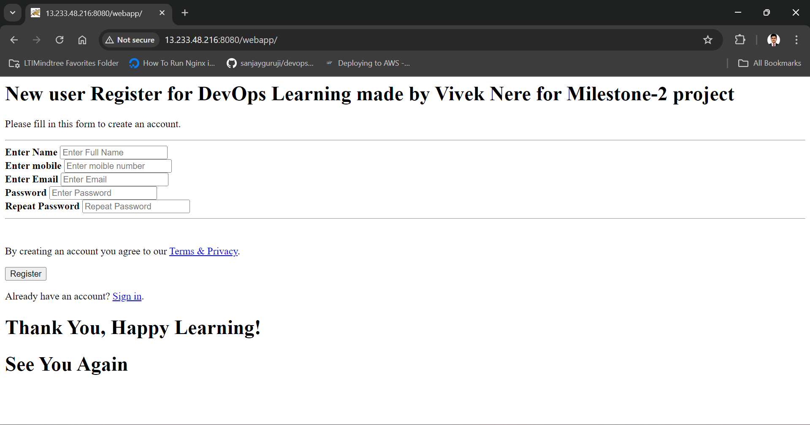

**#4: Docker**

Docker Installation and Configuration with jenkins :

First create an instance for docker using amazon linux as OS with instance type t2.micro and same key-pair and security group which we have use in previous instances.

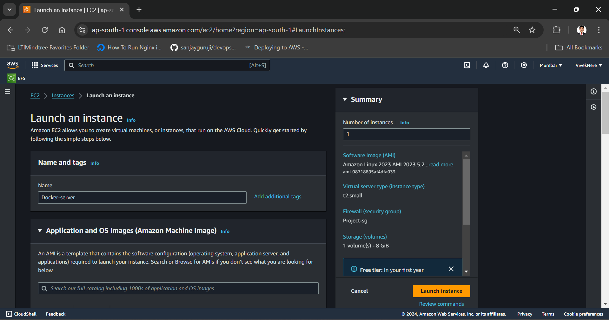

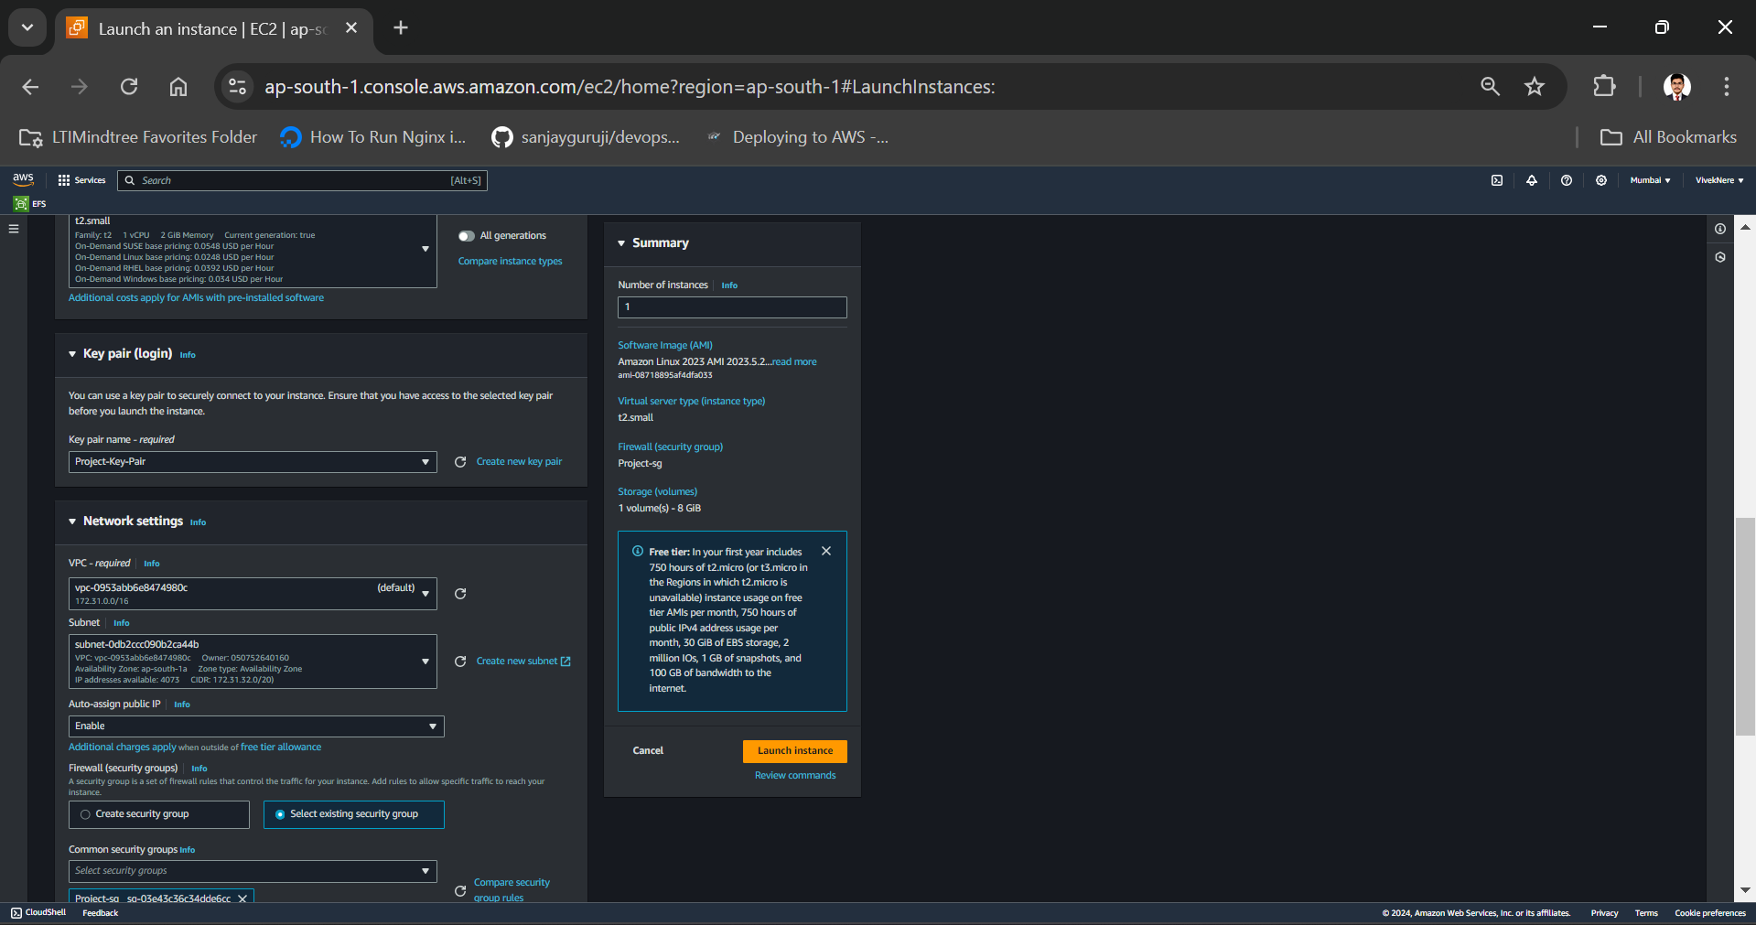

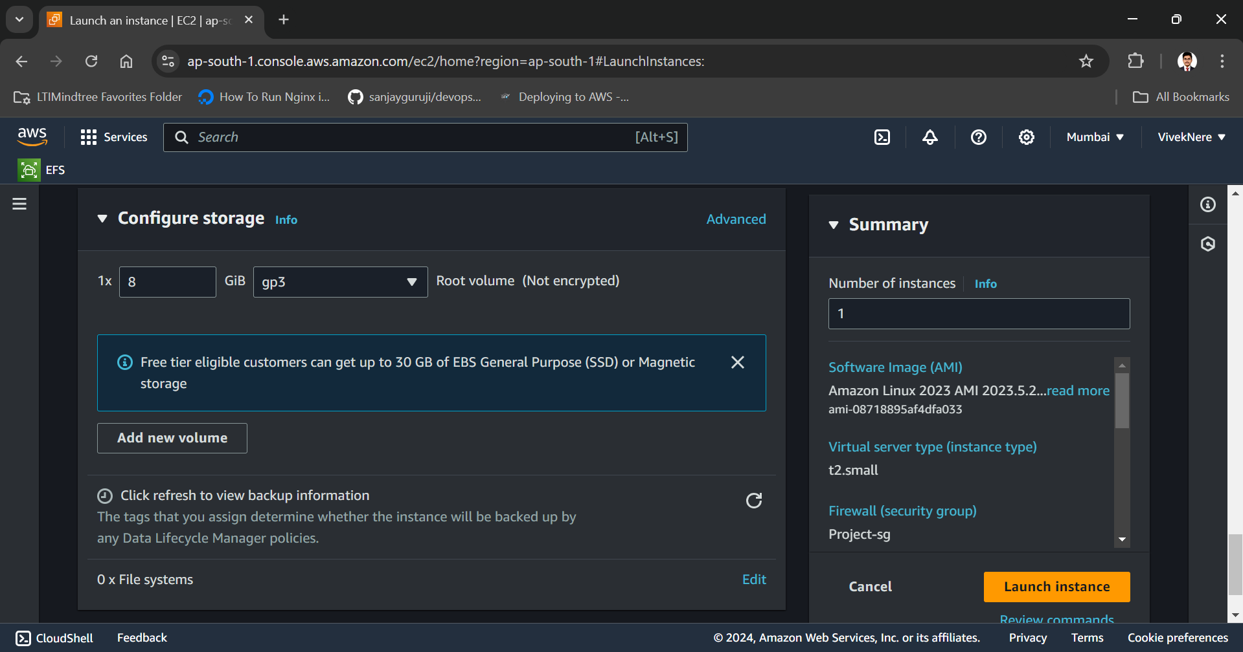

Now connect this docker ec2 in terminal and give hostname as docker-server to it.

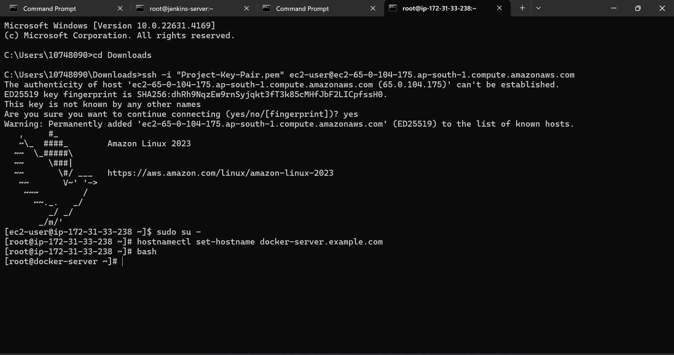

Now we have to install docker in docker-instance.

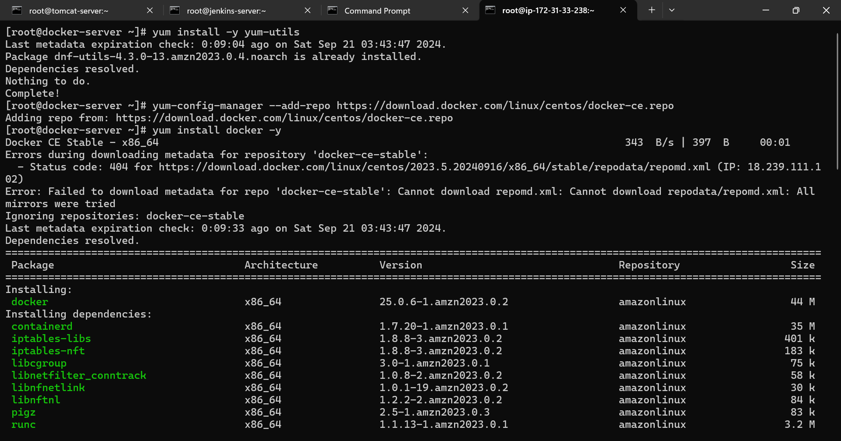

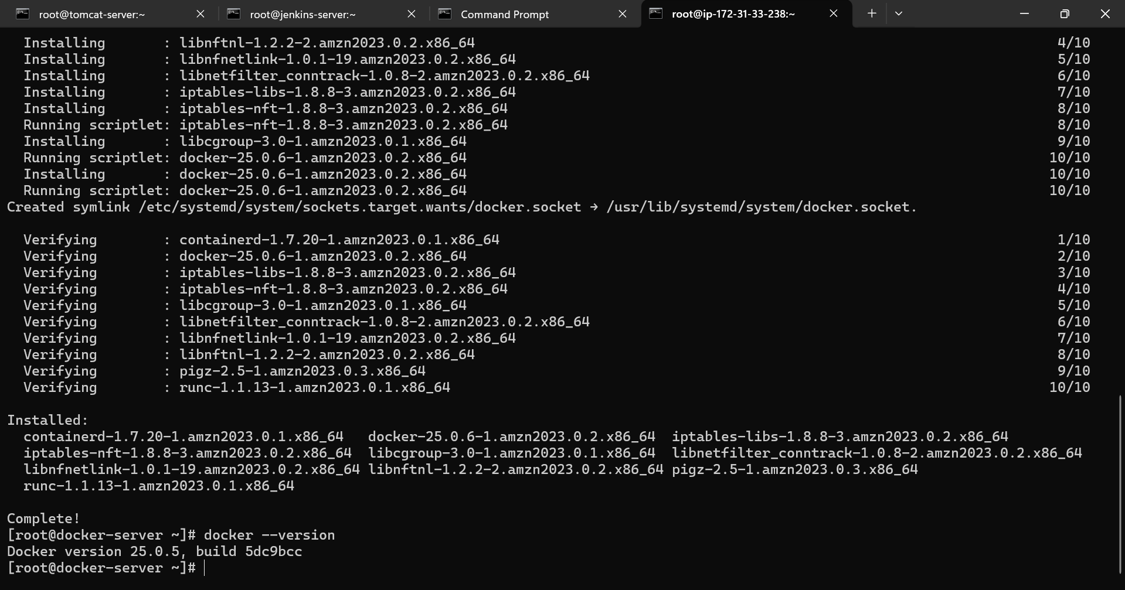

Now aws configure in docker-server

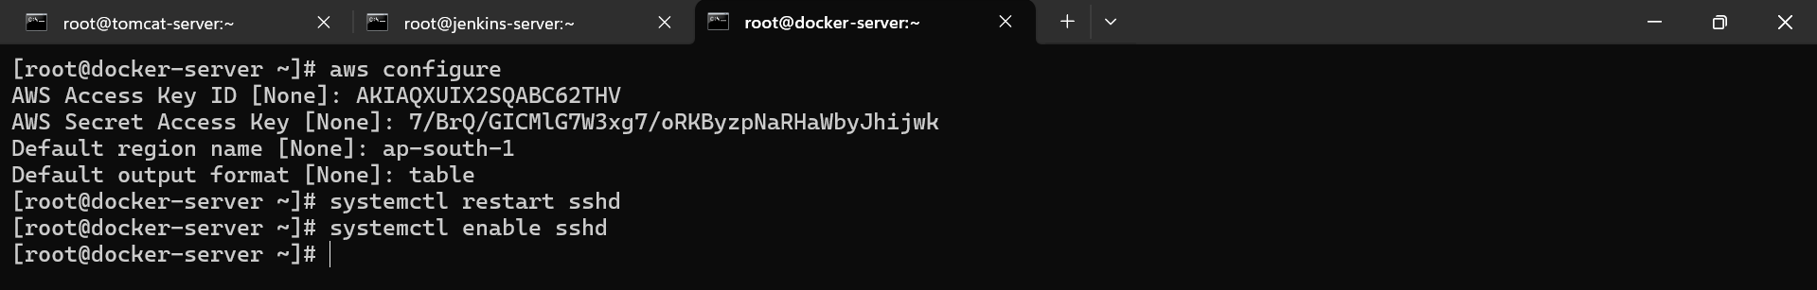

Now we have to set password to the docker-instance and give password related permissions in sshd_config file.

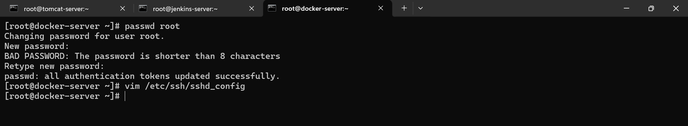

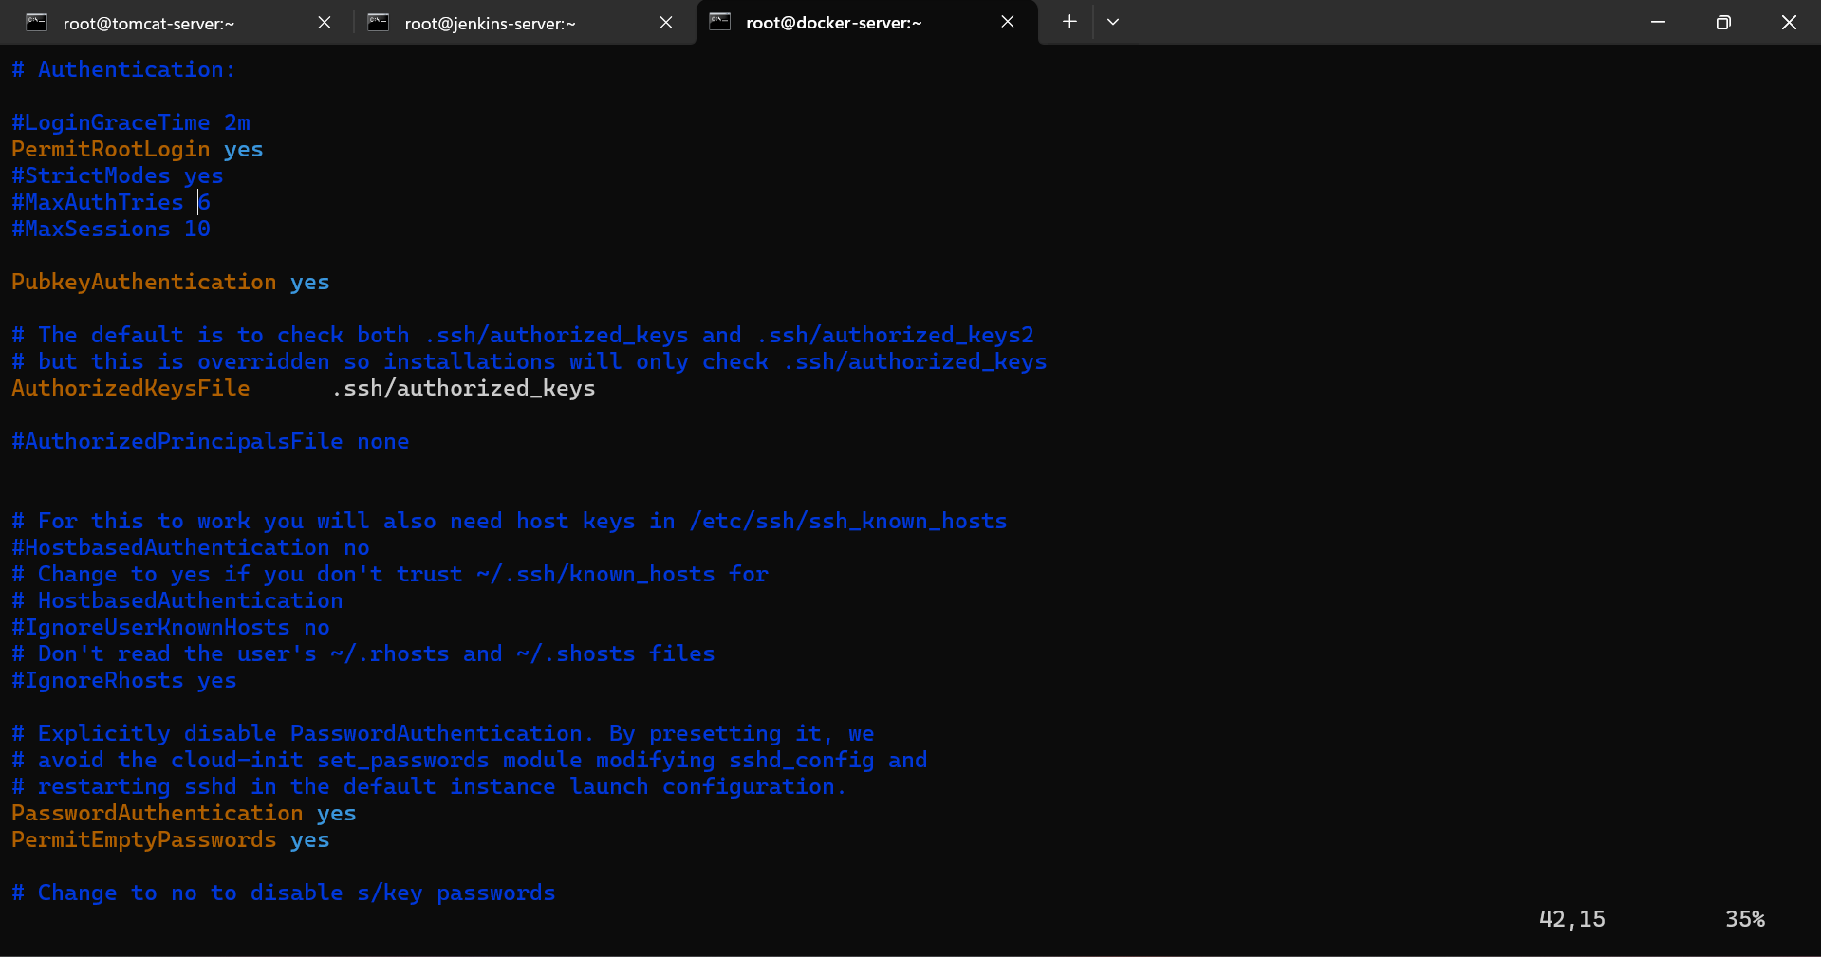

Now we have to created ssh key in docker-instance. 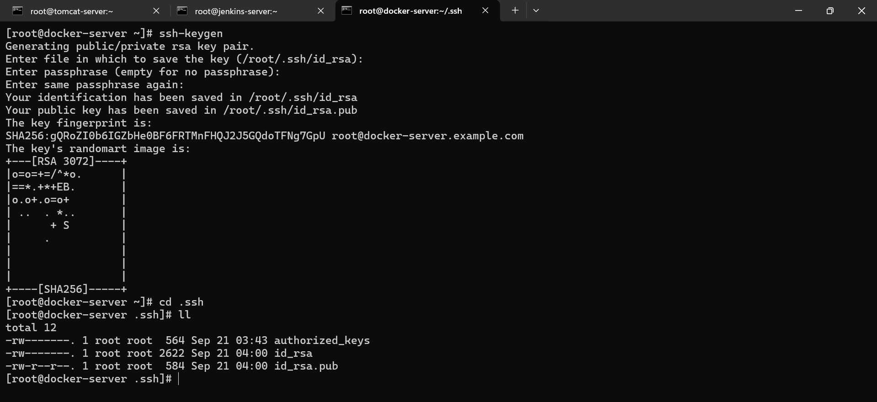

Now we need to transfer this docker ssh-key in jenkins-server.

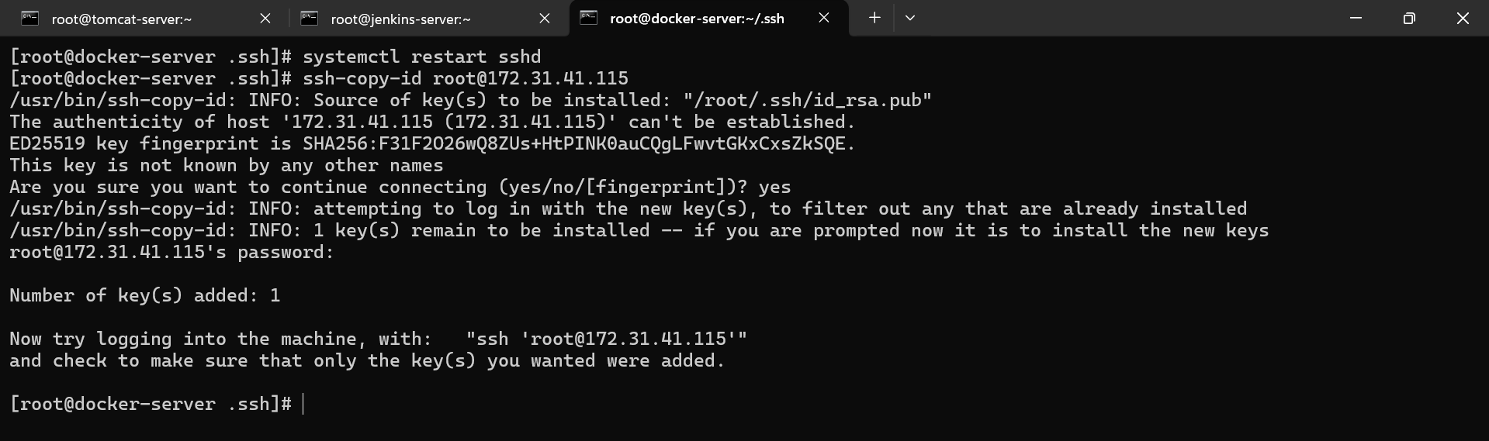

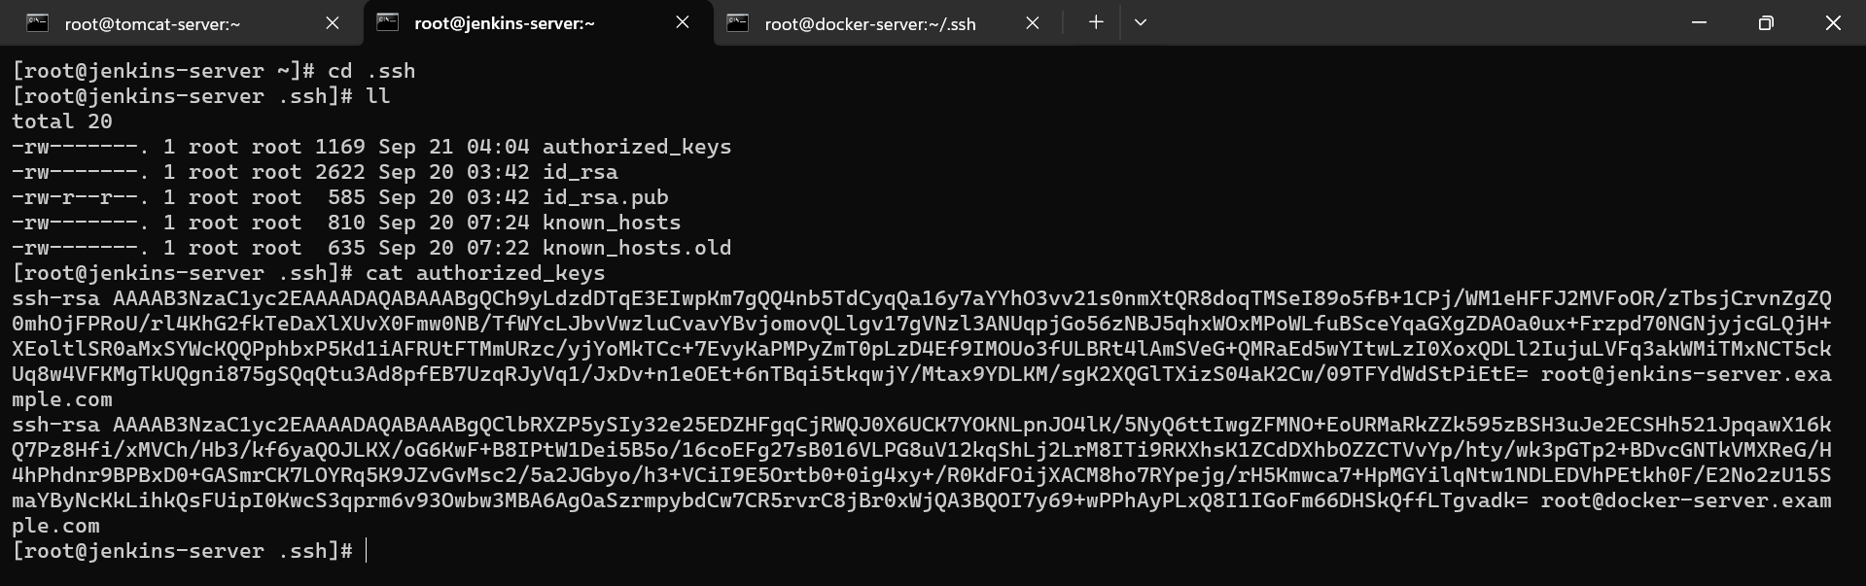

pass the ssh-key of jenkins-server in docker-server.

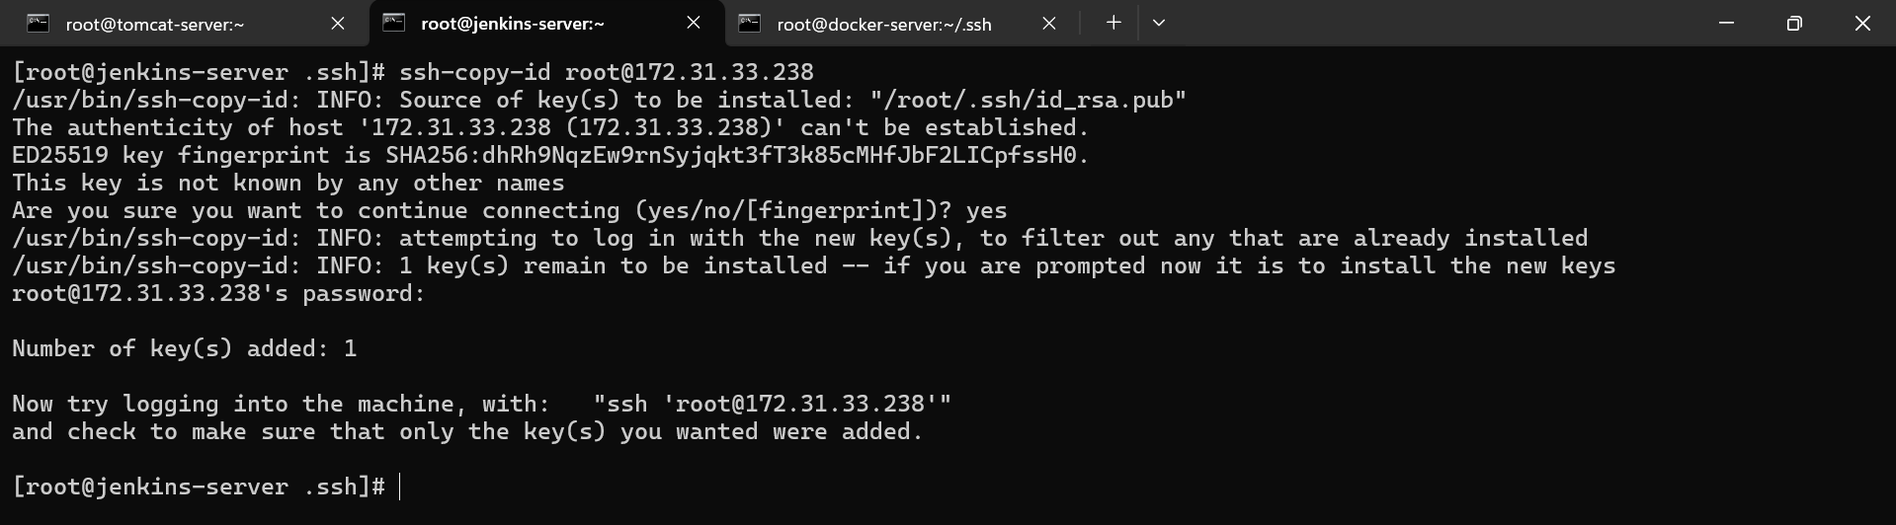

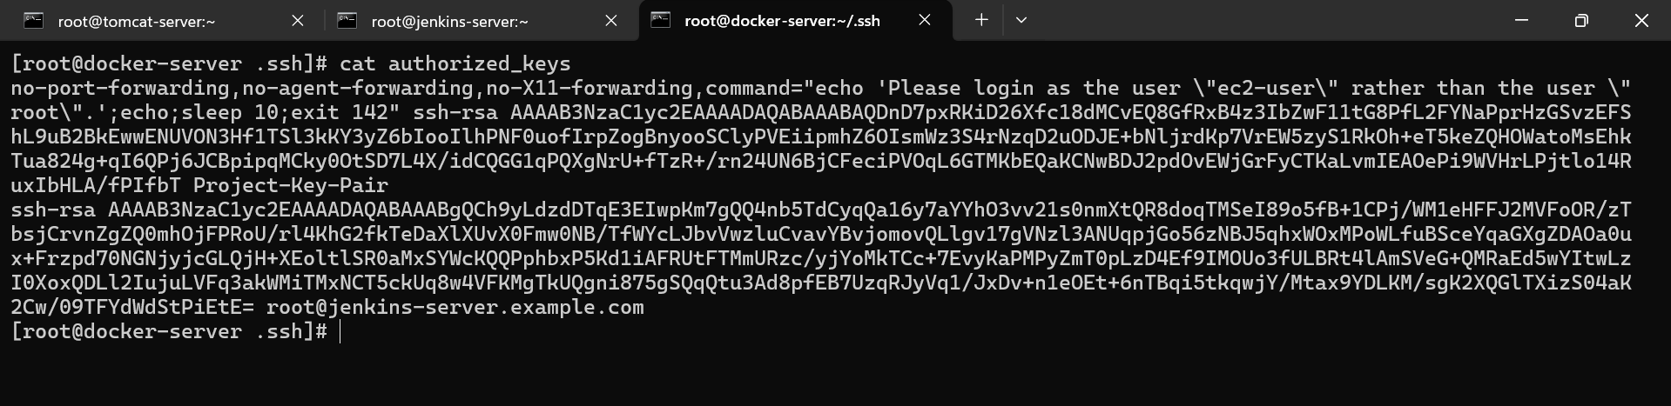

Now we have to create one ECR container to store our docker image.

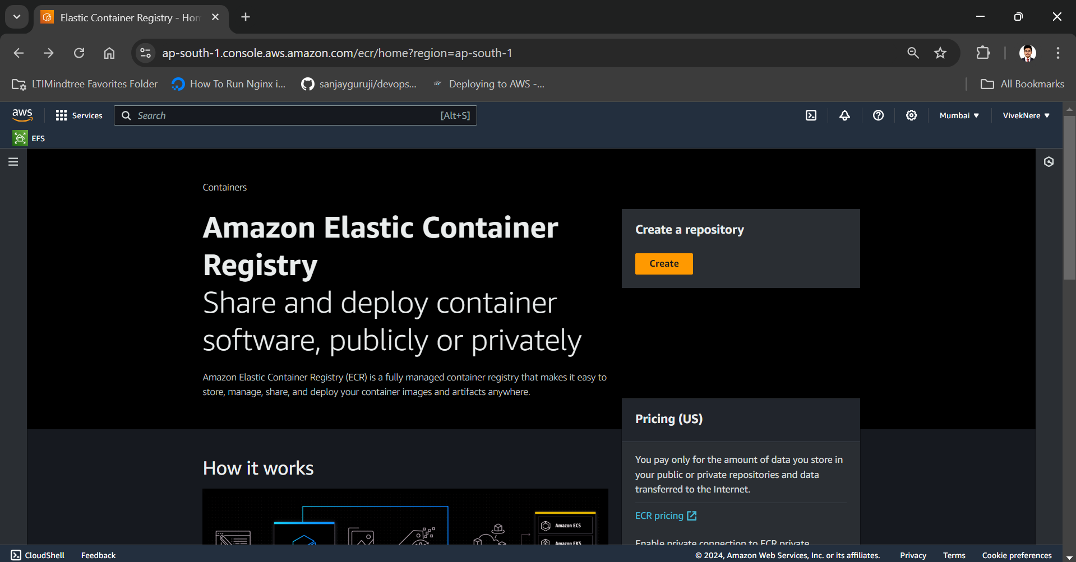

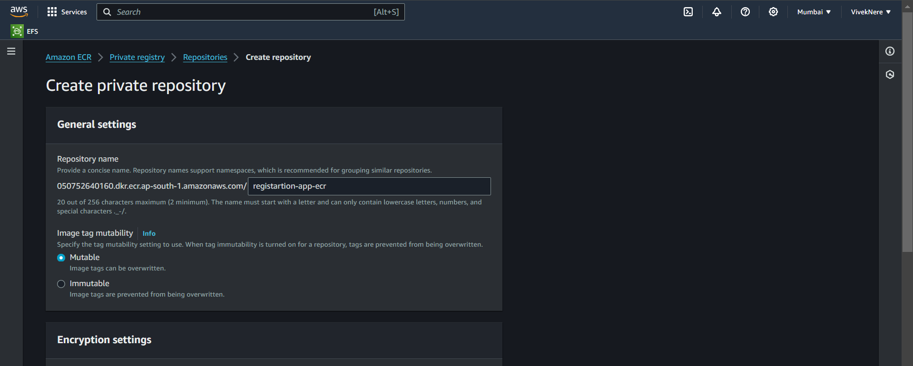

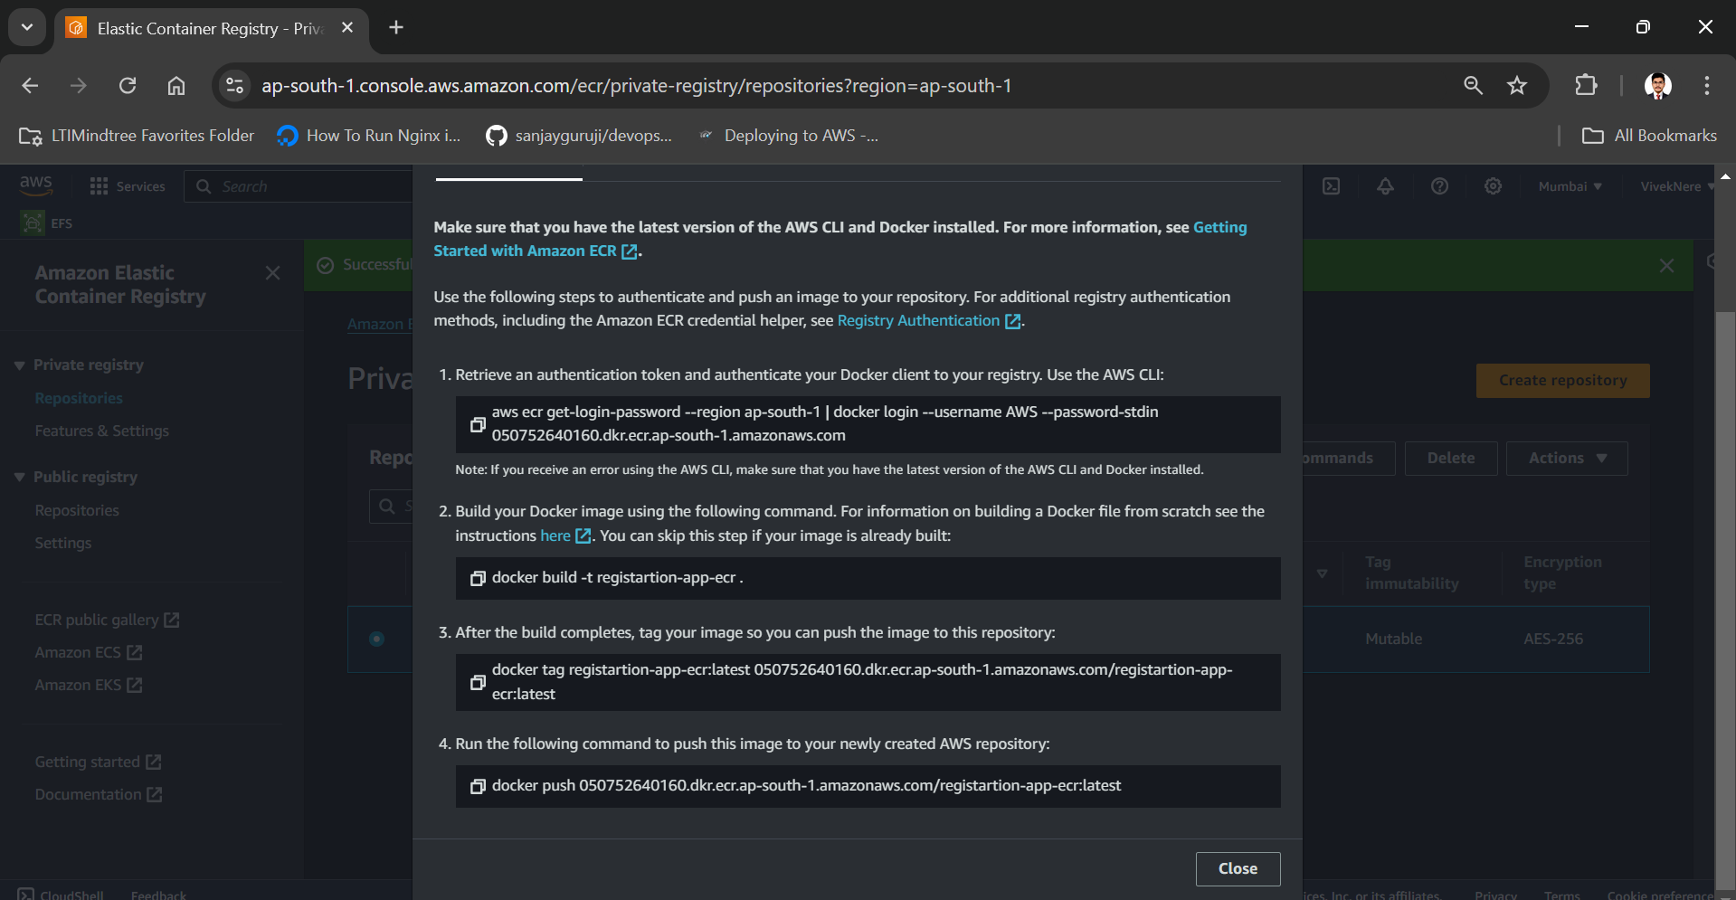

Now we have to configure our docker in jenkins for that we have make some changes in jenkins system.

Dashboard > Manage jenkins > System

In keys we have to paste the private key of jenkins

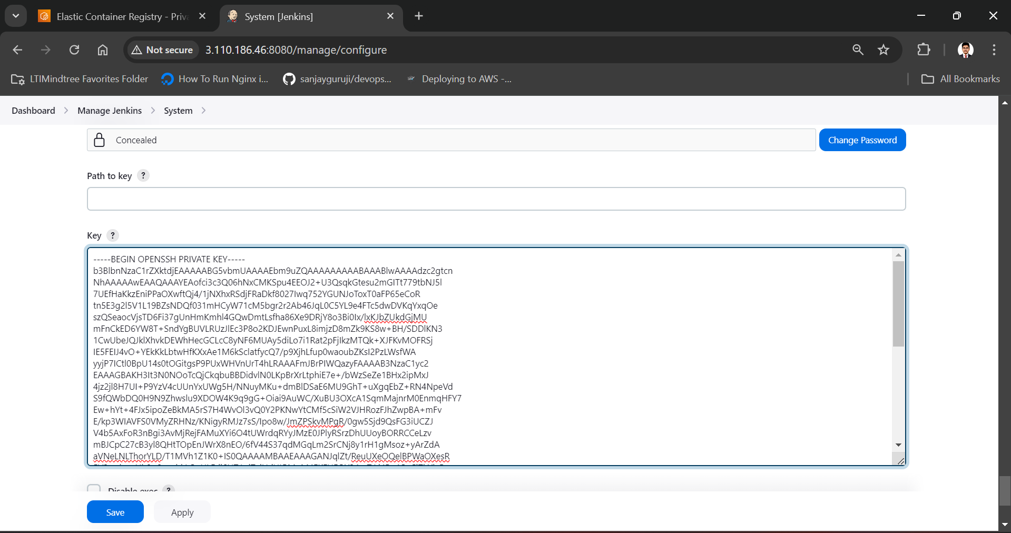

Add jenkins ssh server with hostname as ip and root username ans path as /root

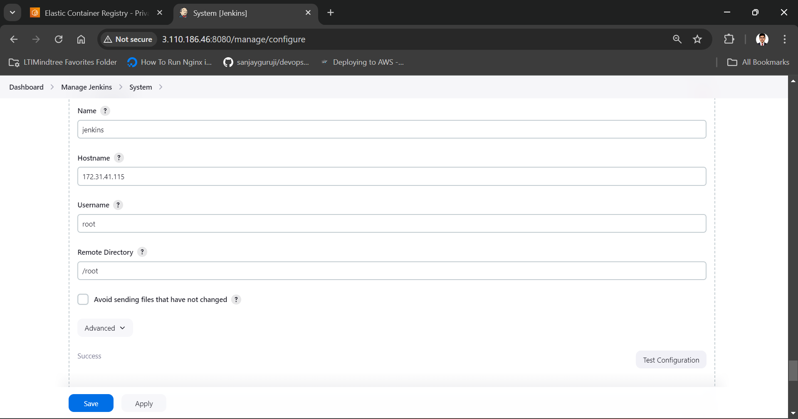

Add docker ssh server with hostname as ip and root username ans path as /root

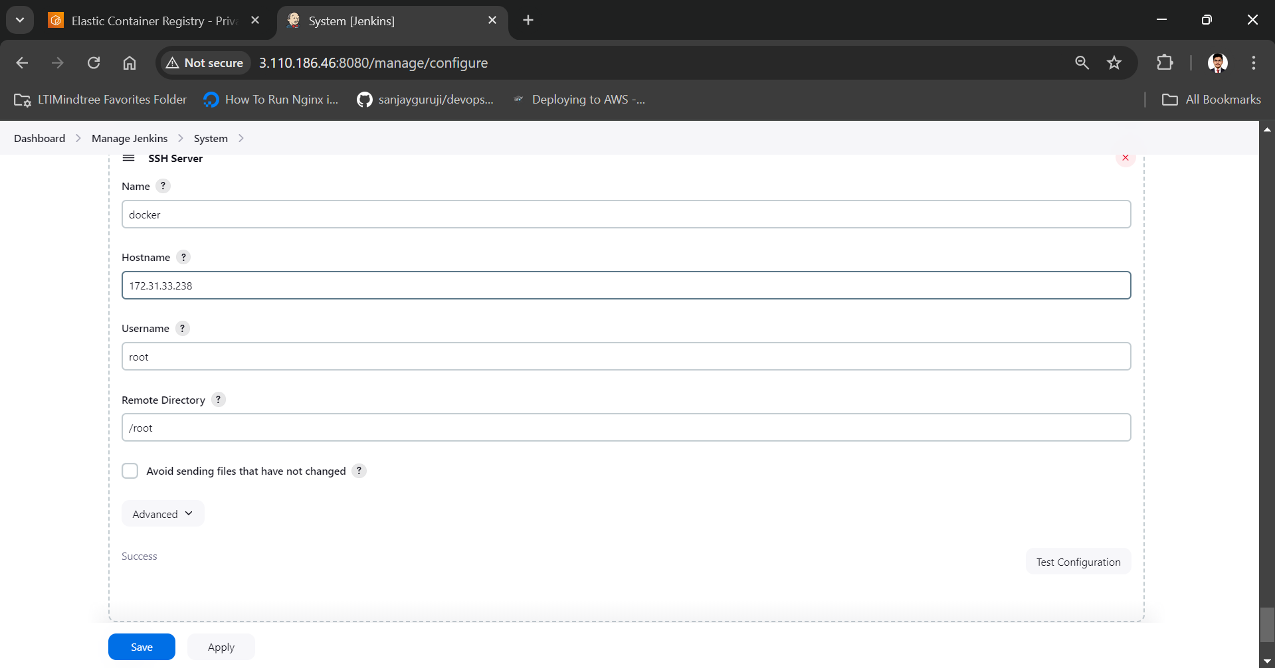

Apply and save.

Create job name as Registration-application-job.

Now select our job in jenkins and in ‘Add post-build action’ add ‘Send build artifacts over SSH’

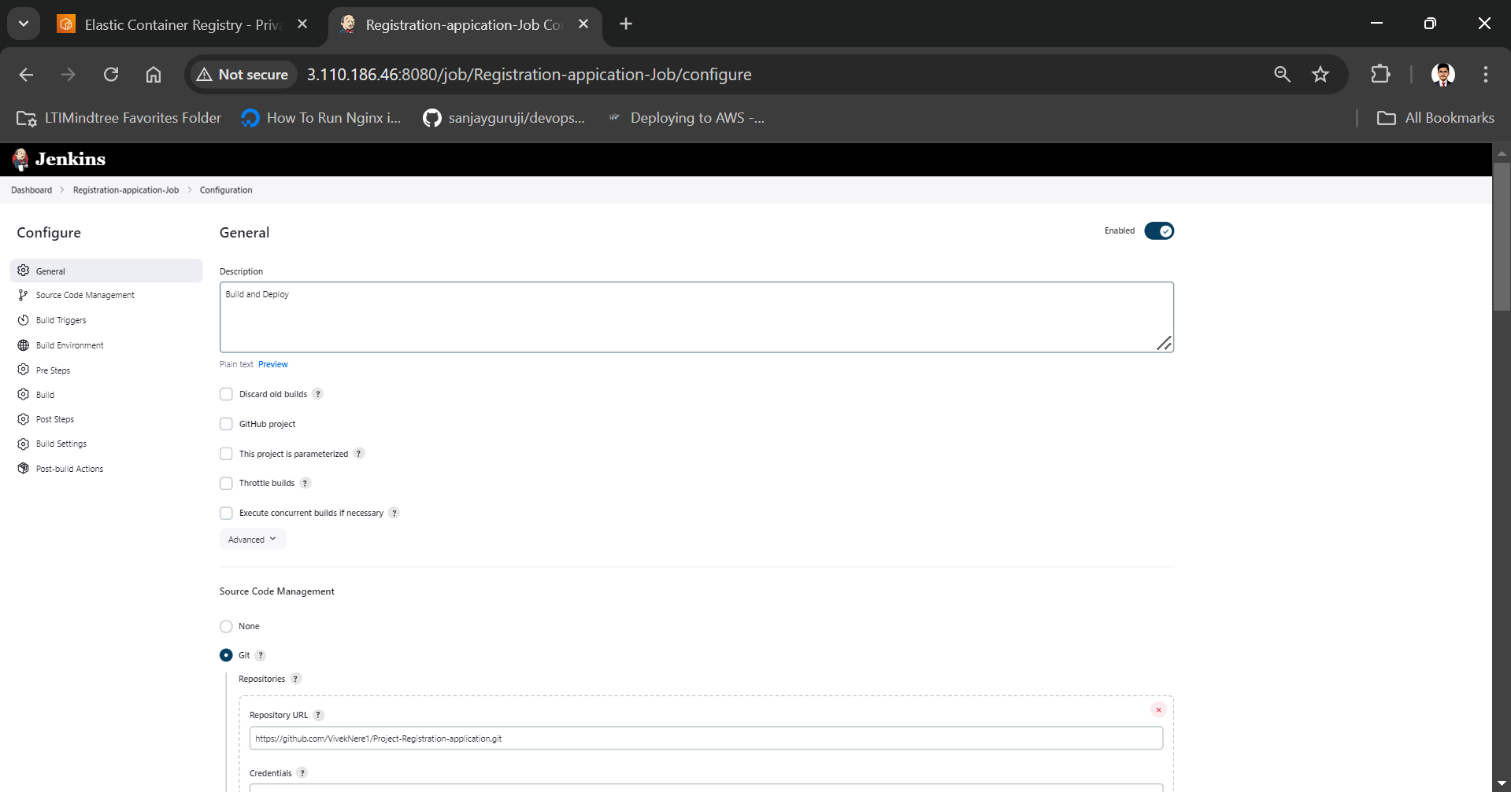

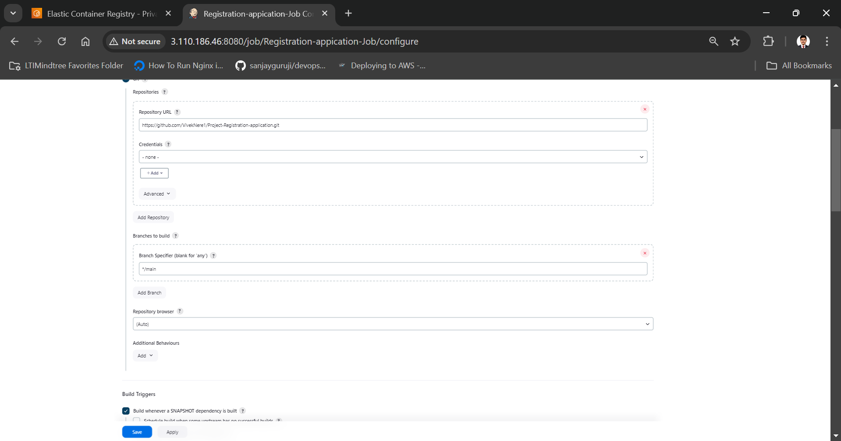

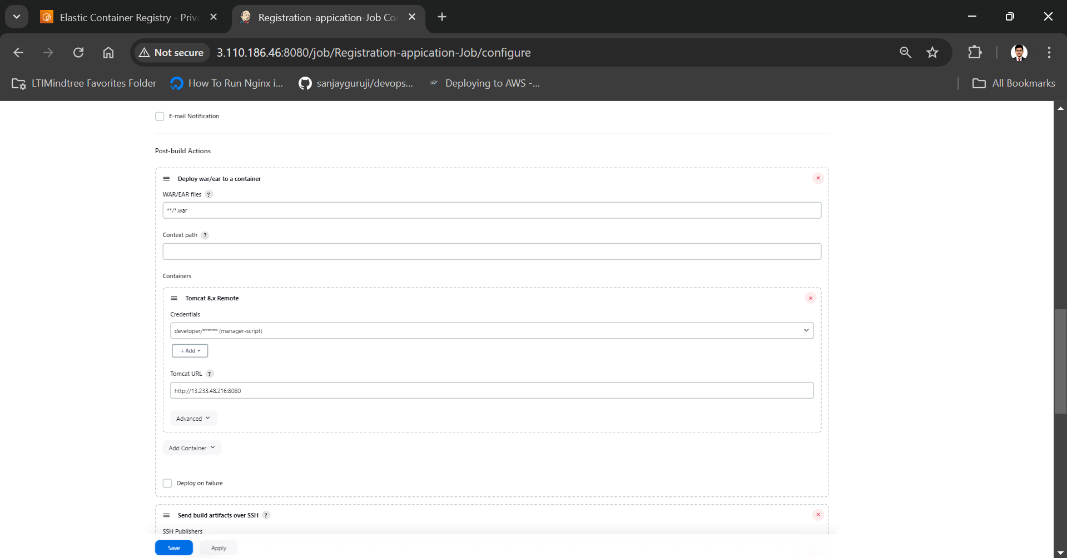

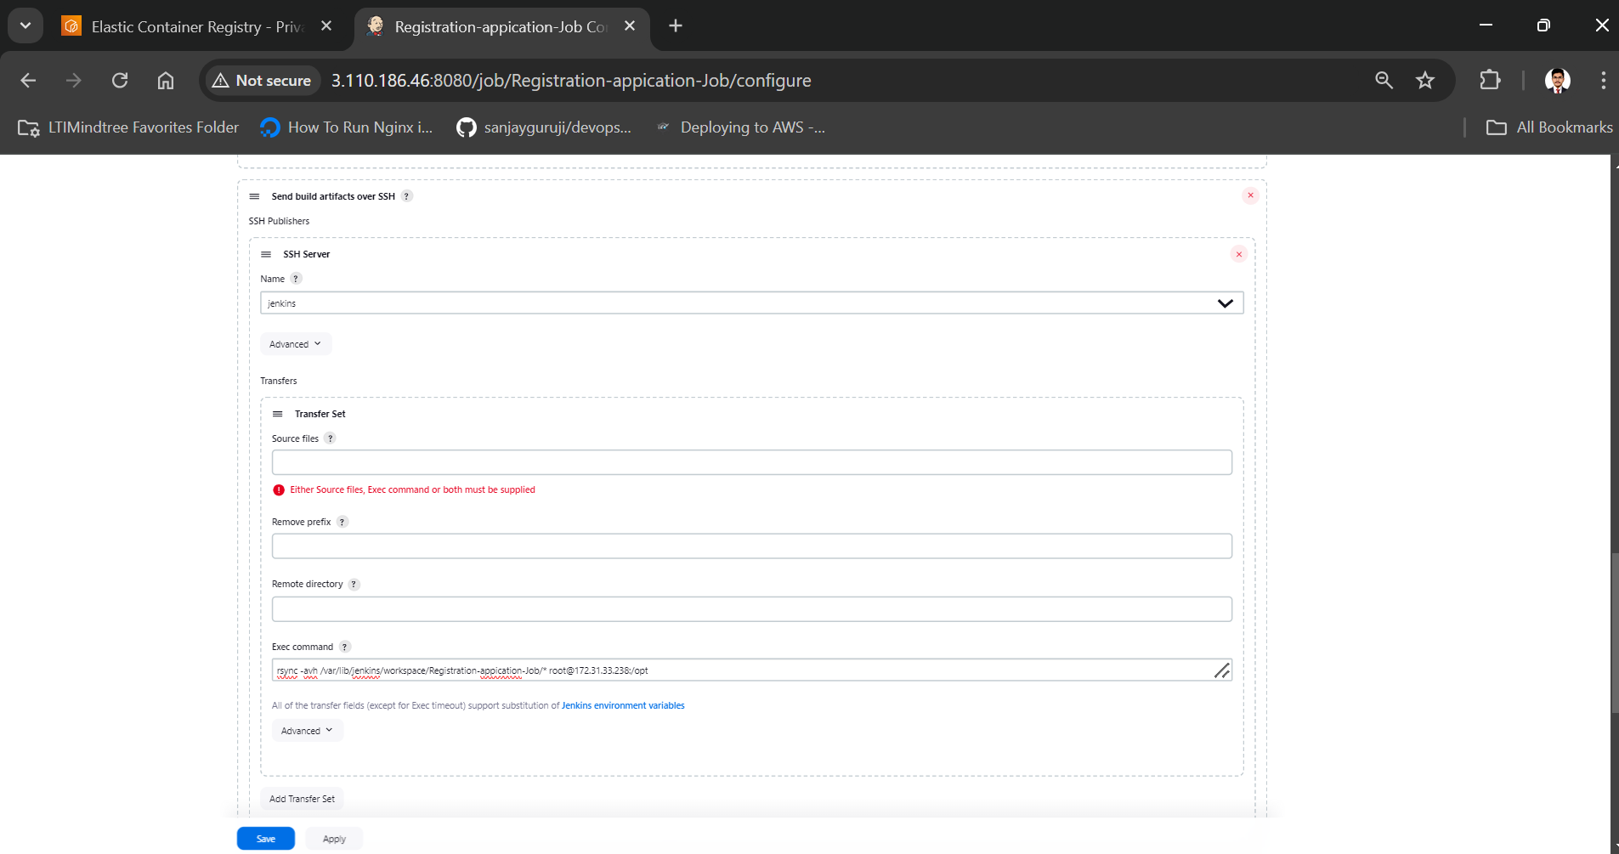

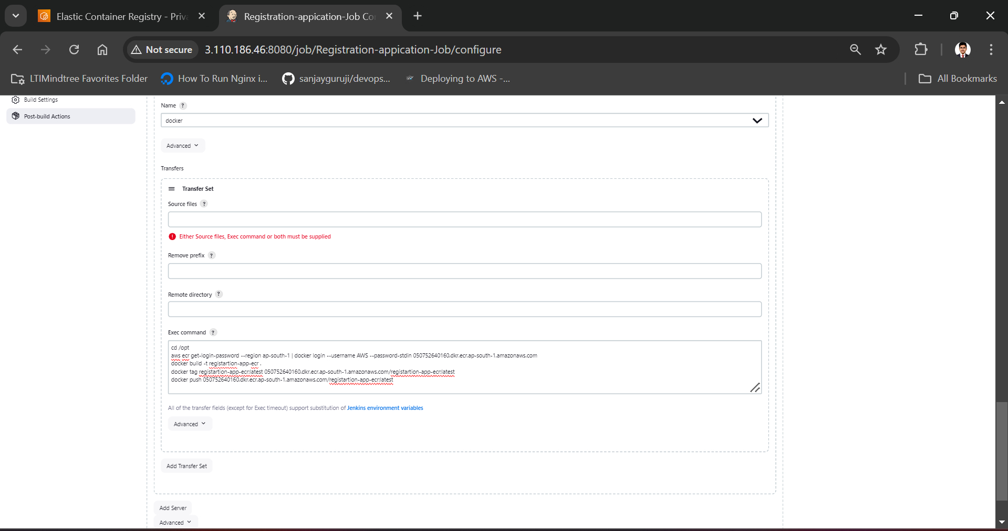

Appy and save.

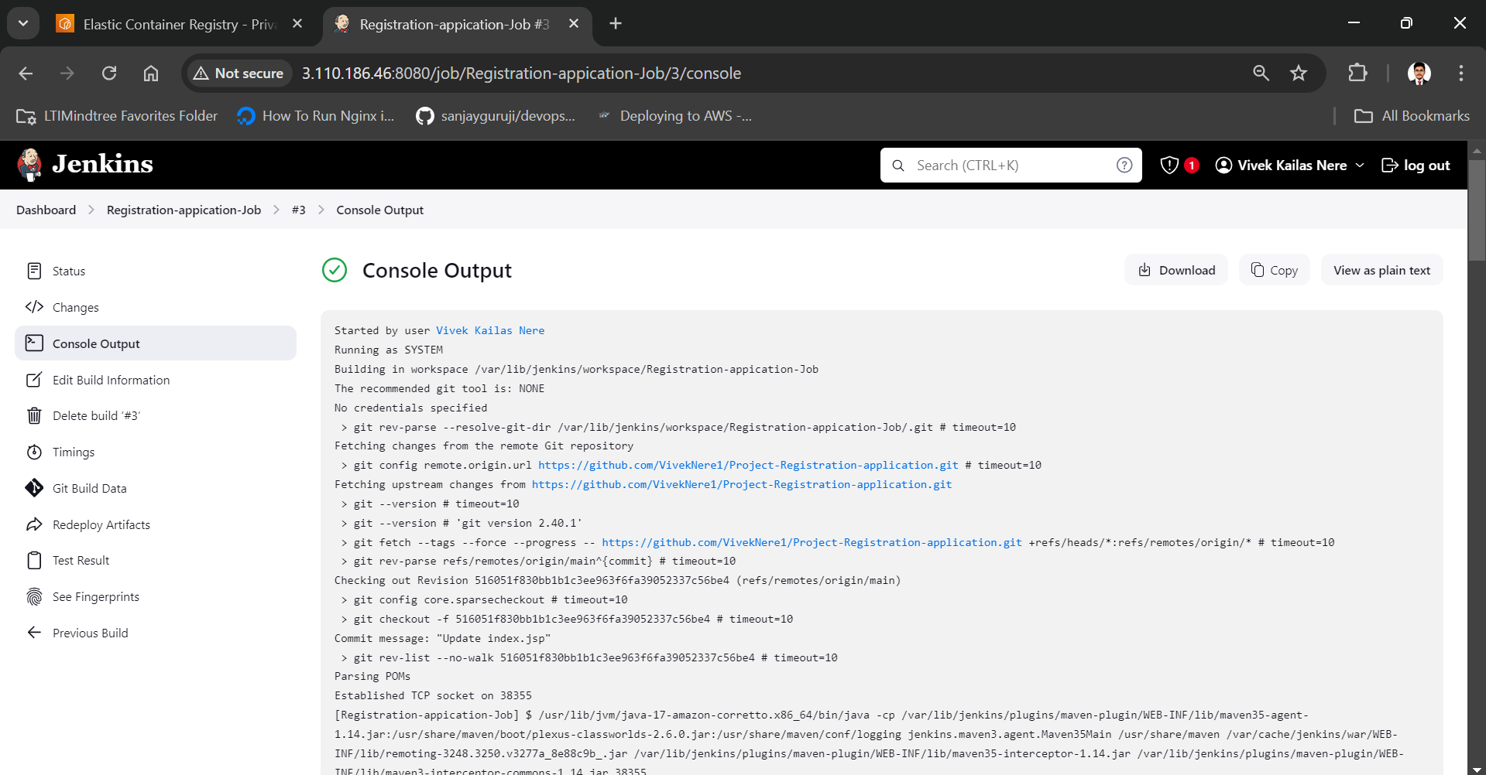

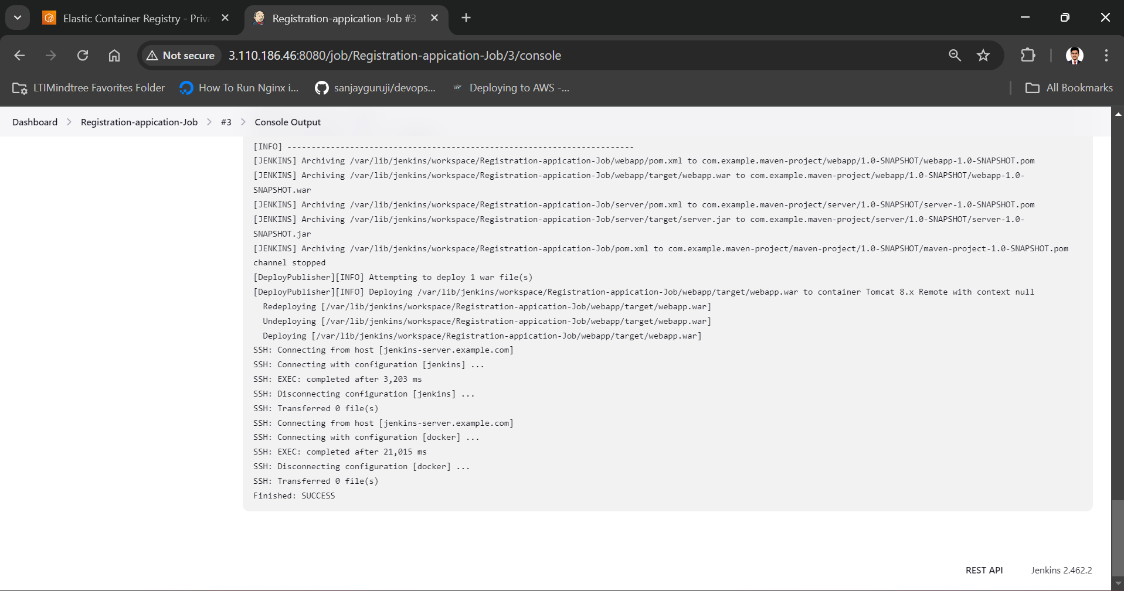

From above we can see our docker build get successful!

**#5: Kubernetes EKS**

kubernetes Installation and Configuration with jenkins:

First create an instance for k8s using amazon linux as OS with instance type t2.micro and same key-pair and security group which we have use in previous instances.

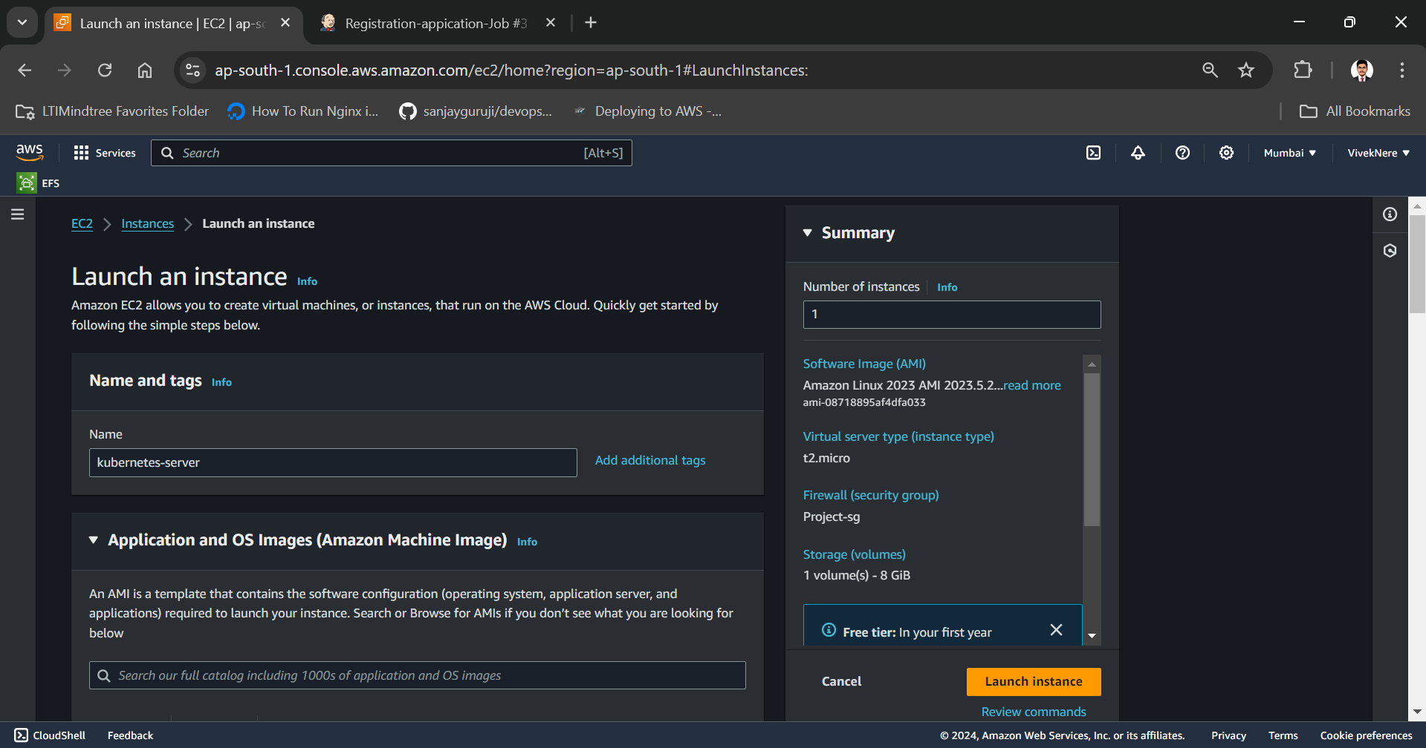

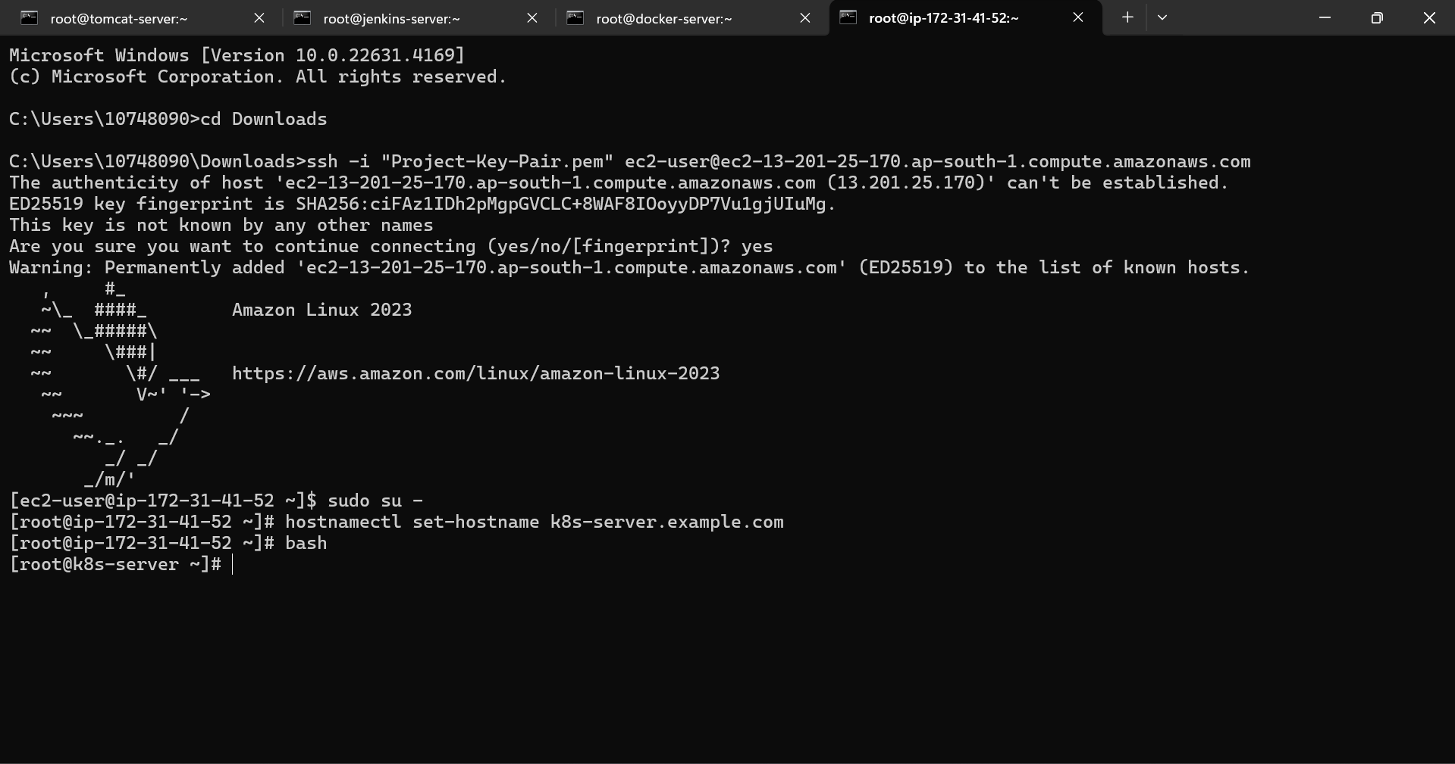

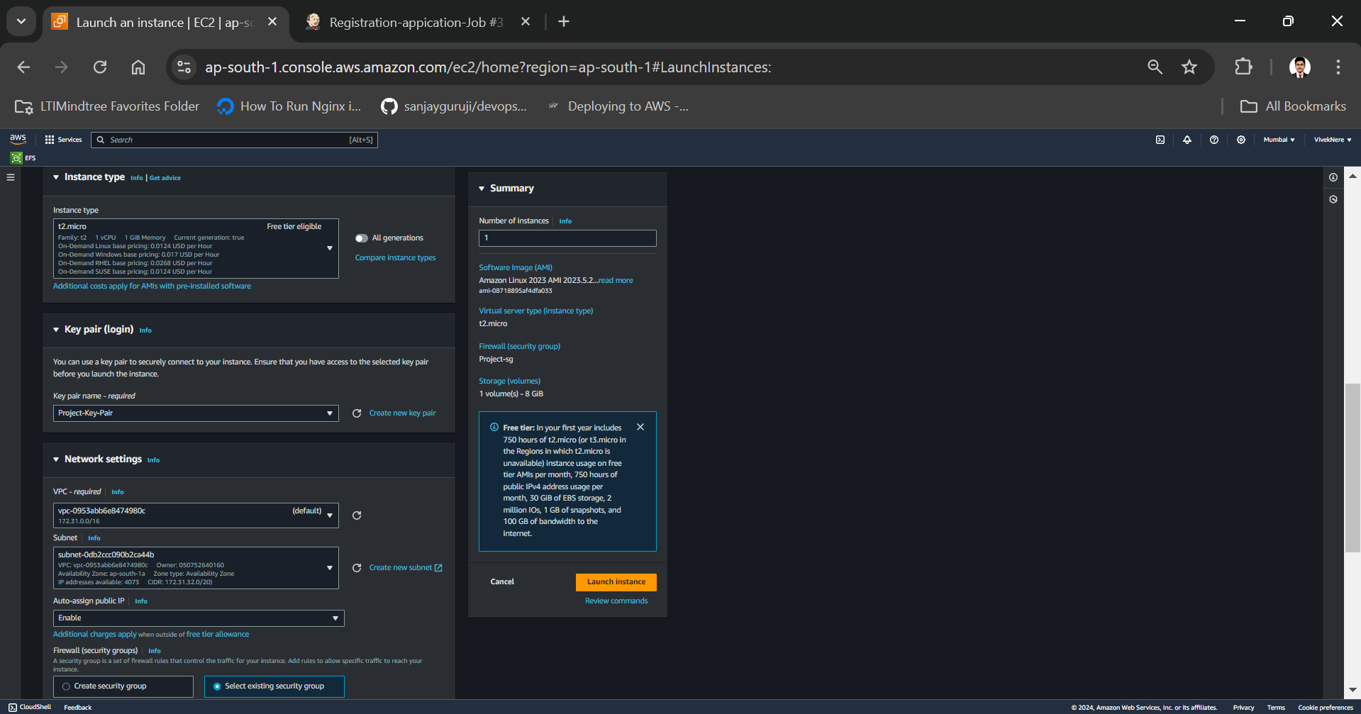

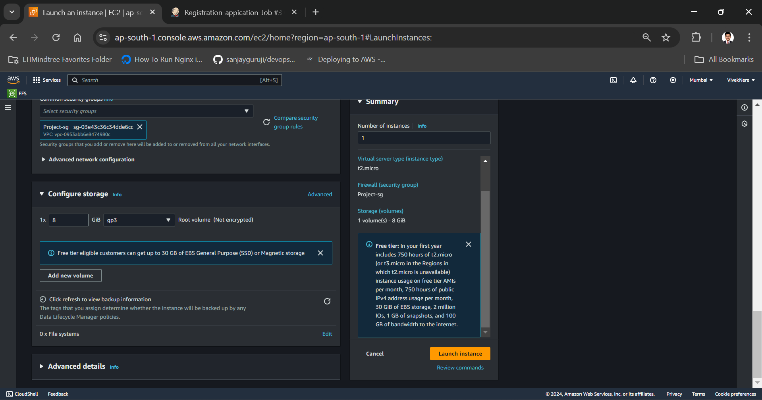

Now connect this kubernetes ec2 in terminal and give hostname as docker-server to it.

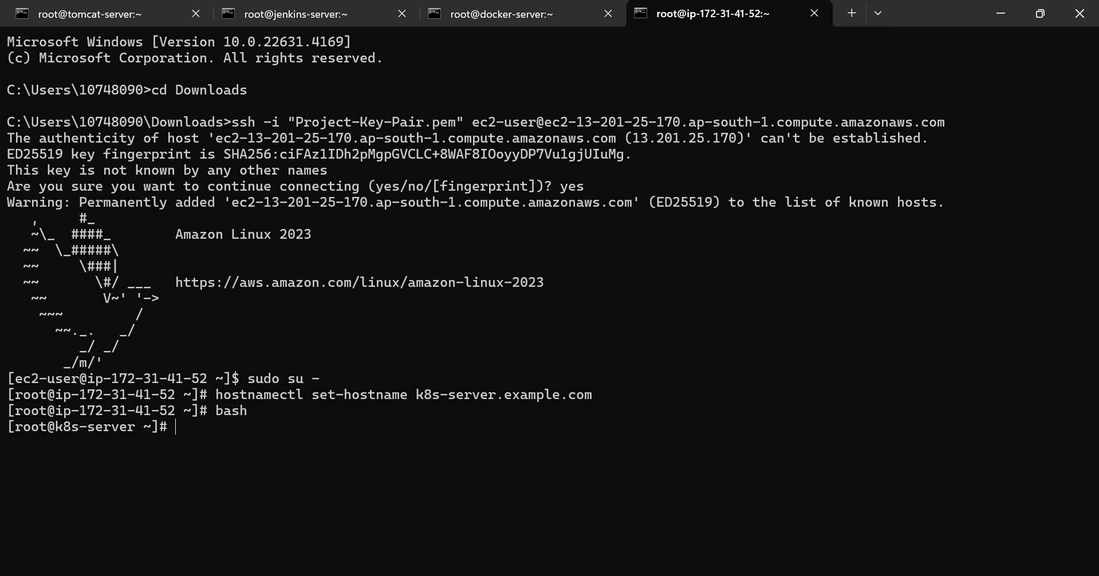

Create EKS cluster in kubernetes-server

Create one IAM role with ECR fullaccess , EKSpolicy and IAM full access policy and attach that role to this kubernetes instance.

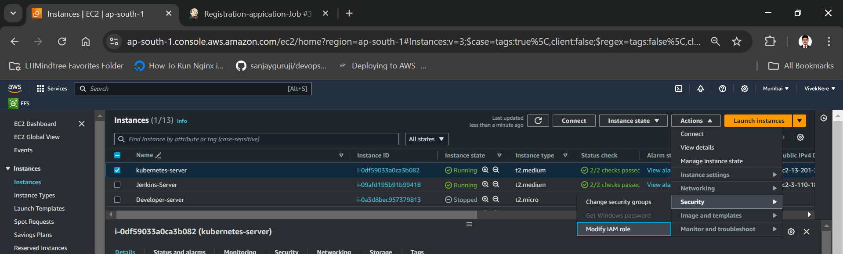

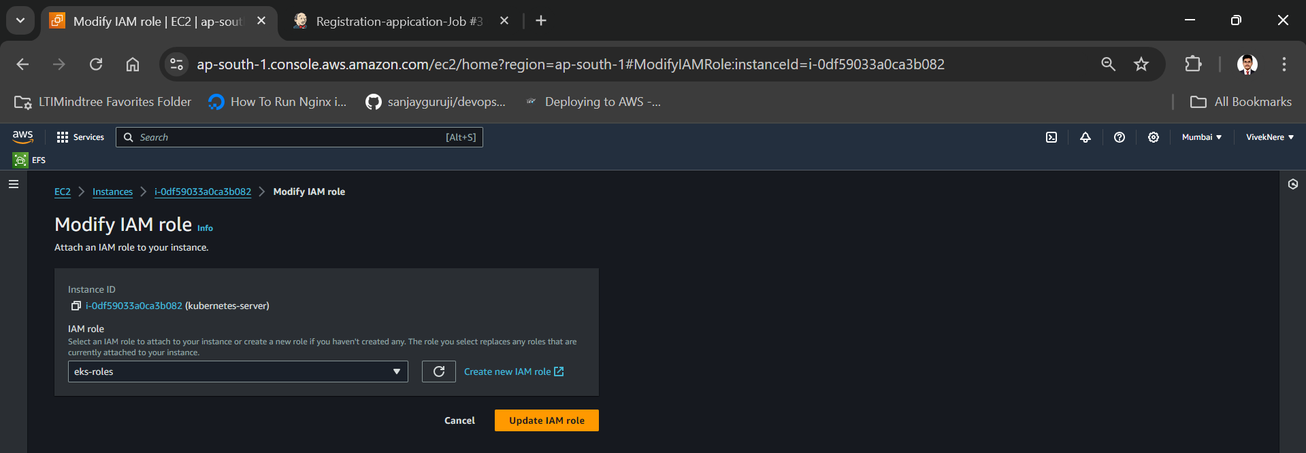

Install aws cli in k8s ec2

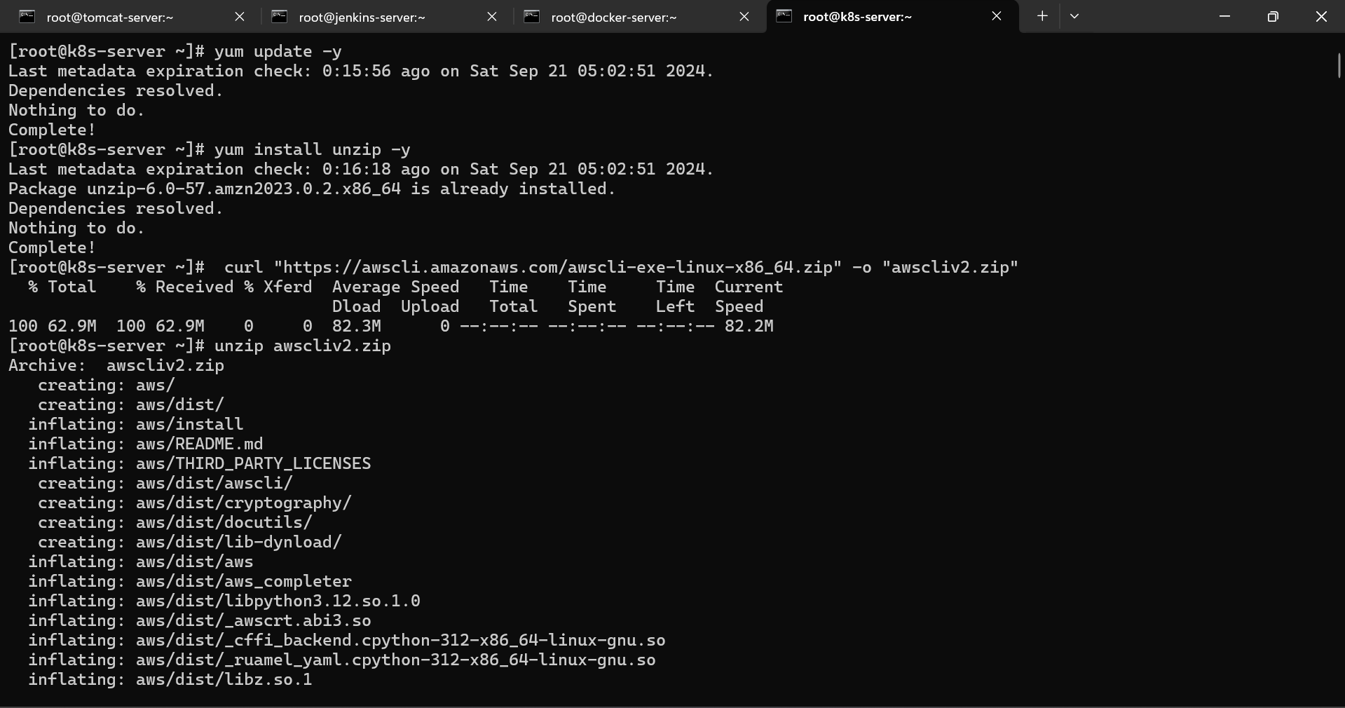

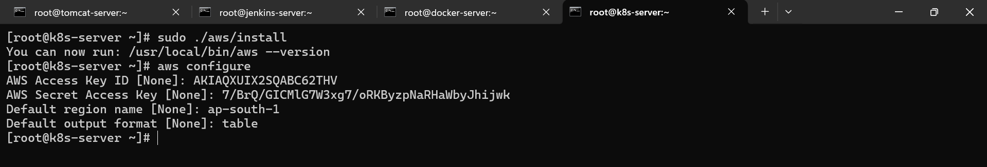

Install EKS tool:

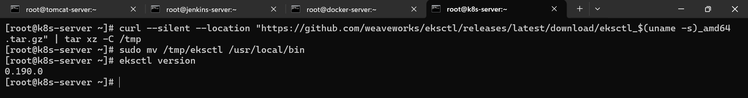

Install Kubectl:

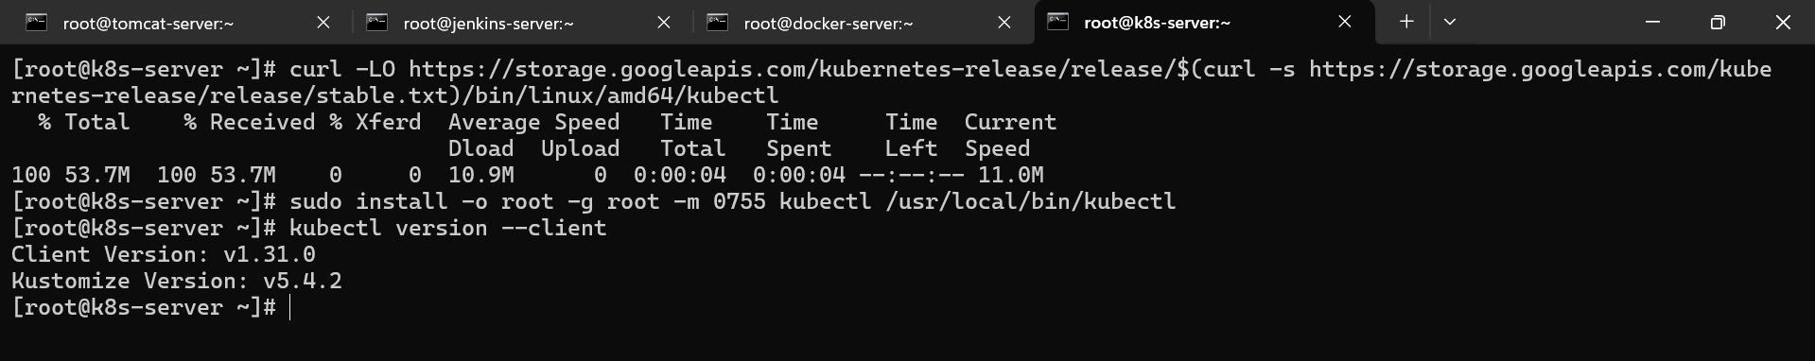

Now create cluster on EKS:

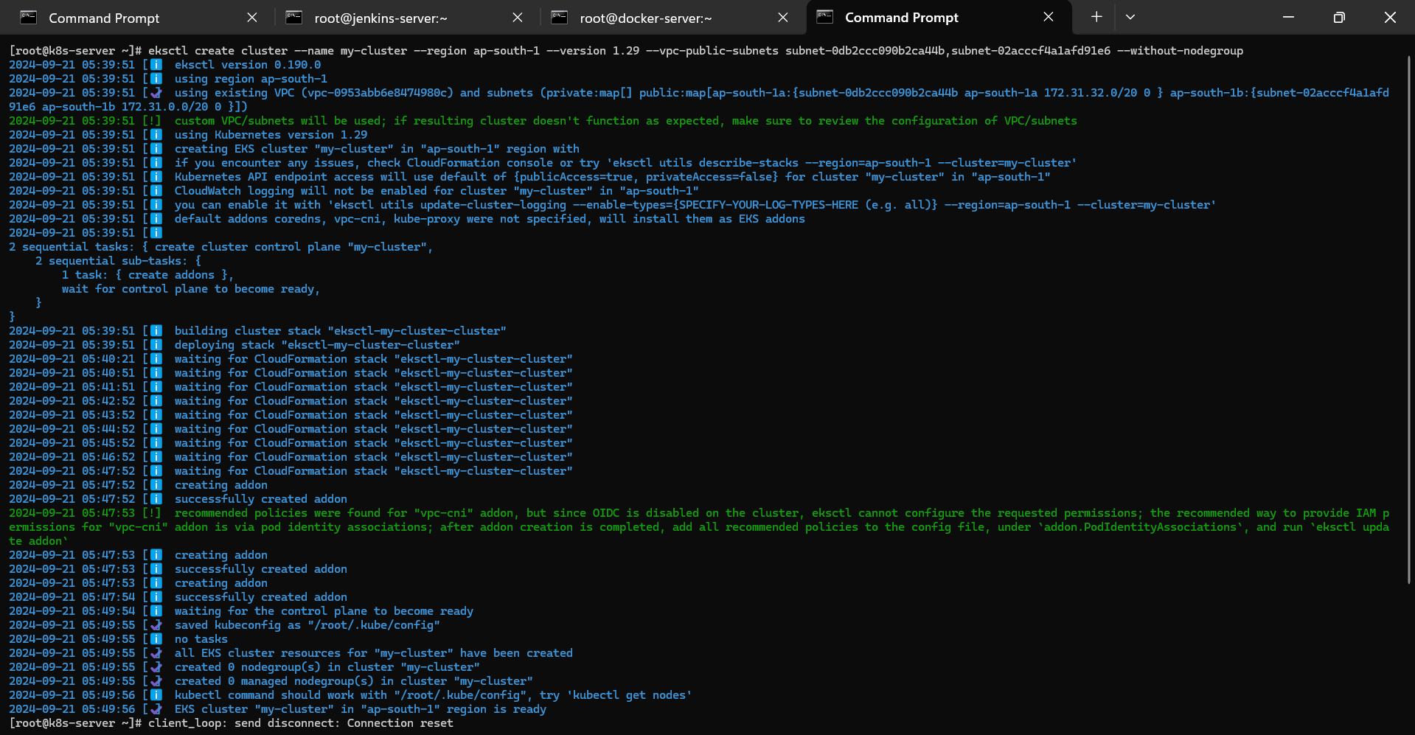

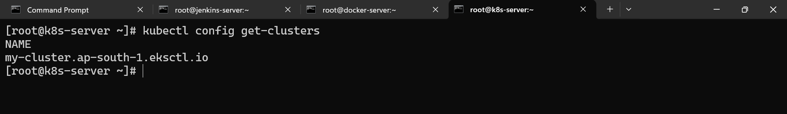

Create ssh-keygen in k8s ec2:

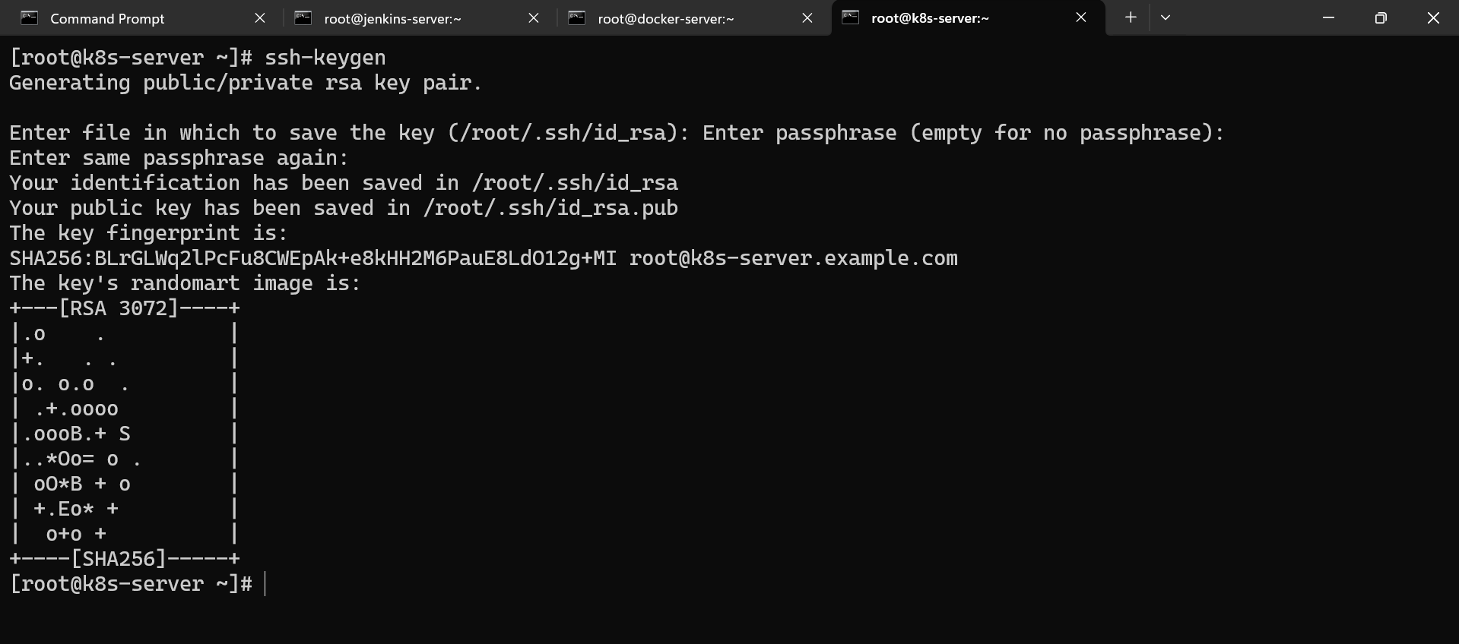

Now we have to create nodes in our cluster:

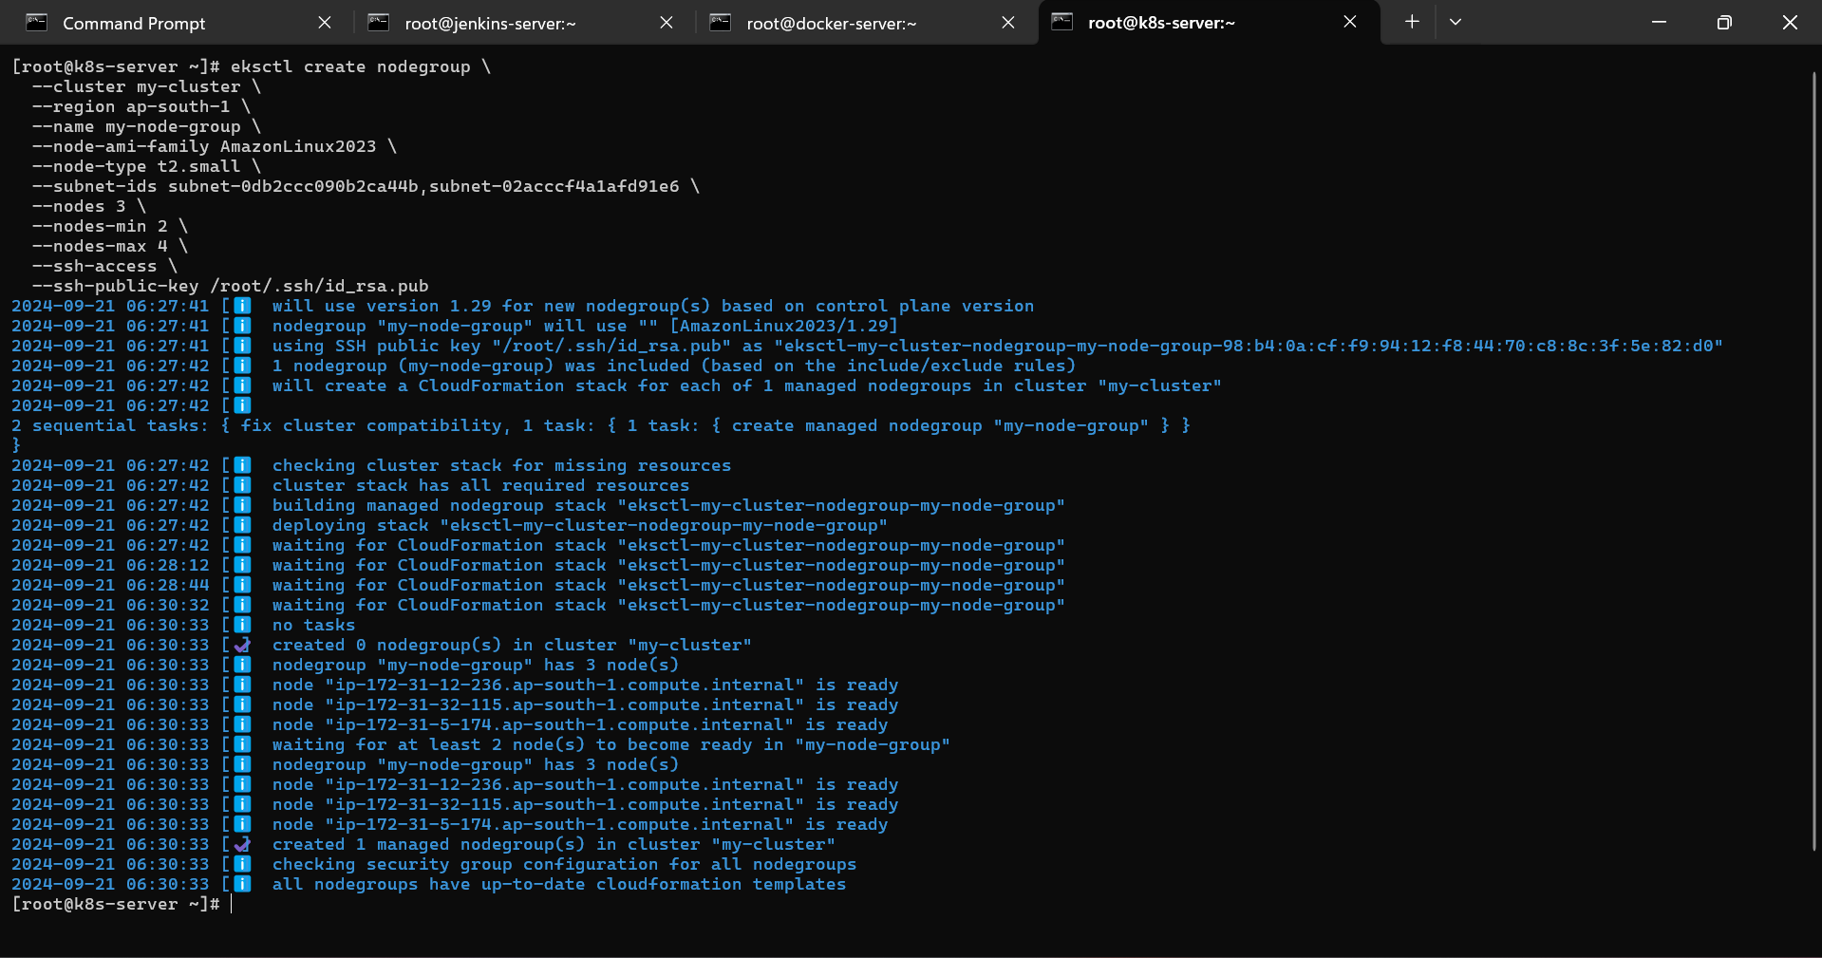

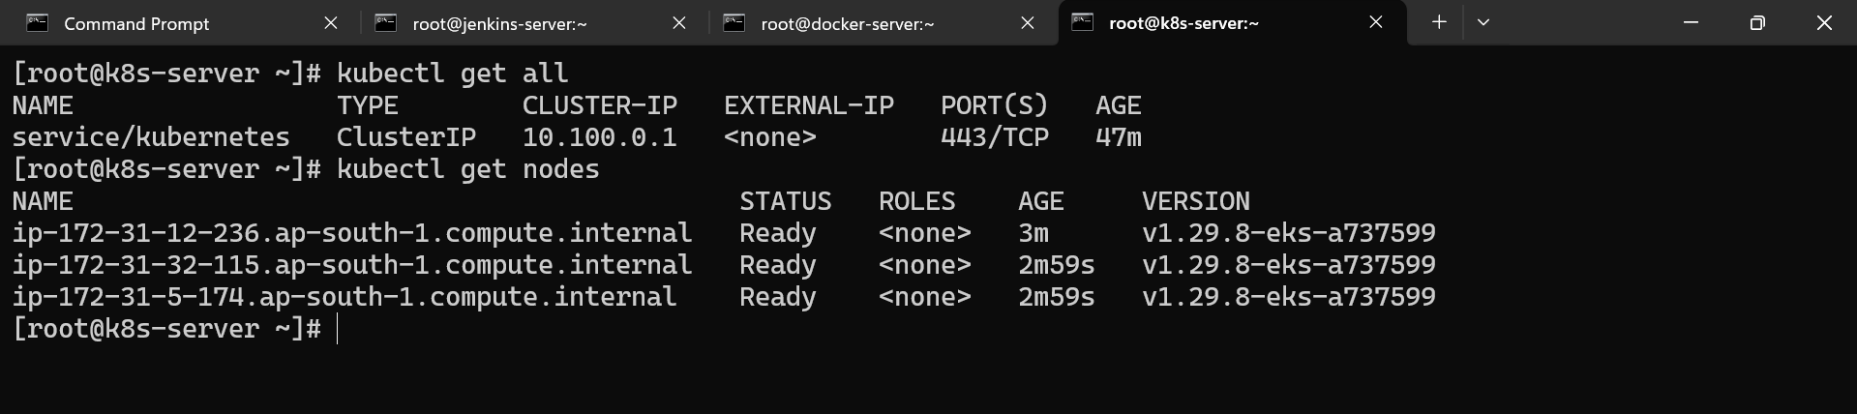

Now we have to create one deployment.yml file ans service.yml file

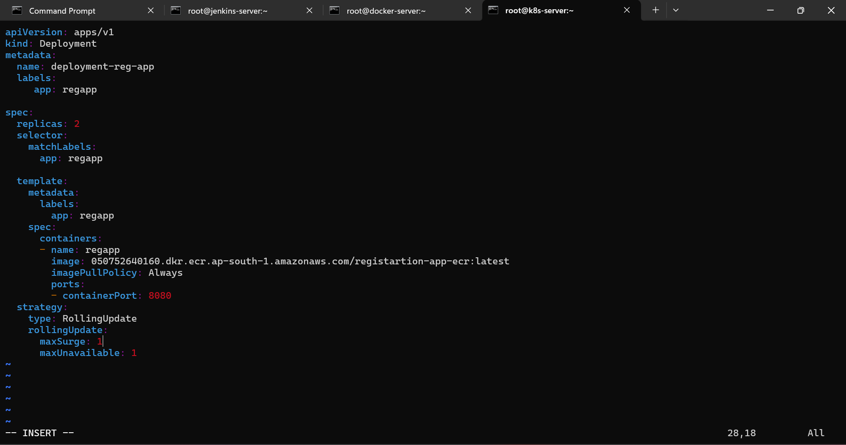

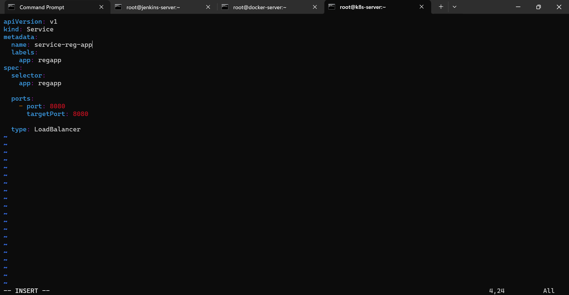

Give ssh-key and password related permission in sshd_config file of kubernetes-server.

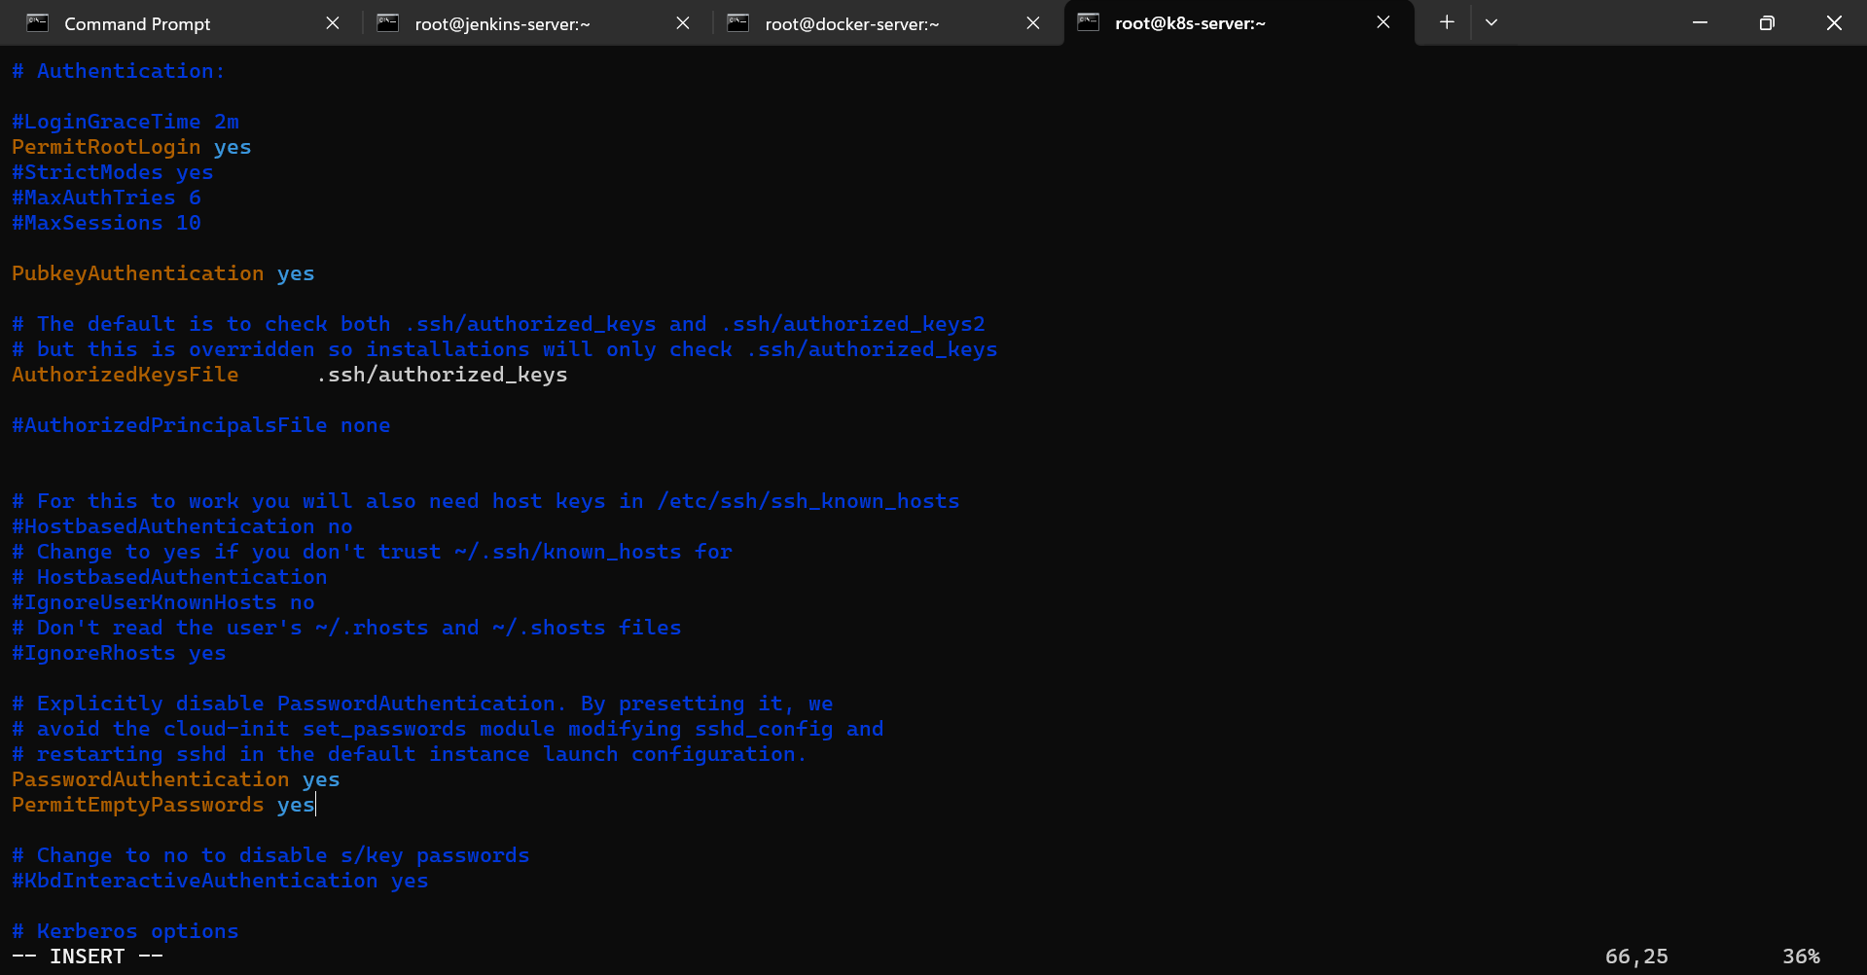

Now we need to transfer this kubernetes ssh-key in jenkins-server And jenkins ssh-key in kubernetes-server

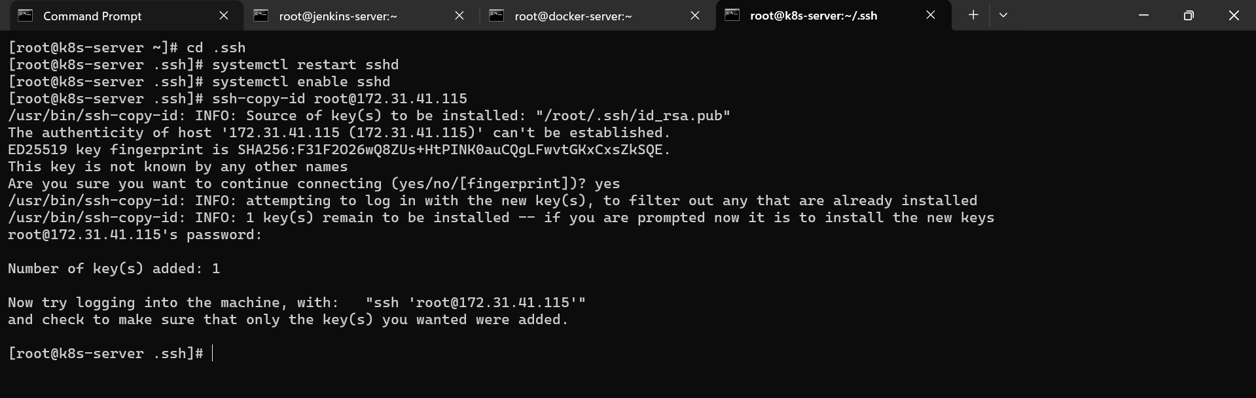

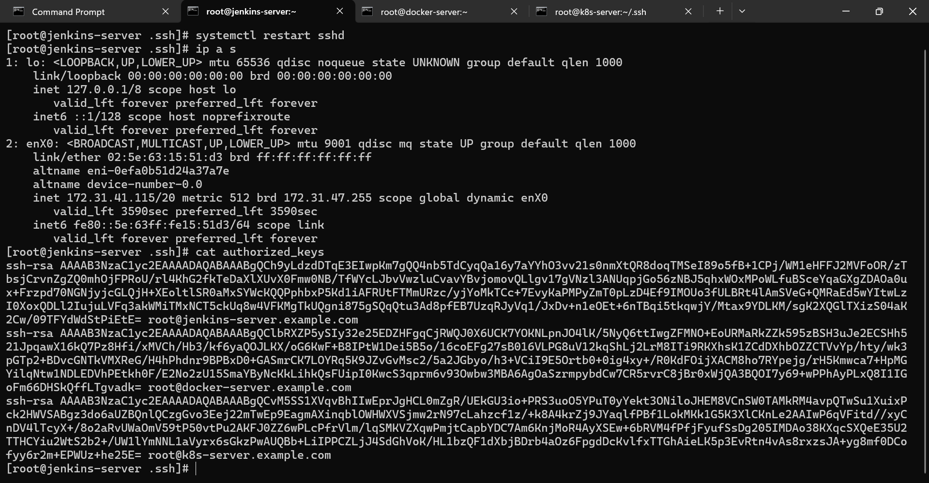

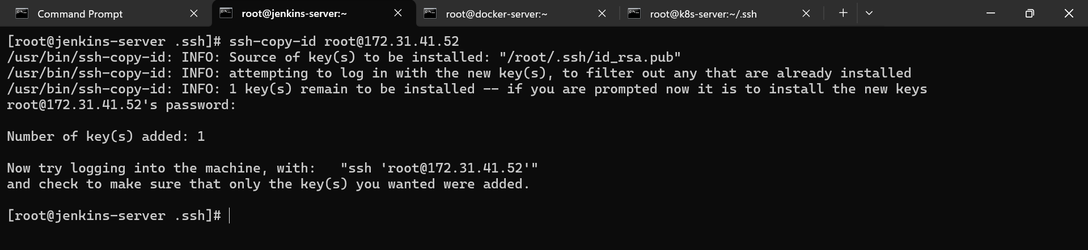

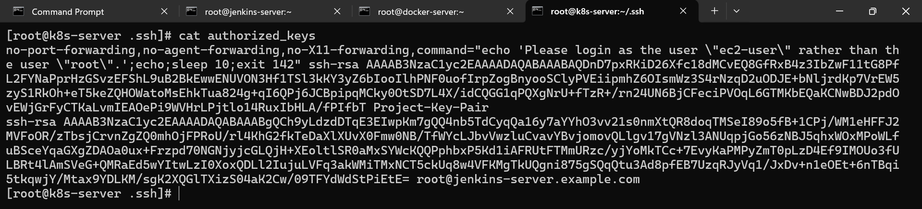

Now we have to configure our kubernetes in jenkins for that we have make some changes in jenkins system.

Dashboard > Manage jenkins > System

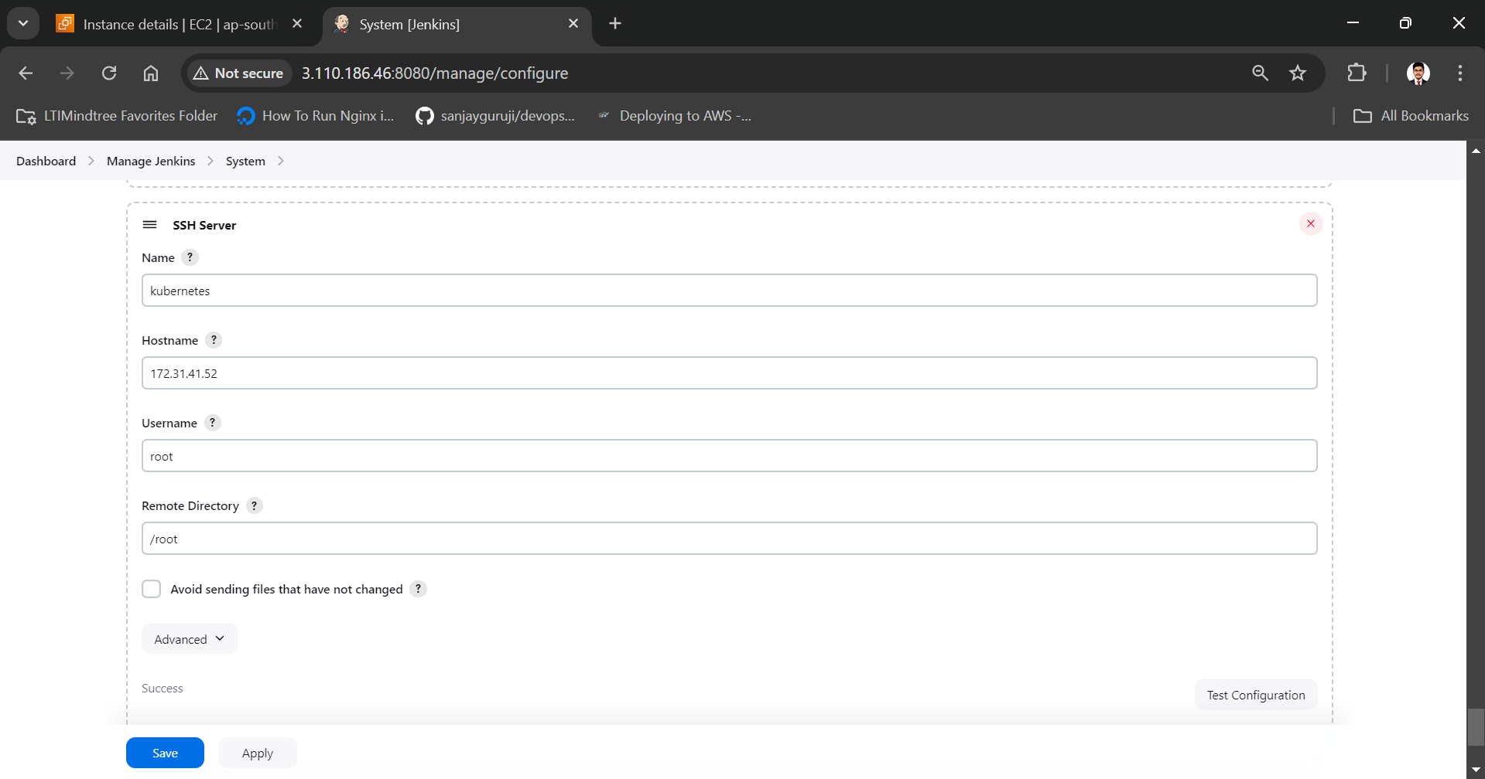

Now in our job **Registration-appication-Job** we have to add ssh-server with exec commands of kubernetes to deploy and create service by Jenkins build.

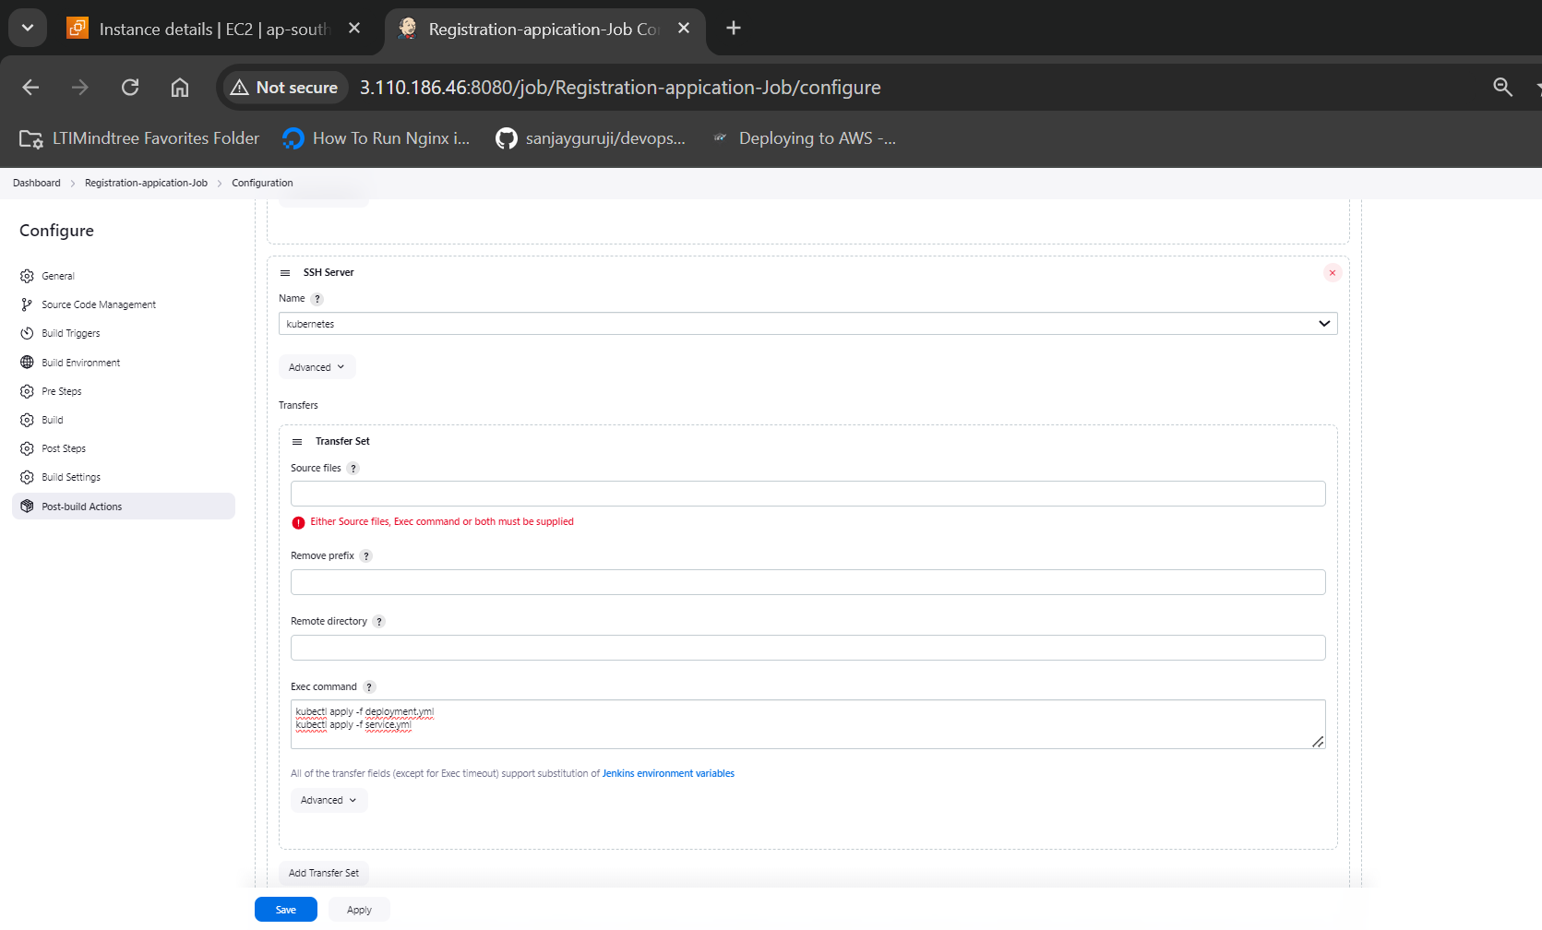

Apply save and build now.

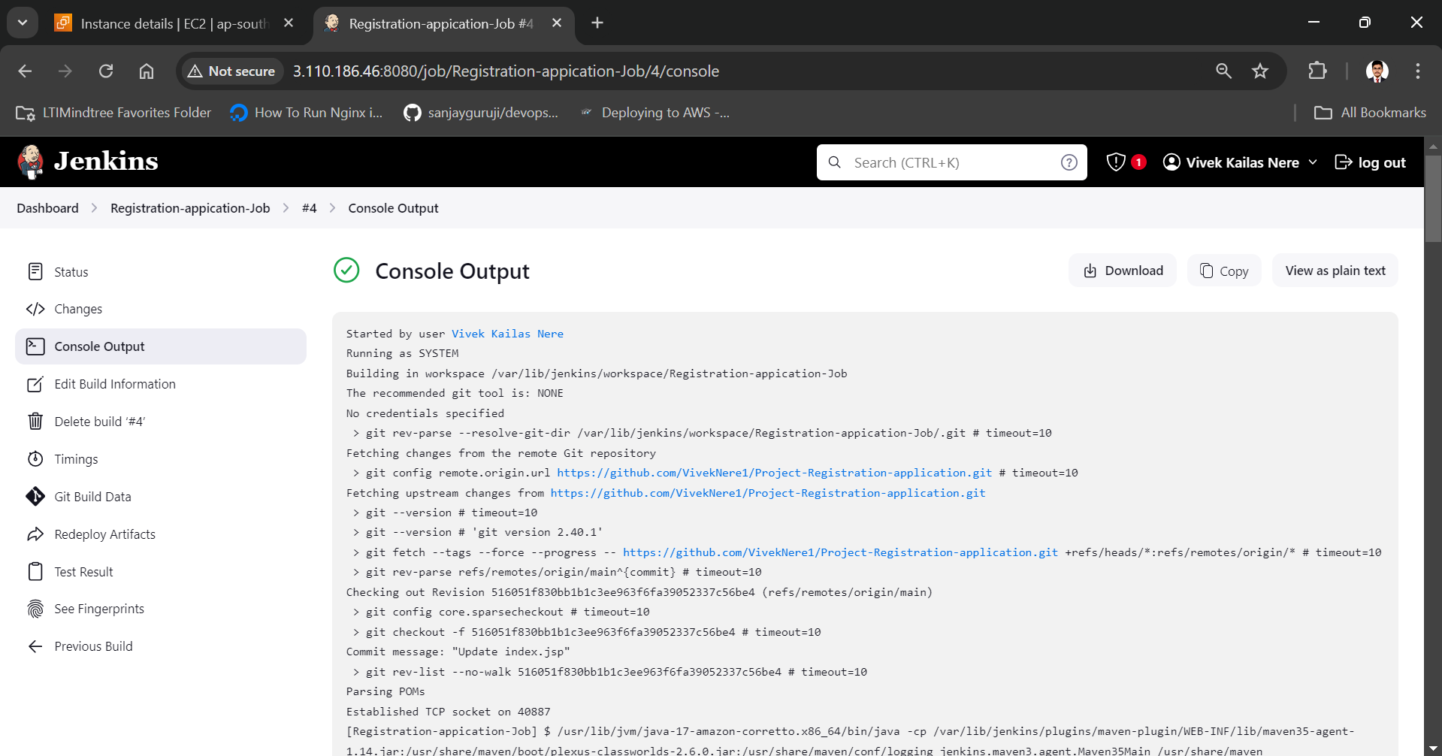

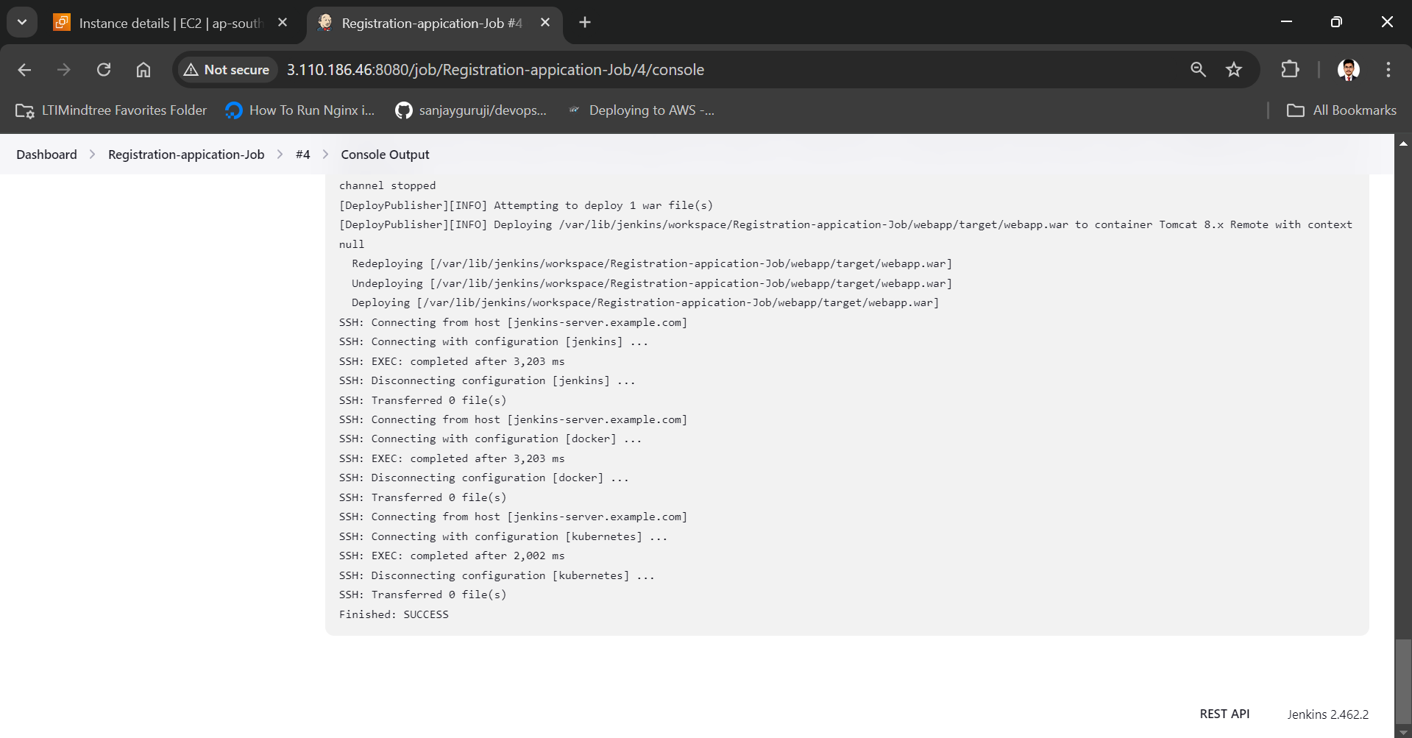

Our Kubernetes configuration with Jenkins build get successful!

Now we have to check in our Kubernetes-server whether service get created or not.

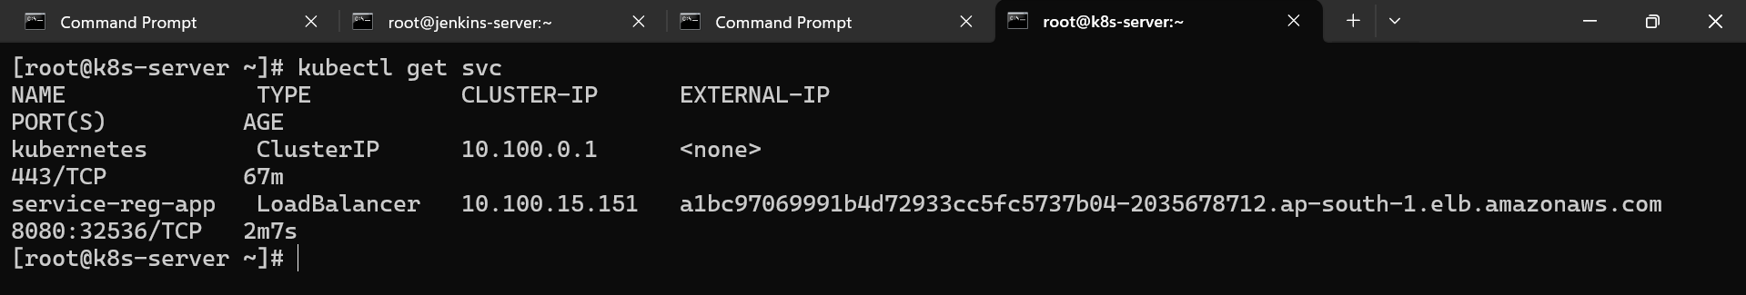

Our service get deployed successfully.

Now we have to check on chrome.

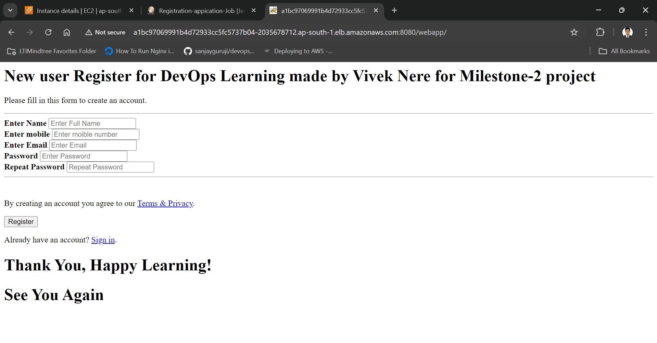

On every change in git we need to delete our old deployment and add new one so for that we have to add one more command in Kubernetes ssh-server exec commands

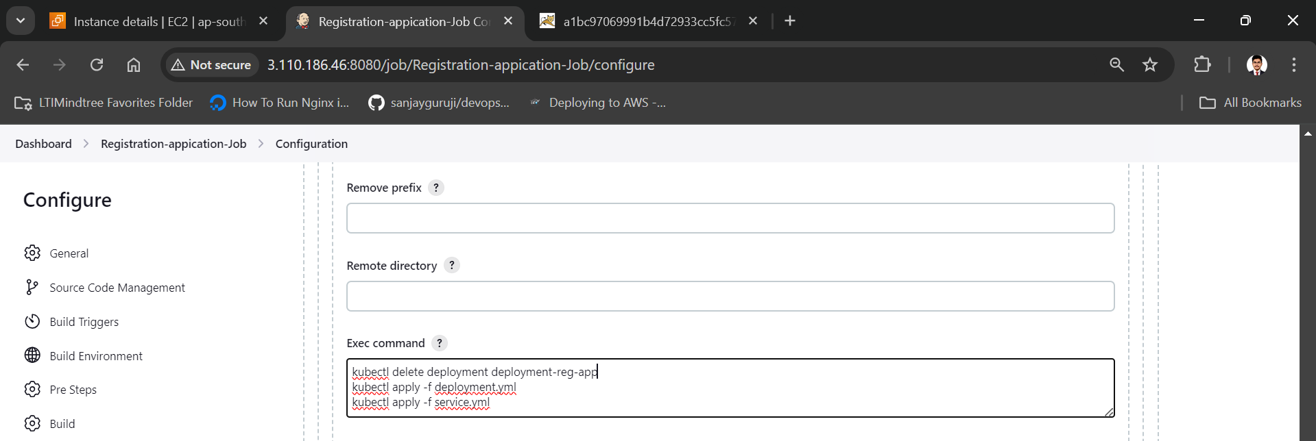

Now we have to made change in code

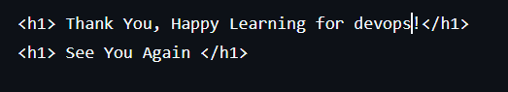

After committing it will automatically reflect in service deployment.

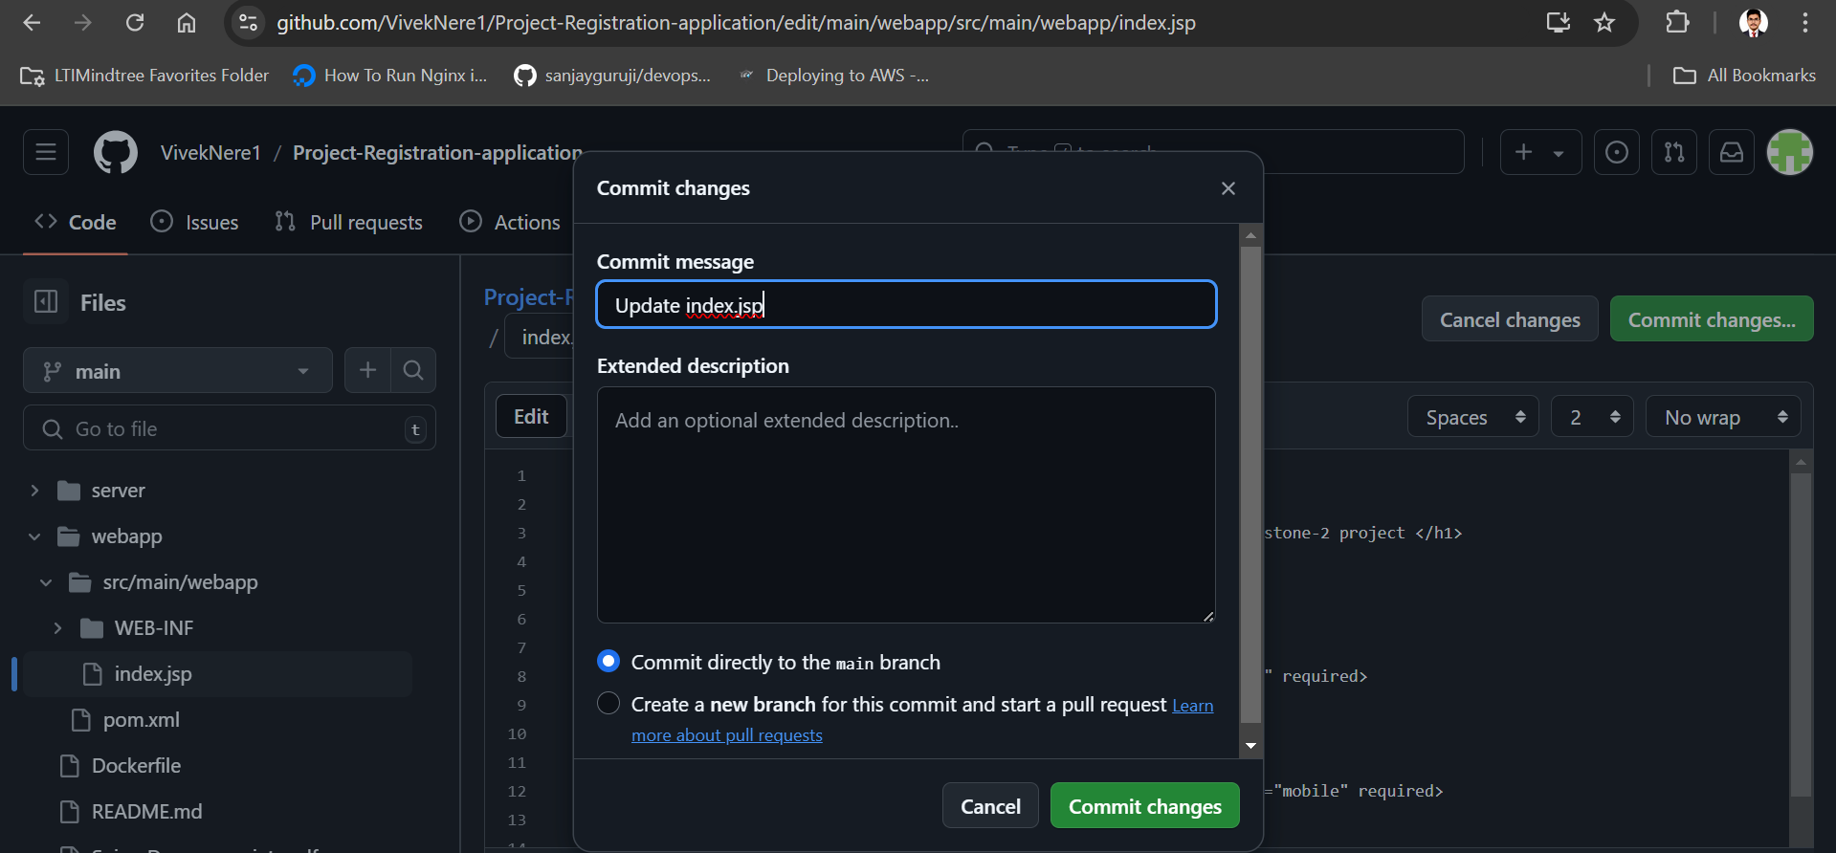

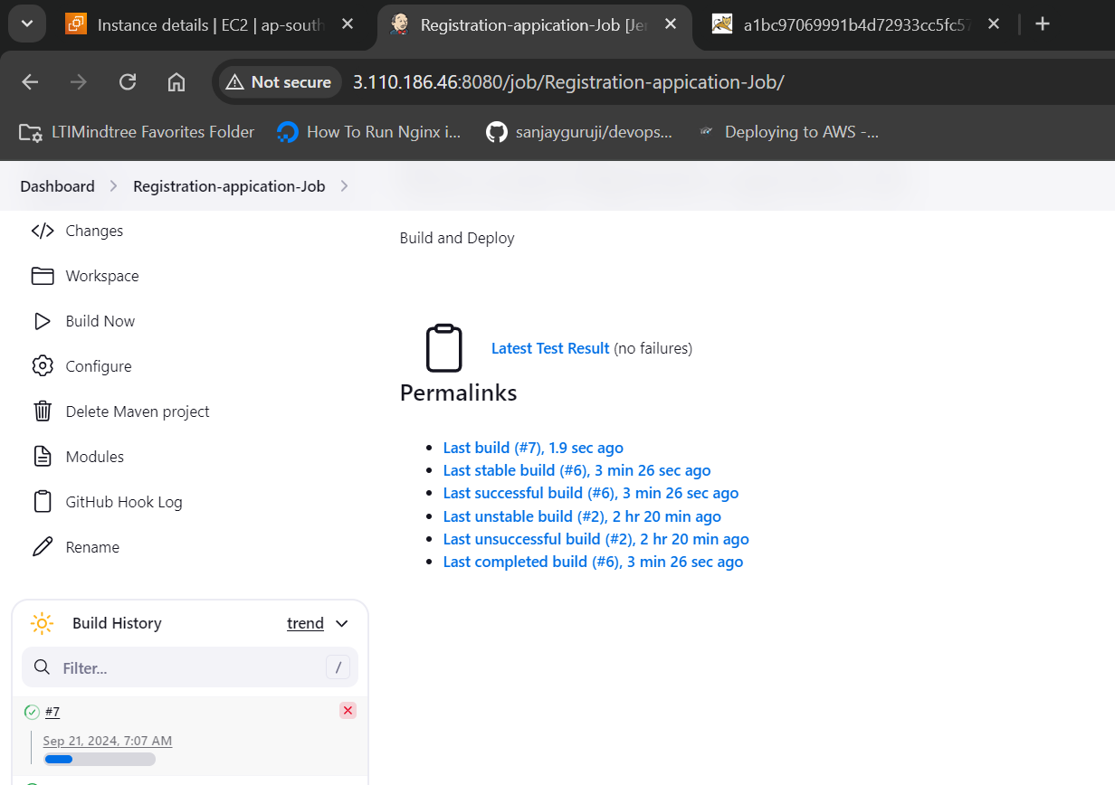

Our build is successful

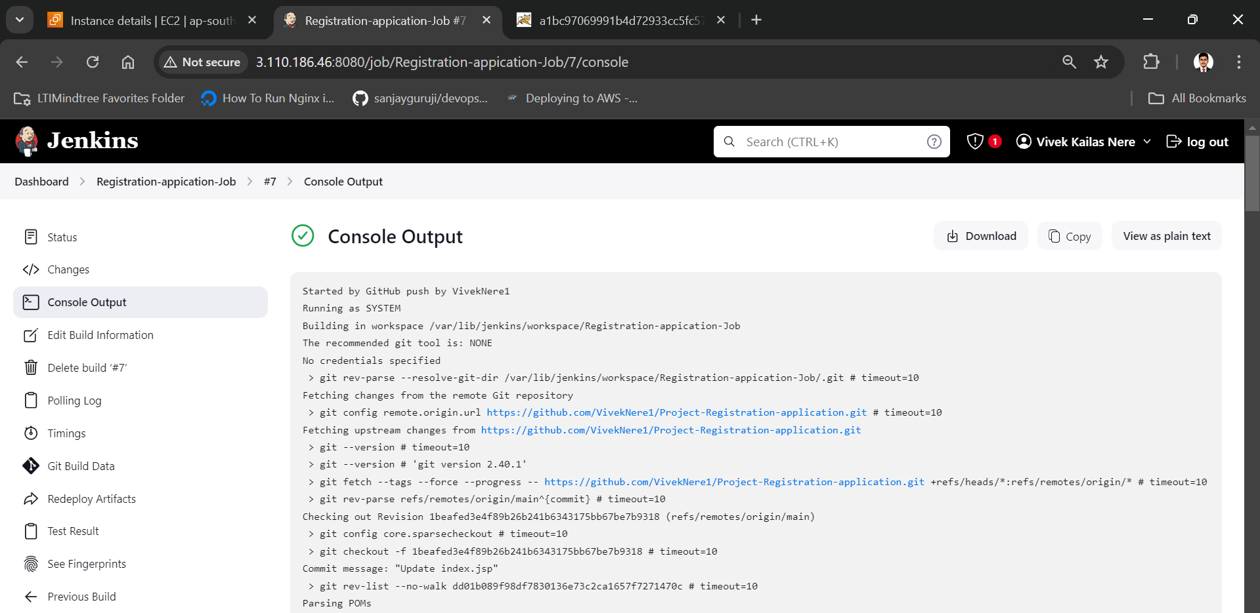

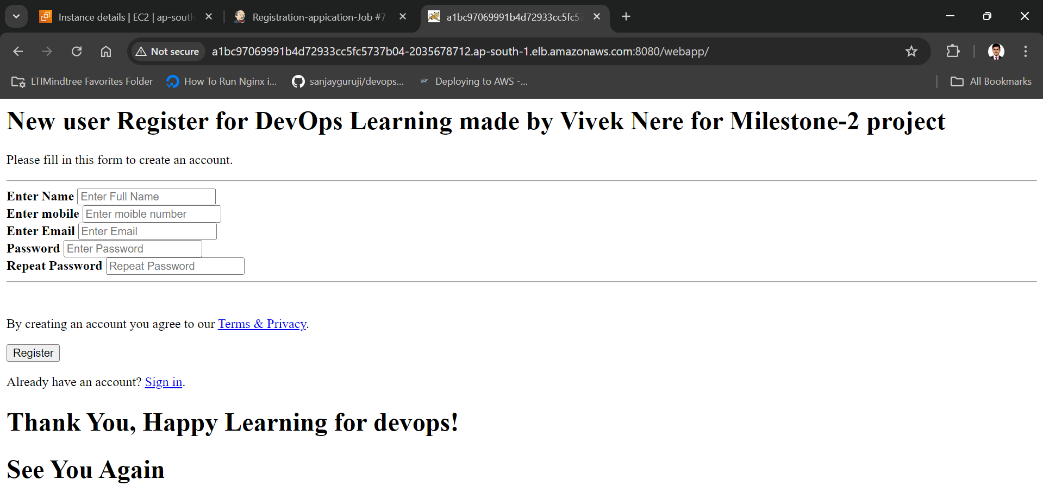

Changes get automatically reflected on server with the help of docker and Kubernetes integration with Jenkins hence we have successfully Created an end to end CI/CD pipeline in AWS platform using Jenkins as the orchestration tool, GitHub as the SCM, Maven as the Build tool, Deploy in a docker instance and create a Docker image, Store the docker image in ECR, Achieve Kubernetes deployment using the ECR image. Build a sample java web app using maven.